Study protocol and statistical analysis plan

1. **Name of the research project**: **Effect of** **ticagrelor monotherapy versus** **clopidogrel plus aspirin in aging patients with unstable angina pectoris after elective percutaneous coronary intervention**
2. **Background：**

The incidence of non-ST-elevation acute coronary syndrome (NSTE-ACS) is increasing year by year. At present, the most effective treatment for NSTE-ACS is percutaneous coronary intervention (PCI).1,2 However, due to various clinical conditions (such as diabetes and dislipidemia) or complications related to coronary vascular disease (such as complex coronary artery disease and unstable plaques) the risk of ischemic events remains high after PCI.3,4,5

Antiplatelet aggregation therapy has become the focus of current treatment following PCI. For NSTE-ACS patients undergoing PCI postoperative antiplatelet therapy, the current guidelines recommend dual antiplatelet therapy (DAPT) for at least 12 months.6 However, NSTE-ACS ischemic or bleeding events after PCI are more frequent in elderly patients than in normal patients,7 and while dual antiplatelet therapy reduced the risk of ischemia, it also increased bleeding.8,9,10,11 Patients with unstable angina pectoris fall into the ACS category, but have a relatively low risk of ischemia compared to NSTEMI, therefore, how to optimize the post-PCI antiplatelet regimen of elderly UAP patients is still difficult. The latest guidelines suggest that clopidogrel can be used instead of ticagrelor in patients with high bleeding risk or other contraindications.6 A number of studies have shown that in patients receiving DAPT, the value of stopping aspirin 3–6 months after stent implantation depends on a balance between ischemia and bleeding risk.12,13,14 If DAPT is discontinued 3 or 6 months after PCI, there is an increased risk of stent thrombosis and myocardial infarction, as reported in the OPTIMIZE and EXCELLENT trials.15,16 Although such short-term DAPT is associated with increased risk of myocardial infarction and stent thrombosis after PCI, long-term DAPT increases the risk of bleeding, thus offsetting its advantage for reducing recurrent ischemic events. Therefore, whether long- or short-term DAPT followed by aspirin or other treatments such as P2Y12 inhibitor monotherapy are employed after PCI, the results are not completely satisfactory for elderly UAP patients.13,17

In order to reduce the risk of bleeding while not increasing the incidence of ischemic events, the recent TWILIGHT study proposed changing the duration of dual antiplatelet therapy without increasing the incidence of ischemic events.12 Ticagrelor may increase the risk of bleeding in elderly NSTE-ACS patients, but is more effective than clopidogrel in reducing ischemic events.

Fig.1 TWILIGHT study

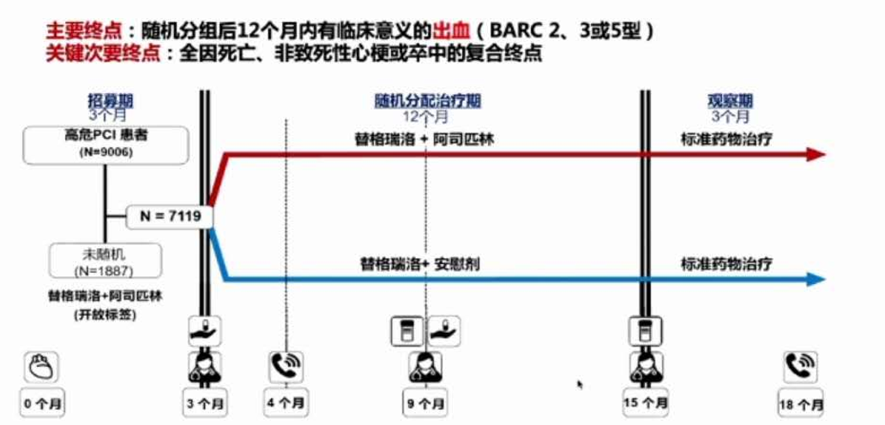

However, the above study is aimed at patients with high ischemic risk. The antiplatelet regimen of elderly UAP patients, who have low ischemic risk and high bleeding risk at once is unclear. Therefore, the purpose of our study was to compare bleeding events and the incidence of major adverse cardiovascular and cerebrovascular events (MACCE) between short-term (ticagrelor 90 mg bid + aspirin 100 mg qd) and long-term (clopidogrel 75 mg qd + aspirin 100 mg qd) DAPT after elective PCI in elderly patients with UAP.

1. **Study design and participants:**

We're going to collect 200 patients with UAP over 65 years of age. Elective coronary angiography and successful stent implantation were performed, and there will have no complications in the perioperative period. After PCI, patients will be divided according to preprocedural antiplatelet therapy into two groups: ticagrelor (ticagrelor 90 mg bid, with aspirin 100 mg qd early during treatment) and clopidogrel (clopidogrel 75 mg qd + aspirin 100 mg qd). Patients in the ticagrelor group will receive aspirin for up to 3 months after PCI unless there have major bleeding or major adverse cardiovascular and cerebrovascular events (MACCE), at which point aspirin is discontinued and ticagrelor (90 mg bid) monotherapy will be administered for the remainder of a 12 month course; treatment for the clopidogrel group will be unchanged over the entire 12 months. The two groups will compare for the incidence of bleeding and MACCE.

1. **Follow-up and endpoints**

At 1, 3 and 6 months after treatment, there will follow up with all patients by telephone, outpatient service and hospitalization. Laboratory examination, electrocardiography, and coronary artery CT or angiography were performed at 12 months after the procedure. The primary endpoints are fatal bleeding events and MACCE. Major bleeding is defined as Bleeding Academic Research Consortium (BARC) type 3 to 5 bleeding.19, while MACCE is defined as a composite endpoint that could include cardiac death, non-fatal myocardial infarction, stroke, and target lesion revascularization.

1. Flow char:

