**PARTICIPANT INFORMATION SHEET**

**Diagnosing and dEtermining the contribution of small FIbre NEuropathy to pain in FibroMyalgia Syndrome**

**Short Study Title: DEFINE-FMS**

**Healthy-Volunteer Participants**

We are asking you to participate in a research study to be conducted by Dr. Uazman Alam, Dr Bernhard Frank, and other DEFINE-FMS investigators at Liverpool University Hospital NHS Foundation Trust and The Walton Centre. This leaflet explains why we are undertaking this study, the benefits and possible discomforts of your participation and what we would like you to do during the study. If you are willing to take part you will be asked to sign a consent form and you will be given a copy to keep.

**WHY IS THIS STUDY BEING DONE?**

The study is being carried out to see if an eye examination called corneal confocal microscopy (CCM) which assesses the front of the eye cornea can detect nerve damage. This will be undertaken in two groups of participants; healthy-volunteer controls and people with fibromyalgia. We will compare the results of the eye test to the current ‘reference’ standard test which is analysis of skin biopsy. Our primary and main aim is to understand how nerve damage occurs in the nerves in the front of the eye and compare this to the nerves in the skin to determine if the eye examination (CCM) is as good as skin biopsy. In addition, we will also determine the relationship of these tests to the types of pain (phenotype of pain) felt by people with fibromyalgia. Some people will be invited to have an additional test called microneurography to assess the function of the nerves and be followed up for examinations after 12 months to see if there are any changes to the nerves or the way they work.

**WHAT ARE WE ASKING YOU TO DO?**

We wish to invite you to the Clinical Sciences Centre at Liverpool University Hospital NHS Foundation Trust (Aintree University Hospital site). We will perform the following tests/assessments during the study:

1. Ascertaining the person’s medical background, current and past use of pain medication, height, weight and blood pressure (30 minutes).
2. Blood tests to exclude any causes of nerve damage including: cholesterol, kidney, glucose control, autoimmune conditions will be assessed. The blood volume we require is approximately 4 teaspoons (around 20 mls) (5 minutes). Once blood has been analysed the specimens will be immediately destroyed and not stored.
3. Clinical neurological evaluation of the lower limbs. This will include completing a symptom questionnaire and assessment of sensitivity to temperature, vibration and touch and a test of nerve function (nerve conduction studies).

Figure 1. This shows the procedure of vibration perception threshold (left) and nerve conduction studies (right) with the relevant equipment being undertaken. Both tests are non-invasive.

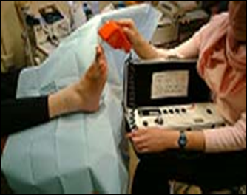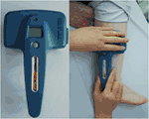

1. Sensory testing involves using a clinical examination to determine the types and quantity of pain through a clinical examination. The examination involves applying limited pressure and pinprick through a number of devices using a standardised internationally recognised protocol. Quantitative sensory testing of thermal threshold is used to measure responses in mainly small nerve fibres which detect changes in temperature (both hot and cold) (point 3 and 4 will take approximately 80 minutes).
2. One skin biopsy will be undertaken from the lower leg and two from the side of the thigh (1 upper thigh and 1 lower thigh). This will take place at the Clinical Sciences Centre, Liverpool University Hospital NHS Foundation Trust (Aintree University Hospital site). A 3mm area of skin is removed from each area. This is performed using a local anaesthetic (numbing medicine) so that no pain or only minimal discomfort is felt. A pencil-like instrument is used to remove a small, thin cylinder of tissue. The small area in the skin will heal over in a few days. The skin sample will then be moved to the laboratories at the University of Liverpool for processing and storage. The samples will then be analysed for markers of small nerve fibres at a later time (in batches). Skin samples will be kept in accordance with the Human Tissue Act and will be respectfully disposed of after the study has been completed after a maximum of 2 years (in accordance with the Human Tissue Act). We may further analyse the skin biopsy after this study is complete (and before the completion of the 2 year period), however, we will gain ethical and Health Regulatory approval before we undertake any such analysis. ***No*** genetic testing will be undertaken on this or any other sample at any time. Skin biopsy samples will be assigned a code and your data will also be identified only by the study number.

A check of the biopsy site will be undertaken after 1 week to ensure the biopsy sites are healing well. If you are on any blood thinning medication please let us know. Unfortunately, if you take warfarin or any other anti-coagulant (rivaroxaban, apixiban, dabigatran, edoxaban) then you will not be able to participate in this study due to the requirement of a skin biopsy. The skin biopsy procedure will take approximately 30 minutes (including the preparation time).

Figure 2. Skin biopsy procedure. The biopsy is 3mm in diameter and only a few millimeters deep. Sites of the biopsy are shown with an * on the image of the leg below.

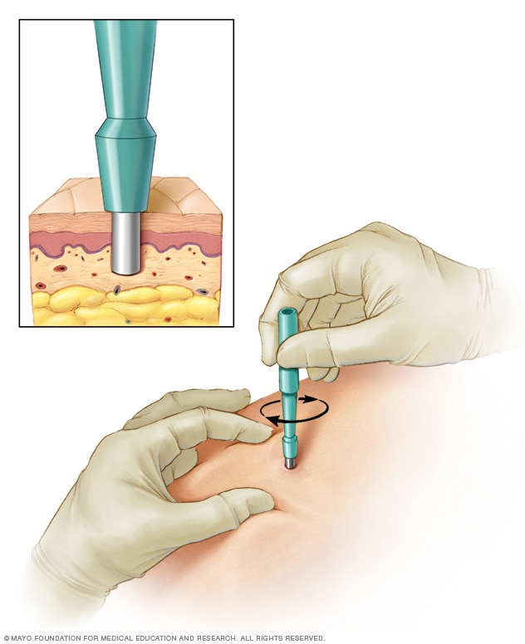

1. Corneal confocal microscopy will be undertaken using a special camera, we will look at the nerves in the front of your eye (cornea). There is usually no or only slight/minimal discomfort to this procedure which is routinely carried out in clinical practice. It takes around 20 minutes for both eyes. A drop of local anaesthetic will be applied to the front of your eye to numb this part to reduce your blinking during the test period. Some jelly (artificial tears) will be applied to the front of your eye. The effects of both of these will wear off after approximately 20 minutes and will not impair your ability to drive home. You will see a white light which does not harm your eye in any way. Images captured from your cornea will be analysed and all the images will be masked (your name and details will be covered).

Figure 3. This shows the procedure of corneal confocal microscopy being undertaken. The corneal confocal microscope is seen in the centre of the image.

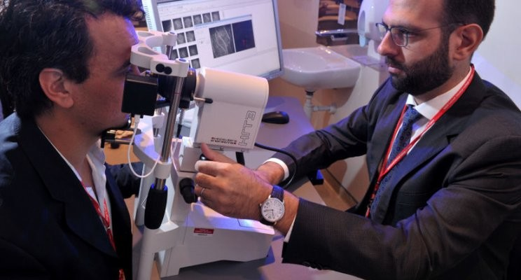

1. We will ask some people (in total 14 of 50 healthy volunteers) to re-attend for a test called **microneurography**. Thisis a method which is used to visualise and record the normal traffic of nerve impulses that are conducted in the nerves of people.  To study nerve impulses, a very fine tungsten needle electrode (similar to a hair) will be inserted into the nerve in the lower leg and connected to an amplifier. The exact position of the electrode tip within the nerve will be adjusted in minute steps until the electrode discriminates impulses of the nerve. This visit will take between 2-3 hours depending on ability to record the impulses.

Tests will be conducted at the Clinical Sciences Centre, Aintree University Hospital site. Corneal confocal microscopy will be undertaken at Clinical Sciences Centre, Aintree University Hospital site or St. Paul’s Eye Unit, Royal Liverpool University Hospital site depending on the availability of the corneal confocal microscope. This will be discussed with you at the first visit. We expect the tests (points 1-6) to take approximately 4 hours in total. For those undertaking microneurography, this will take approximately 2-3 hours.

The only invasive tests are routine blood tests, skin biopsy and microneurography. This study ***does not*** involve the use of any new (investigatory) drugs.

**WHO IS ORGANISING AND FUNDING THE RESEARCH?**

University of Liverpool is the sponsor for this study based in the United Kingdom. We will be using information from you and/or your medical records in order to undertake this study and will act as the data controller for this study. This means that we are responsible for looking after your information and using it properly. University of Liverpool will keep identifiable information about you for no more than 24 months after the study has finished.

Your rights to access, change or move your information are limited, as we need to manage your information in specific ways in order for the research to be reliable and accurate. If you withdraw from the study, we will keep the information about you that we have already obtained. To safeguard your rights, we will use the minimum personally-identifiable information possible.

You can find out more about how we use your information by contacting our data protection officer. Our Data Protection Officer is Victoria Heath and you can contact them at [V.Heath@liverpool.ac.uk](mailto:V.Heath@liverpool.ac.uk) (Legal & Compliance 2nd Floor, The Foundation Building, 765 Brownlow Hill, Liverpool L69 7ZX).

Versus Arthritis have provided funding to the University of Liverpool for this research.

**DO I HAVE TO TAKE PART?**

No, this is voluntary. If you would prefer not to take part you do not have to give a reason. Your current or future medical treatment would not be affected.

**WHY AM I BEING ASKED TO DO THIS STUDY AS I DO NOT HAVE FIBROMYALGIA?**

People without fibromyalgia and who are not in pain; with healthy nerves known as healthy-volunteer controls are needed to provide a comparison. It is so that changes in the corneal nerves, nerves in the skin and type of pain perceived in those with fibromyalgia can be compared to people with healthy nerves and no pain.

**AM I ELLIGIBLE FOR THIS STUDY?**

For the healthy-volunteer group, we need people without fibromyalgia or conditions that causes nerve damage. If you have any known cause of nerve damage i.e. diabetes, Sjorgren’s syndrome, rheumatoid arthritis or chemotherapy-induced peripheral neuropathy then you will not be able to participate in this study. If in the unlikely event nerve damage is detected with one of the tests then you will not be able to participate in the study. We will inform you and your GP (with you consent) so this may be followed up. We will ask you about these conditions once we have consented you. We will need to ensure other conditions that commonly cause nerve damage are excluded and we will undertake blood tests to look for these.

**WHAT ARE THE POSSIBLE RISKS OF TAKING PART?**

There may be bleeding and some discomfort at the skin biopsy site. Occasionally, there may be some slight discolouration at the site of the skin biopsy after it is healed. There is a rare possibility of an infection or poor healing at the biopsy site. A biopsy site check will be undertaken at 1 week to ensure there are no complications. There may be some minor bruising at the site of the routine blood tests. There are no recognised risks of the other procedures proposed for this study. If you have any problems which you think may affect you in the study you should let the research team know at once.

**ARE THERE ANY POSSIBLE BENEFITS?**

There are no direct benefits from undertaking this study. During the study your condition will be assessed in detail. The knowledge gained from this study may affect the tests employed in the future to diagnose nerve damage. In the event of identifying any abnormal results which require attention, we will write to inform you and your GP (with your consent). We may also contact your GP and/or pain medicine consultant/rheumatologist (with your consent) to review previous pain medication use and any reason for withdrawal of these medications.

Upon your request, you will be provided with a summary of the investigations.

**WHAT WILL HAPPEN IF I DON’T WANT TO CARRY ON WITH THE STUDY?**

You are free to withdraw at any time throughout the course of the project. You can contact a member of the research team by writing or by phone if you wish to withdraw and we will not contact you any further. If you decide to withdraw, you do not have to give us a reason why you do not wish to carry on with the study.

Results including coded images and data (not including your identifiable information) and relevant test results up to the period of withdrawal may be used, if you are happy for this to be done. Otherwise you may request that they are destroyed and no further use is made of them. It must be noted however that any safety data or adverse events although very unlikely collected up to the point of withdrawal cannot be removed from the overall study analysis.

**WHAT EXPENSES WILL I RECIEVE?**

You will not be paid for taking part in this study however the research team will reimburse you for any parking costs and travel expenses incurred. This is with a fixed payment of £50 inclusive of all visits and then a further £50 for those people who are to be followed up after 12 months. Refreshments and drinks will be provided for the longer visits at the Clinical Sciences Centre, Aintree University Hospital site.

**WHO WILL SEE THE INFORMATION ABOUT ME?**

All information resulting from your participation in the study will be securely stored and analysed in a computer and will be treated confidentially. The data on the safety of the study may be reviewed by appropriate oversight committees if required. Data may also be looked at by representatives of regulatory authorities and by authorised people from the NHS Trust(s) and other NHS bodies to check that the study is being carried out correctly. All personnel will have a duty of confidentiality to you as a research participant. The study records will not be made available in any form to anyone other than authorised representatives. All information about you will be coded and anonymised. This will be fed into a secure computer kept in a locked room in the secure research centres (3rd floor Clinical Sciences Centre, Aintree University Hospital site and Clinical Eye Research Centre, St. Paul’s Eye Unit, Royal Liverpool University Hospital (if CCM is undertaken at this site), accessible only via strict password protection and all the data and results will be securely stored. Only members of the research team will have access to this code.

Your own GP will be notified of your participation if you are happy for your GP to know. Your confidentiality will be maintained in accordance with the Data Protection Act. The results of this study may be published, however your identity will remain confidential.

As a University we use personally-identifiable information to conduct research to improve health, care and services. As a publicly-funded organisation, we have to ensure that it is in the public interest when we use personally-identifiable information from people who have agreed to take part in research.  This means that when you agree to take part in a research study, we will use your data in the ways needed to conduct and analyse the research study. Your rights to access, change or move your information are limited, as we need to manage your information in specific ways in order for the research to be reliable and accurate. If you withdraw from the study, we will keep the information about you that we have already obtained. To safeguard your rights, we will use the minimum personally-identifiable information possible.

Health and care research should serve the public interest, which means that we have to demonstrate that our research serves the interests of society as a whole. We do this by following the [UK Policy Framework for Health and Social Care Research](https://www.hra.nhs.uk/planning-and-improving-research/policies-standards-legislation/uk-policy-framework-health-social-care-research/) – https://www.hra.nhs.uk/planning-and-improving-research/policies-standards-legislation/uk-policy-framework-health-social-care-research/

If you wish to raise a complaint on how we have handled your personal data, you can contact our Data Protection Officer who will investigate the matter. If you are not satisfied with our response or believe we are processing your personal data in a way that is not lawful you can complain to the Information Commissioner’s Office (ICO).

Our Data Protection Officer is Victoria Heath and you can contact them at [V.Heath@liverpool.ac.uk](mailto:V.Heath@liverpool.ac.uk) (Legal & Compliance 2nd Floor, The Foundation Building, 765 Brownlow Hill, Liverpool L69 7ZX).

Liverpool University Hospital NHS Foundation Trust will use your name and contact details to contact you about the research study, and make sure that relevant information about the study is recorded for your care, and to oversee the quality of the study. Individuals from University of Liverpool and regulatory organisations may look at your medical and research records to check the accuracy of the research study. Liverpool University Hospital NHS Foundation Trust will pass these details to the University of Liverpool along with the information collected from you and your medical records. The only people in the University of Liverpool who will have access to information that identifies you will be people who need to contact you to conduct the research or audit the data collection process. The people who analyse the information will not be able to identify you and will not be able to find out your name, or contact details.

Liverpool University Hospital NHS Foundation Trust will keep identifiable information about you from this study for no more than 12 months after the study has finished.

**WILL ANY GENETIC TESTS BE DONE?**

There will be no genetic tests performed on samples in this study.

**YOUR DOCTOR WILL NOT RECEIVE ANY PAYMENT FOR INCLUDING YOU IN THIS STUDY.**

None of the health care team will personally receive any payment for running this trial.

**WHO HAS REVIEWED THE STUDY?**

The study has been reviewed by members of the South West – Frenchay Research Ethics Committee for ethical considerations.

**COMPENSATION IN CASE OF INJURY**

In the unlikely event that something does go wrong and you are harmed during the research and this is due to someone's negligence then you may have grounds for a legal action for compensation against University of Liverpool and/or NHS Trusts detailed, but you may have to pay your legal costs. The normal National Health Service complaints mechanisms will still be available to you.

If you have a concern about any aspect of this study, you should ask to speak with the researchers who will do their best to answer your questions. If you remain unhappy and wish to complain formally, you can do this through the Patients Advice and Complaints Team (PACT) Aintree University Hospital site (Tel: 0151 529 3287 or email complaints@aintree.nhs.uk.

**WHAT DO I DO NOW?**

One of our study team will contact you in the near future (at least one week after providing this information sheet). We will call you to answer any questions you may have, and we can arrange a suitable appointment for you to visit us. You will also be able to ask further questions if you decide to attend and prior to enrolling in this study. Thank you very much for considering taking part in our research. Please discuss this information with your family, friends or GP if you wish.

If you have any questions, please contact:

Dr. Uazman Alam (Consultant Physician and Senior Clinical Lecturer) Tel. 0151 529 5918

Address: Clinical Sciences Centre, Liverpool University Hospital NHS Foundation Trust (Aintree University Hospital site), Longmoor Lane, Liverpool. L9 7AL.

Thank you for taking the time to read and consider this information sheet. Should you decide to take part in the study, you will be given a copy of the signed consent form to keep.