Title of the study

To test the efficacy of a Slimpod audio/visual intervention for type 2 diabetics with particular reference to achieving NICE recommended targets for management of HbA1C, blood pressure and cholesterol.

Short study title

Can unconscious persuasion in the form of a Slimpod programme help people with type 2 diabetes to lower blood sugar levels, cholesterol and blood pressure to recommended levels.

This protocol has regard for the Health Research Authority guidance on clinical research projects.

The study will be conducted in compliance with the approved protocol and will adhere to the principles outlined in the Declaration of Helsinki and other regulatory requirements. The confidential information obtained during this study will not be used for any other purpose than the evaluation of conduct of the investigation. The findings of the study will be made publicly available through publication or other dissemination tools without any unnecessary delay and an honest, accurate and transparent account of the study will be given. Any discrepancies from the study as planned in the protocol will be explained.

Abstract

Background: The rising number of people suffering from type 2 diabetes, often linked to being overweight, poor diet and low exercise levels, is challenging. Type 2 diabetes is a global pandemic that threatens the health of the population and the sustainability of publicly-funded healthcare. In England in 2019, hospital admissions related to type 2 diabetes cost the NHS £986million and 2,721,000 type 2 diabetes patients were on register. Finding alternative strategies to support weight loss and lower the level of glucose in the blood is essential. This RCT addresses the gap in the literature surrounding unconscious persuasion and its use in weight loss, weight management and the reduction of blood sugar levels associated with type 2 diabetes.

Aim: To test the efficacy of a Slimpod audio weight loss intervention with type 2 diabetics with particular reference to meeting NICE recommended targets of HbA1c <= 58 mmol/mol (7.5%); blood pressure <=140/80 mmHg; cholesterol <5 mmol/L [NICE guidelines NG28 updated August 28, 2019].
Clinical staff at the GP’s practice will record participants’ weight, HbA1c, blood pressure and cholesterol level at weeks 0, 12 and 24.
Blood pressure will be measured using a sphygmomanometer to record systolic pressure and diastolic pressure.
A blood sample will be taken from a vein in the arm to provide a sample for a glycated haemoglobin test to check blood glucose levels.
A lipid profile test will measure the amount of cholesterol and triglyceride fats.
Weight will be measured and recorded in kilograms on the surgery’s scales.

Design/Setting: Randomised control trial, intervention group receive Slimpod programme intervention and the control group follow the standard NICE guidelines on treatment of type 2 diabetes at a GP’s practice in Denton, Manchester.

Method: Participants with a BMI over 25 and with a history of type 2 diabetes will be recruited by the GP practice staff for a 24-week trial. Planned size of sample is circa 100. The intervention group will receive the Slimpod audio/visual control and its associated programme; the Slimpod 9-minute audio recording will be listened to daily and videos watched as directed by the programme.
Control group participants will receive the standard NICE guideline treatment which focuses on patient education, dietary advice, managing cardiovascular risk, managing blood glucose levels, and identifying and managing long-term complications. There will be measurements of HbA1c, blood pressure and cholesterol levels at three time points, 0, 12 and 24 weeks.

Integrated Research Application System number: XXXXXXXXX

Sponsor: ThinkingSlimmer Ltd, Ashbrooke House, Old Hall Drive, Pinner HA5 4SW

Funder: ThinkingSlimmer Ltd, Ashbrooke House, Old Hall Drive, Pinner HA5 4SW

Chief Investigator: Dr Assad Ali, Millgate Healthcare Partnership, 119 Manchester Road, Denton M34 3RA

The protocol

Title of the study

To test the efficacy of a Slimpod audio/visual intervention for type 2 diabetics with particular reference to achieving NICE recommended targets for management of HbA1C, blood pressure and cholesterol.

Sponsor’s role

The sponsor assumes overall responsibility for the initiation and management of the study but the choice of participants and the monitoring of their weight, blood sugar levels, blood pressure and cholesterol levels is the sole domain of the Chief Investigator and his clinical staff. Independent data analysis and interpretation shall be commissioned by the Sponsor and financed by the Funder but neither the Sponsor nor the Funder shall have the final decision on any of these aspects of the study. The Sponsor will assist in manuscript writing subject to the final approval of the Chief Investigator and the independent analyst and the Sponsor shall also be responsible for the dissemination of the study findings.

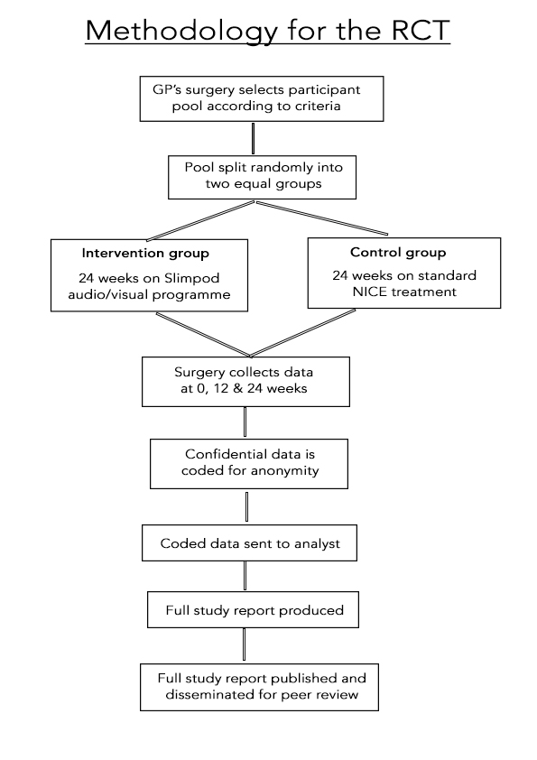

Study design, methods of data collection and data analysis

Clinical staff at the GP’s practice will record participants’ weight, HbA1c, blood pressure and cholesterol level at weeks 0, 12 and 24.

This will be done at the surgery and the data will be stored on the surgery’s computer database in the participants’ patient records in order to maintain confidentiality and remain in full compliance with the requirements of the Data Protection Act 1998 and the General Data Protection Regulation 2016/679.

All investigators and study staff will be trained in, comply with and uphold the core principles of the Act and the GDPR.

At the end of 24 weeks, the data will be transcribed on to a spreadsheet by the surgery staff. Depersonalised data will be created so that each participant’s identifying information will be replaced by an unrelated sequence of characters.

Access to the data, coded and uncoded, will be limited to the minimum number of individuals necessary for quality control, audit and analysis. The sponsor and co-investigators shall only ever see the coded data, which when complete will be sent in coded form to the statistician and analyst nominated by the Sponsor..

The uncoded data shall be stored by the GP’s surgery in line with its normal practices regarding patient confidentiality and shall be stored for as long as the GP considers there to be a medical need to hold such information for the treatment of patients.

The data custodian is Dr Asad Ali.

Sample and recruitment

Eligibility criteria

Participants must have been registered as NHS patients at the Millgate Healthcare Partnership, 119 Manchester Road, Denton M34 3RA at least four weeks before the commencement of recruitment.
Participants will be identified and recruited by the clinical staff at the surgery based on potential participants’ medical history.

Inclusion criteria

Non-gender specific
Age between 30 and 65
BMI 25 or greater
Diagnosed as having type 2 diabetes
Any ethnicity
Any socio-economic grouping

Exclusion criteria
Outside of location stated above
Outside of stated age range
Not suffering from type 2 diabetes
Having a BMI <25

Sampling technique

Participants will be split randomly into the intervention and control groups to ensure that knowledge of the patients’ medical history cannot influence which treatment they receive. Simple randomisation will occur to allocate participants to the intervention or control groups using a 1:1 allocation ratio. A computer run programme will generate a random number to assign each participant to a trial arm. The trial statistician will not be involved in the process of recruitment, randomisation, or group assignment.

Statistical methods

Baseline characteristics: mean and standard deviation (SD) for continuous data and n (%) for categorical data. Baselines will be collected and defined as the values stated before the commencement of randomised treatment. Analysis of covariance (ANCOVA) will ensue for comparison of the control and intervention groups. The change from baseline at each post-baseline assessment will be noted separately, with the baseline fitted as a covariate; the interaction between baseline and treatment will be assessed.

Consent

Informed consent shall be obtained from every participant of the RCT before undergoing any activities specifically for the purposes of the study.

In order for consent to be obtained, there will be a confidential discussion between the potential participant or his/her legally acceptable representatives and a member of the surgery team who is knowledgeable about the research. This discussion will outline the nature and objectives of the study. Potential participants will have the opportunity to ask questions and there will be an assessment of capacity made by the surgery team member to ensure that participants are capable of giving consent for themselves; understand the purpose and nature of the RCT; understand the alternatives to taking part; and are able to retain the information long enough to make an effective decision and a free choice.

Ethical and regulatory considerations

There is no known risk to participants using the non-invasive Slimpod intervention or control invention. An independent assessment by Mr Gideon Felton, MRCPsych, then a senior psychiatrist at the Central Middlesex Hospital, London, concluded: “I have found no evidence of any psychologically dangerous mechanisms and on this basis, I am willing to endorse Slimpod on safety grounds. I have found the benefits of it profound and positively life-changing.”

Data collection will be carried out by members of the clinical team at the Chief Investigator’s surgery and at all times will protect and uphold the confidentiality and dignity of the participants.

Research Ethics Committee review

Before the start of the RCT, a favourable opinion will be sought from a Research Ethics Committee (REC) for the protocol, informed consent forms and other relevant documents such as explanatory leaflets. Any substantial amendments to the protocol which require review by the REC will not be implemented until that review is in place.
Regulatory compliance
Before the surgery team can enrol patients into the study, the Chief Investigator or designee will ensure that appropriate approvals from participating organisations are in place and comply with the relevant guidance.
For any amendment to the study, the Chief Investigator or designee will, in agreement with the Sponsor, submit information to the appropriate body in order for them to issue approval for the amendment.
Peer review

This study protocol has been reviewed at the request of the Sponsor and Funder by two independent experts who are not involved in the study in any way. Both have a detailed knowledge of the disciplines of unconscious persuasion and positive psychology.

The full study report will be subject to high quality peer review upon public dissemination.

Protocol compliance

An independent Trial Monitor with medical qualifications and extensive experience in blood testing and research procedures will be appointed. The Trial Monitor will ensure that the standardised operation procedures for the trial are being followed, reporting and managing any deviations from the investigation plan as they occur.

It is recognised by all parties involved in the RCT that accidental protocol deviations can happen at any time. Such deviations shall be properly documented and reported to the Chief Investigator, Trial Monitor and Sponsor immediately. Immediate steps shall be taken to rectify deviations from the protocol which are found to frequently recur.

Indemnity insurance

The Sponsor shall provide indemnity insurance to pay compensation to any volunteers in the event of injury due to participation in the clinical trial. The Sponsor has taken out appropriate indemnity insurance with Hiscox Insurance Company Ltd policy number CCZCPL19AB-NUW01-11895 in the sum of £2,000,000 (two million pounds).

Who will have access to the final study set?

Dissemination policy

The data arising from the study in coded form shall be owned by the Sponsor. On completion of the study, the data will be analysed and tabulated and a final independent study report prepared. This full study report can be accessed via the Sponsor’s website, www.ThinkingSlimmer.com. The Sponsor shall have the right to publish any of the anonymous study data within 24 months of completion of the full study report.

Participants in the study may be notified by email, letter or text of the outcome of the study at the sole discretion of the Chief Investigator. If a participant requests results from their individual outcome then that shall be a matter for the Chief Investigator and his clinical staff to decide.

Authorship

Authorship of the final study report shall be jointly granted to Sandra Roycroft-Davis, chief executive officer of ThinkingSlimmer Ltd; Dr Assad Ali, the Chief Investigator; and Daniel Williams MA, the independent person selected to analyse and interpret the data.

