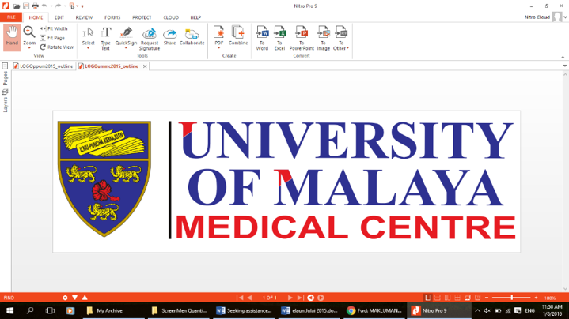

**PARTICIPANT INFORMATION SHEET**

**Study Title: Eye-masks and earplugs to improve night sleep duration in pregnancy and effect on oral glucose tolerance test: A randomized trial**

**Version No: 2**

**Version Date: 11/06/2021**

*We would like to invite you to take part in a research study. Before you decide whether to participate, you need to understand why the research is being done and what it would involve. Please take time to read the following information carefully; talk to others about the study if you wish.*

*Ask us if there is anything that is not clear or if you would like more information. Take time to decide whether or not you wish to take part.*

1. **What is the purpose of this study?**

The study aim is to evaluate the use of eye mask and earplug to increase sleep duration in pregnant women with reported short sleep less than 7 hours at gestation less than 34 weeks in relation to glucose metabolism

1. **Why is this study important?**

Short sleep duration in pregnancy has been associated with poor pregnancy outcomes like longer labour, developing gestational diabetes mellitus, hypertension, preterm birth and caesarean section. Sleep problem is very common in pregnancy. it may be possible to reduce the adverse pregnancy outcome by improving sleep and to find sleep aids that can achieve that

1. **What type of study is this?**

This is an interventional randomised-controlled trial where participants will be assigned by a computer to receive either 1) Eye-mask, earplugs or 2) control group

1. **What is the procedure that is being tested?**

Trying to improve sleep duration at night

1. **Does the investigatory product contain culturally sensitive ingredients eg: bovine or porcine?**

No.

**BK-MIS-1116-E03**

1. **Why have I been invited to participate in this study?**

You have been invited to participate because you reported a short night sleep duration of fewer than 7 hours and your pregnancy is less than 34 weeks and fulfil other criteria to take part.

1. **Who should not participate in the study?**

You should not participate in the study if you have pre-existing sleep, psychiatric or medical disorders; active smoker or consume alcohol, body mass index above 35; co-sleeping child/children,

night shift worker, night care-taker of other family members or the baby you are is known to have severe issues or inability to used eye mask , earplug or the Actigraph watch

1. **Can I refuse to take part in the study?**

Participation in this study is completely voluntary. Not consenting to participate or withdrawal of consent will not affect your entitled medical services. You do not have to participate in this study to get treatment for your disease or condition. Declining to take part will not affect your care in any way.

1. **What will happen to me if I take part?**
2. Wear the wristwatch-like device when you go to bed at night, this device detects movement (actigraphy) and the information will be downloaded to give your night sleep duration.
3. You will need to record in a diary the time you go to bed to sleep and the time you wake to get out of bed. This information is needed by the actigraphy software to work out your night sleep duration
4. At the end of week 1 (end of 7 days), you will need to return for actigraphy data to be downloaded and analysed.
5. Use eye-mask and earplugs when you go to bed at night if assigned to this intervention
6. **How long will I be involved in this study?**

The study takes 1 week to complete. The actigraphy wristwatch is to be worn every night when you go to bed to sleep for the whole 1 weeks

1. **What are the possible disadvantages and risks?**

The use of eye-mask and earplugs is not expected to have any adverse during pregnancy. Please ask your study doctor if you need more information on risks and side effects.

1. **What are the possible benefits to me?**

There may or may not be any benefits to you. Information obtained from this study will help improve the treatment or management of other patients with the same disease or condition.

1. **Who will have access to my medical records and research data?**

Only the investigators will have access to your medical records and research data.

**BK-MIS-1116-E03**

1. **Will my records/data be kept confidential?**

All your information obtained in this study will be kept and handled confidentially, following applicable laws and/or regulations. When publishing or presenting the study results, your identity will not be revealed without your expressed consent. Individuals involved in this study and your medical care, qualified monitors, auditors, the sponsor, its affiliates and governmental or regulatory authorities may inspect and copy your medical records, where appropriate and necessary. Data from the study will be archived for analysis, but your identity will not be revealed at any time.

1. **What will happen to any samples I give? (If applicable)**

Not applicable.

1. **What will happen if I don’t want to carry on with the study?**

You may withdraw from the study at any stage without having to give a reason. Your care will not be affected if you choose to withdraw.

1. **What if relevant new information about the procedure/ drug/ intervention becomes available?**

You will be informed of any new information (relevant to the consent become available and may need to re-consent, based on new information.

1. **What happens when the research study stops?**

If the study is stopped early for any reason, you will be informed and arrangements made for your care.

1. **What will happen to the results of the research study?**

It will be presented and published in the Clinical Masters final thesis and may be reproduced in international scientific journals.

1. **Will I receive compensation for participating in this study or any extra expenses that I need to pay?**

No, there will not be any compensation provide and there will be no additional expenses needed.

1. **Who funds this study?**

The Department of Obstetrics & Gynaecology, UMMC.

1. **Who should I contact if I have additional questions/problems during the study?**

If you have any questions about the study or if you may have a study-related injury and want information about treatment, please contact the study doctor;

Dr Normala binti Mohammad Som, UMMC

H/P: 016-4144953

1. **Who should I contact if I am unhappy with how the study is being conducted?**

Medical Research Ethics Committee

University of Malaya Medical Centre

Telephone number: 03-79493209/2251

**BK-MIS-1116-E03**