P2S1 Protocol

Exploration of the Association Between Hydration Status and Competence in Doctors

Background and Significance
Dehydration has detrimental implications for health and behaviour. El-Sharkaway et al., (2016) examined the extent to which dehydration affected doctors, and demonstrated that UK doctors were clinically dehydrated at the start (36%) and end (45%) of shifts; this was associated with significant cognitive impairment in dehydrated participants in pre- and post-shift analyses as measured by the Sternberg short-term memory tests. As little as 2% dehydration as a percentage of total body weight can cause impaired physical, psychomotor, cognitive, psychiatric and visuomotor performance), in addition to greater fatigue, and reduced alertness (Wilson and Morley, 2003; Shirreffs, Merson, Fraser and Archer, 2004; Adan, 2012). Homeostatic hydration maintenance is typically mediated by thirst sensation, however intrinsic self-regulatory mechanisms can be disrupted by a range of biopsychosocial factors. The addition of PPE as standard workplace practice (beyond what was previously expected) is likely to have magnified the speed at which doctors dehydrate (due to elevated temperature), and due to the functional infection-control barriers of fluid intake. Therefore, given the fundamental importance of hydration for psychophysiological functioning, exploring doctor’s hydration levels and impact on measures of competence is a valuable area of research.

Research Aims
The primary aim of this study is to explore the association between hydration status and competence of doctors. Through psychophysiological effects, this research hypothesises that there will be a positive association between hydration status and competency. A secondary aim will be to explore the competence data to identify which elements of the competence construct have state effects (as opposed to trait), and thus which elements are likely to be more sensitive to changes in psychophysiological status.

Design
In order to examine the relationship between hydration and competence, this observational cohort study will assess measures of competence, hydration and psychophysiological status immediately prior to, and immediately following two working shifts. The primary end point is competence, measured using the General Medical Council (GMC) Self-Assessment Questionnaire (SQ), and the primary predictor variable is hydration status. Secondary end points are diagnostic reasoning ability, personality, emotional competence, stress, lifestyle risk, working memory performance and capacity.

This research will be undertaken online using Collector (https://psyarxiv.com/u3saf/), and University of Reading licensed academic research survey software; ‘JISC Online Surveys’. In summary, data will be collected at three time points on three separate days; baseline, Time 1, and Time 2. The baseline assessment will collect data on baseline characteristics and secondary variables of interest (see below). The IV (hydration status) and the DVs (various) will be assessed at Time points 1 and 2. Essentially, the doctors will be asked to complete a questionnaire survey at the end of two working shifts as consecutively as possible within a 10-day period. Time 1 will be at the end of the first working day, and Time 2 will be at the end of the second working day.

Participants
This study will recruit a convenience sample of qualified practicing doctors from advertising through doctor-support and trade union organisations e.g., the Doctor’s Support Network (DSN), The British Medical Association (BMA) and The Royal Society of Medicine (RSM). Inclusion criteria are healthy adult volunteers currently in employment as a doctor by the National Health Service in the United Kingdom, and have access to a private home laptop or PC to complete the online testing. Participants who are pregnant, or who are breastfeeding will be excluded due to their hydration needs differing from the general population. Participants with current renal, cardiac, pulmonary, hepatic, digestive, thyroid, neurological or haematological disease, in addition to anyone taking medications (either prescribed or over-the-counter) that influence weight, fluid, or electrolyte balance, will also be excluded.

Sample size. Formal sample size calculations for this study were not possible due to the lack of published data on the mean and standard deviation of the scores on the GMC self-assessment questionnaire. Based upon published guidance (Bell, Whitehead and Julious, 2018) on statistical considerations and precision of expected estimates/effect size etc., the required sample size in this exploratory study would be between 30 to 40 participants. Therefore, a minimum of N = 35 participants should be sufficient to assess associations between hydration status and competence. However, a comparable study exploring hydration status and cognition in this population reported a completion rate of 52% based on a two-day testing procedure (El-Sharkawy et al., 2016). Therefore, this study will continue to recruit until 35 participants have completed the study, based on previous research, the enrolment of approximately 70 participants will be required to allow for the anticipated dropout rate.

Study Procedures
Screening. Potential participants will be invited to fill in a brief (5-10 minutes) online screening survey comprised of questions related to the inclusion and exclusion criteria. Participants who meet the eligibility criteria will be provided by email with the participant information sheet and consent form. Once the consent form is completed participants will be asked to provide telephone and residential postal contact details, and offered a telephone briefing.

If the screening questionnaire responses fulfil the inclusion/exclusion criteria and the participant is happy to proceed, participants will be emailed an assigned participant ID, an information sheet, and a link to an online survey platform. Participants will also receive a postal testing pack including sample pots, urinalysis reagent strips and comprehensive self-testing and online reporting instructions. Participants will access their surveys in privacy via a home laptop or PC. The survey links will be accessible for invited participants for three weeks, two engagement reminder invitations and instructions will be sent approximately one week apart.

Screening Questionnaire |  | Baseline Testing Session |  | Working Day Assessment Protocol
- Eligibility Survey  - Contact Form |  | - Demographic Survey  - Professional Context  - Retrospective Measures

Figure 1. General timeline of the study. This study procedure includes an online screening questionnaire, baseline testing session, followed by a typical working day assessment protocol.
Baseline testing session. The baseline testing session will take approximately 40 minutes. At timepoint 0 (T0), participants will complete questionnaires related to socio-demographic information (age, ethnicity, sex, gender-identity), the professional context of their work, and three open questions on the barriers and facilitators of optimum hydration behaviours during work, and impact of Covid-19 on their fluid-intake at work. Five measures will provide retrospective baseline data, including:
- The Professional Quality of Life – Version 5 (ProQOL-5) to assess coping competence, burnout, secondary traumatic stress and compassion satisfaction.
- The Profile of Emotional Competence (PEC) as a self-reported measure of intra- and inter-personal emotional competence and global emotional intelligence.
- The Almost Perfect Scale-Revised Short Form (APS-R SF) to assess attitudes towards others, themselves and their performance, orthogonally measuring the maladaptive and adaptive aspects of perfectionism.
- The Diagnostic Thinking Inventory (DTI) which is a widely applied self-assessment tool used to determine clinical diagnostic reasoning in doctors at all stages of their career. The DTI assesses two clinical reasoning domains: knowledge structure in memory and flexibility in thinking.
- The Lifestyle Appraisal Questionnaire (LAQ) as a comprehensive assessment of lifestyle.

Within 3-days following the baseline testing session, participants will also be asked to complete Day 1 of the working day assessment. B0 - T2 is designed to be completed (ideally) within a 7-day period according to each doctor’s shift pattern.

Working day assessment. Following the baseline testing session participants will be asked to complete two working day assessments. (T1 and T2). This will include:
- The primary outcome measure of competence is the GMC Self-Assessment Questionnaire (SQ) which is a measure relevant to all specialties at all stages of a doctor’s career and is used as one of the multi-source assessment measures for revalidation. Instructions for the SQ have been modified to specify reflection on competence during a single-shift versus a broader measure.
- The Daily Stress Inventory (DSI) items measure a 24-hour period and three daily scores are derived on the number of events, the sum of the impact of the events, and the average impact rating of the events.
- The N-back (level 2 and 3) tasks will be used as a cognitive assessment to measure performance of a part of working memory and working memory capacity.
- The primary predictor variable is hydration status; therefore, participants will be asked to undertake self-assessed urinalysis using reagent Labstick’s. Hydration will be assessed using urine specific gravity (U_{specific} _{gravity}) for monitoring hydration status, and urinary PH (U_{pH}) as a measure of physiologic and psychological stress. Urine colour (U_{colour}) will be analysed using an NHS 8-level colour chart. The participant-administered urinalysis measures are quick, non-invasive and require no prior expertise. In addition, participants will be required to provide a fluid record based on the volume and type of fluid consumed over the duration of their working shift.

Bayer Reagent Strip Analysis to report  U_{specific} _{gravity,} U_{pH,} leucite esterase and nitrate. | 8-level colour chart (NHS, 2017)  To record Urine colour (U_{colour}).
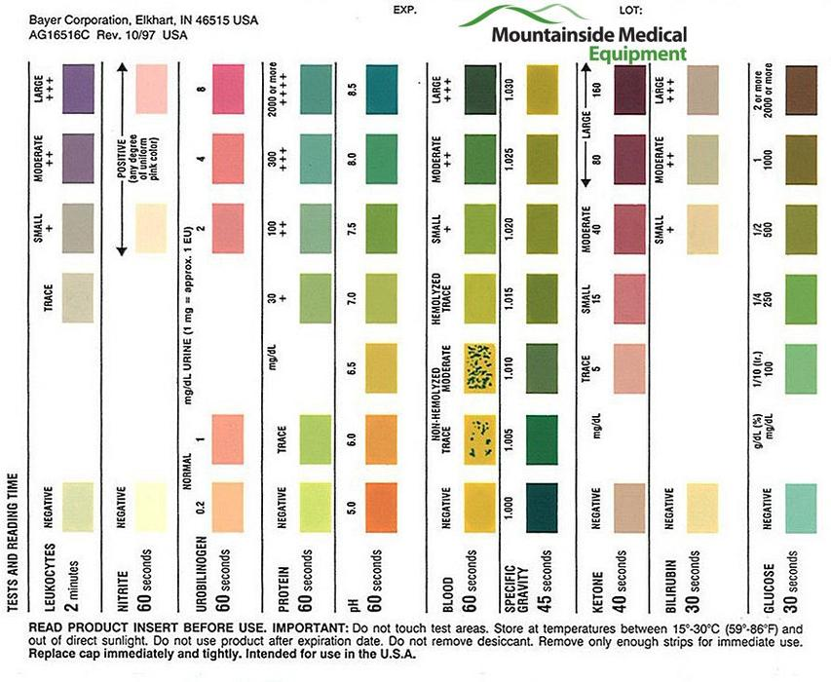 | 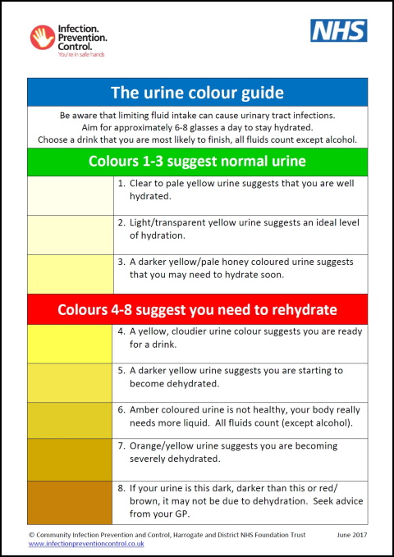

Figure 2. Reagent Strip Analysis and U_{colour} Reporting Scales.

Completion. On completion, participants will be emailed a debriefing sheet including a list of support and information services (e.g., Samaritans, NHS 111), and offered a telephone debriefing on request.
Timeline
Following attainment of ethical approval and engagement of stakeholders for recruitment advertising (anticipated 1 month), the anticipated duration of Study P2S1 is a maximum of 6 months.

Figure 3. Anticipated Completion Timeline

References
Adan, A. (2012). Cognitive performance and dehydration. Journal of the American College of Nutrition, 31(2), 71-78. https://doi.org/10.1080/07315724.2012.10720011
Bell, M. L., Whitehead, A. L., & Julious, S. A. (2018). Guidance for using pilot studies to inform the design of intervention trials with continuous outcomes. Clinical epidemiology, 10, 153–157. doi: 10.2147/CLEP.S146397
El-Sharkawy, A., Bragg, D., Watson, P., Neal, K., Sahota, O., Maughan, R., and Lobo, D. (2016). Hydration amongst nurses and doctors on-call (the HANDS on prospective cohort study). Clinical Nutrition, 35(4), 935-942. http://dx.doi.org/10.1016/j.clnu.2015.07.007
Shirreffs, S., Merson, S., Fraser, S., and Archer, D. (2004). The effects of fluid restriction on hydration status and subjective feelings in man. British Journal of Nutrition, 91(6), 951-958. https://doi.org/10.1079/BJN20041149
West, C. P., Tan, A. D., Habermann, T. M., Sloan, J. A., & Shanafelt, T. D. (2009). Association of resident fatigue and distress with perceived medical errors. JAMA, 302(12), 1294–300. doi: 10.1001/jama.2009.1389
Wilson, M., and Morley, J. (2003). Impaired cognitive function and mental performance in mild dehydration. European Journal of Clinical Nutrition, 57(2), s24-29. Doi: 10.1038/sj.ejcn.1601898

Measures
Bordage, G., Grant, J., & Marsden, P. (2014). Diagnostic Thinking Inventory Instrument. Retrieved from https://www.researchgate.net/publication/263733394_DIAGNOSTIC_THINKING_INVENTORYinstrument
Brantley, P., Waggoner, C., Jones, G., & Rappaport, N. (1987). A Daily Stress Inventory: Development, reliability, and validity. Journal of Behavioral Medicine. 10. 61-73. doi: 10.1007/BF00845128.
Brasseur, S., Grégoire, J., Bourdu, R., & Mikolajczak, M. (2013). The Profile of Emotional Competence (PEC): Development and Validation of a Self-Reported Measure that Fits Dimensions of Emotional Competence Theory. PLoS ONE, 8(5): e62635. doi:10.1371/journal.pone.0062635
Craig, A., Hancock, K., & Craig, M. (1996). The lifestyle appraisal questionnaire: A comprehensive assessment of health and stress. Psychology and Health, 11(3), 331-343. doi: 10.1080/08870449608400262
General Medical Council (GMC). Self-Assessment Questionnaire. Retrieved from https://www.gmc-uk.org/-/media/documents/Self_assessment_questionnaire___DC7525.pdf_60924494.pdf
Slaney, R., Rice, K., Mobley, M., Trippi, J., & Ashby, J. (2001). The revised Almost Perfect Scale. Measurement and Evaluation in Counselling and Development, 34(3), 130-145. doi: 10.1080/07481756.2002.12069030
Stamm, B. (2009). Professional Quality of Life: Compassion Satisfaction and Fatigue Version 5 (ProQOL). Retrieved from https://proqol.org/uploads/ProQOL_5_English.pdf

