Breast Cancer Survivorship Care Models in Taiwan: A Randomized Controlled Study
Yong Alison Wang^{1,2*}, Kai-Hsin Hsu¹; Chen-Fang Hung¹
- Koo Foundation Sun-Yat Sen Cancer Center, Taipei, Taiwan
- National Yang Ming Chiao Tung University School of Medicine, Taipei, Taiwan

*Corresponding Author:
Yong Alison Wang, Department of Internal Medicine, Koo Foundation Sun-Yat Sen Cancer Center, 125 Lih Der Rd, Beitou District, Taipei 11259, Taiwan. Email: wang@kfsyscc.org Tel: +886-2-2897-0011 ext 1746 Fax: +886-2-2858-6134, ORCID 0000-0001-7361-348X

Background
Early detection and improvements in treatment of breast cancer have resulted in rapidly increasing number of breast cancer survivors [1]. The 5-year survival rate is 98% for localized disease and is 84% for regional disease in the United States [2]. In Taiwan, similar 5-year survival rates have been observed, 95% for stage I disease, 89% for stage II disease and 70% for stage III disease [3]. With the increasing incidence of breast cancer in Taiwan, continued improvement in detection and treatment, and the aging population, the number of breast cancer survivors continued to increase. Survivors who have completed their initial treatments require surveillance for recurrence, general screening and preventive care, psychosocial care, as well as care for comorbid conditions [4]. However, effective and efficient ways in which to organize, deliver and facilitate services are complex. Different models of follow-up care have been tested, including follow-up by cancer specialists compared to general practitioners, and by doctors compared to trained nurses [5-9]. These studies showed that there were no significant differences in time to confirmation of recurrence [6], recurrence-related serious clinical events [7], patient satisfaction, quality of life and level of patient anxiety [6-9].
In Taiwan, there is limited primary care network for continuity of patient care. Since the National Health Insurance provides universal care, patients can access care from any specialist in any frequency. Coordination between providers and continuity of care are poor. Cancer survivorship care could range from being followed by multiple providers in high frequency to complete lost to follow-up. With the growth in number of cancer survivors, the impact on quality of national health care and its cost effectiveness would be significant. By 2009, the Koo Foundation Sun Yat-Sen Cancer Center was the highest-volume breast cancer provider in Taiwan, treating about 10% of all new breast cancer patients. Most breast cancer patients treated at KF-SYSCC continued to receive survivorship care at KF-SYSCC. These patients had been followed mostly by their cancer treatment specialists indefinitely, impacting the availability of these specialists to treat new cancer patients. General practitioners and advanced practice nurses have undergone training to provide care for breast cancer survivors at KF-SYSCC. A comprehensive long term follow-up program coordinated by general practitioners has been set up to provide holistic cancer survivorship care. This study will randomize treated breast cancer patients to transfer to the generalist physician coordinated long term follow-up program at one or two years after surgery (Figure 1,2). We aimed to compare the quality of care delivered to breast cancer survivors by general practitioners and oncology specialists in terms of quality of life, breast cancer specific long term adverse effect, anxiety and depression, time to recurrence confirmation, and management of co-morbid conditions. We also assessed feasibility of generalist survivorship care, including adherence and timing of transfer of care, satisfaction to care, number/frequency/type of visits, and number/type of tests done.

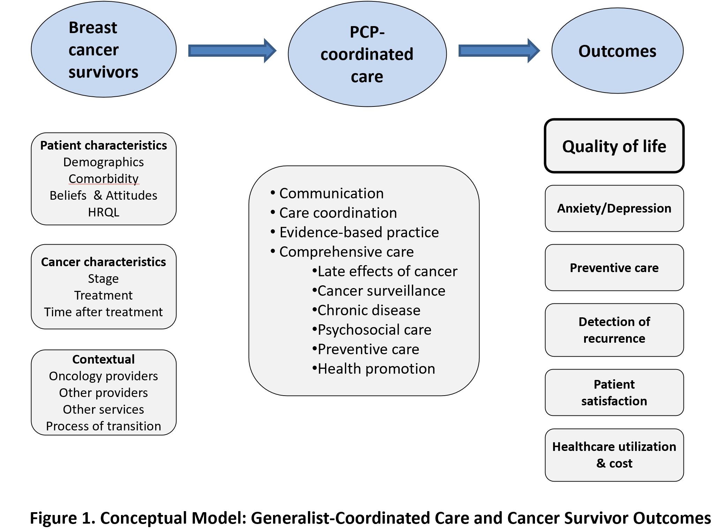

Methods
This was an open-label, randomized controlled study with staggered transfer for care of breast cancer survivors, with two groups with planned transition to the generalist-coordinated program at one year or two years after cancer surgery. Comparison of quality-of-life measures in mental and physical health dimensions were made between the one-year and two-year transfer groups.
Patient enrollment and follow-up
Stage 0,1,2,3 breast cancer patients treated at KFSYSCC were identified after surgery, chemotherapy, or radiation therapy. As an institutional policy, breast cancer survivors had been encouraged to transfer to generalist-coordinated cancer survivorship care team (LTFU program), usually at 3 to 5 years after surgery. The generalist care program focuses more on holistic care including long term adverse effects of cancer and its treatment, psychosocial care, preventive care, health promotion and management of comorbidities. The LTFU program was staffed by family physicians or general internists who had undergone training and were experienced in caring for breast cancer survivors. For the study, the enrolled patients were transferred to the LTFU program earlier than routine practice, either at one year or at two years after surgery. Patients were approached to explain about the study and to obtain informed consent for enrollment at 3 to 9 months after their breast cancer surgery. We did not approach patients after 9 months from surgery, since time to transfer at 1 year would be less than 3 months, too short for arranging transfer, and for a valid comparison between baseline measures and after intervention.

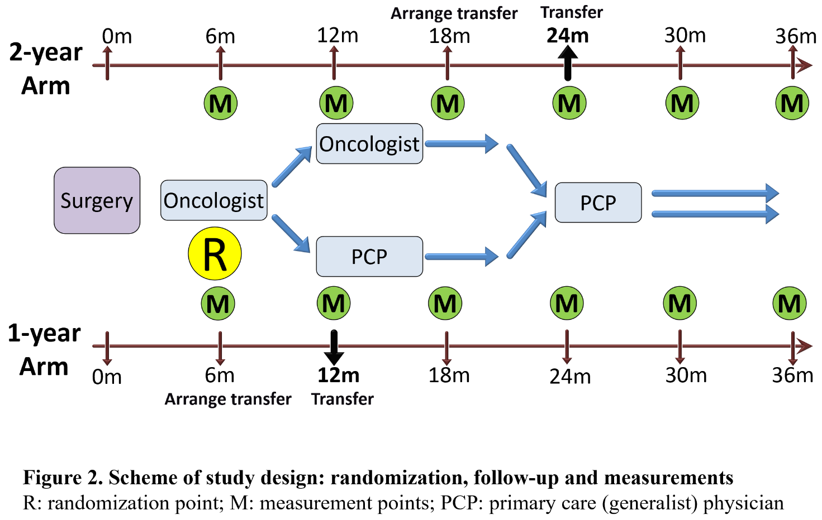
Enrolled patients were randomized to one of two groups using a web-based permuted block randomization method with a block size of 10, stratified by whether or not they had locally advanced breast cancer. Three to six months before the planned transfer, appointment was made with a LTFU generalist physician based on time availability, patient or oncologist preference. We respected patients’ wish to not transfer to LTFU program at specified times, or to switch physicians, or to transfer back to their oncologist(s) without clear medical reasons. We made efforts to understand the reasons and resolve issues, and continued collecting study measurements. For the primary intent-to-treat analysis, patients were analyzed in the initially randomized group.
Patient characteristics are collected as the following: age of breast cancer diagnosis, stage and other cancer characteristics (site, ER, Her2-neu), surgery (mastectomy or breast-conserving surgery), adjuvant treatment (chemotherapy, radiotherapy), and demographics.
Outcome survey instruments were measured at baseline and every 6 months until 36 months after surgery. Three-month range before or after the designated time for surveys were allowed. Measurements include the following:
- Breast cancer-specific physical symptom scale (Breast Cancer Prevention Trial BCPT Symptom Scale), 18 questions, 8 dimensions, score range 0-4, lower is better:
  - Hot flashes: 1, 14
  - Nausea: 2, 3
  - Bladder control: 4, 5
  - Vaginal problems: 6, 7
  - Musculoskeletal pain: 8, 9, 10
  - Cognitive problems: 13, 15, 16
  - Weight problems: 11, 12
  - Arm problems: 17, 18
- Anxiety/depression: PHQ-9, GAD-7
  - PHQ-9: depression (lower score is better)
    - Score range 0-27
    - Cutoff 5, 10, 15, 20: mild, moderate, moderately severe, severe depression
  - GAD-7: anxiety
    - Score range 0-21
    - Cutoff 5, 10, 15: mild, moderate, severe anxiety
- Health-Related Quality of life: SF-36, 36 questions, 9 dimensions, score range 0-100, higher is better
  - Physical functioning
  - Role physical
  - Role emotional
  - Social functioning
  - Bodily pain
  - Energy/fatigue
  - Mental health
  - General health perceptions
  - Change in health from a year ago
- Satisfaction with care survey
For those patients who develop cancer recurrence, we measured the following:
- Time from symptom or image finding to confirmation of recurrence
- Stage of locoregional or contralateral breast recurrence
- Serious recurrence-related clinical events
The BCPT symptom scale uses a Likert scale (0-4) for each question, and scores were added for each dimension. PHQ9 and GAD7 use a total score with ranges for categorical interpretation. SF-36 is calculated as a normalized score from 0-100 in eight dimensions as well as composite Physical and Mental Component Summary (PCS and MCS) subscales. The patient satisfaction questionnaires used Likert scales.
Statistical Analysis
We estimated that with a sample size of 900 patients (450 in each group), the study would have 80% power to detect a difference of 20% effect size (Dmean/SD) in outcome measures, allowing a drop-out rate of 10%, with a two-sided test for the null hypothesis at a significance level of 0.05.
We used descriptive statistics with Chi-squared test for categorical variables and t test for continuous variables to compare demographics and clinical characteristics in the intervention and the control groups. The BCPT symptom scale, SF-36 scales, PHQ-9 and GAD-7 scores at enrollment were compared to ensure the two groups had similar baseline scores.
For the primary outcome analyses, we compared measurement scores at 24 months after surgery, when the 1-year transfer group had been followed by the generalist team for 6-12 months, while the 2-year transfer group had remained under oncologist care. Secondary outcomes include comparison of BCPT, PHQ9, GAD7, SF36 scores at 30 and 36 months, score trend over time after surgery, time to confirmation of cancer recurrence, and satisfaction with care. We used repeated-measures mixed effect model with group-assignment and time interaction terms, to account for multiple measurements over time for each individual with error terms not independent across observations. Time to confirmation to cancer recurrence for those who had locoregional or metastatic recurrence was calculated as time from the day patient presented with a symptom or sign or imaging finding that ultimately led to diagnosis of recurrence to the day of pathological or clinical confirmation. Two-group t test were used to test the null hypothesis that the intervention group showed no inferiority in the time it took to detect cancer recurrence.
Both intention-to-treat and per-protocol analyses were performed. Statistical analysis was done with STATA13® (StataCorp, College Station, TX).
Results
From February 2015 to August 2021, 902 patients were enrolled, with an enrollment rate of 53% (out of 1701 patients approached), 450 in the 1-year transfer group, 452 in the 2-year transfer group. The study flow chart is shown in Figure 3.
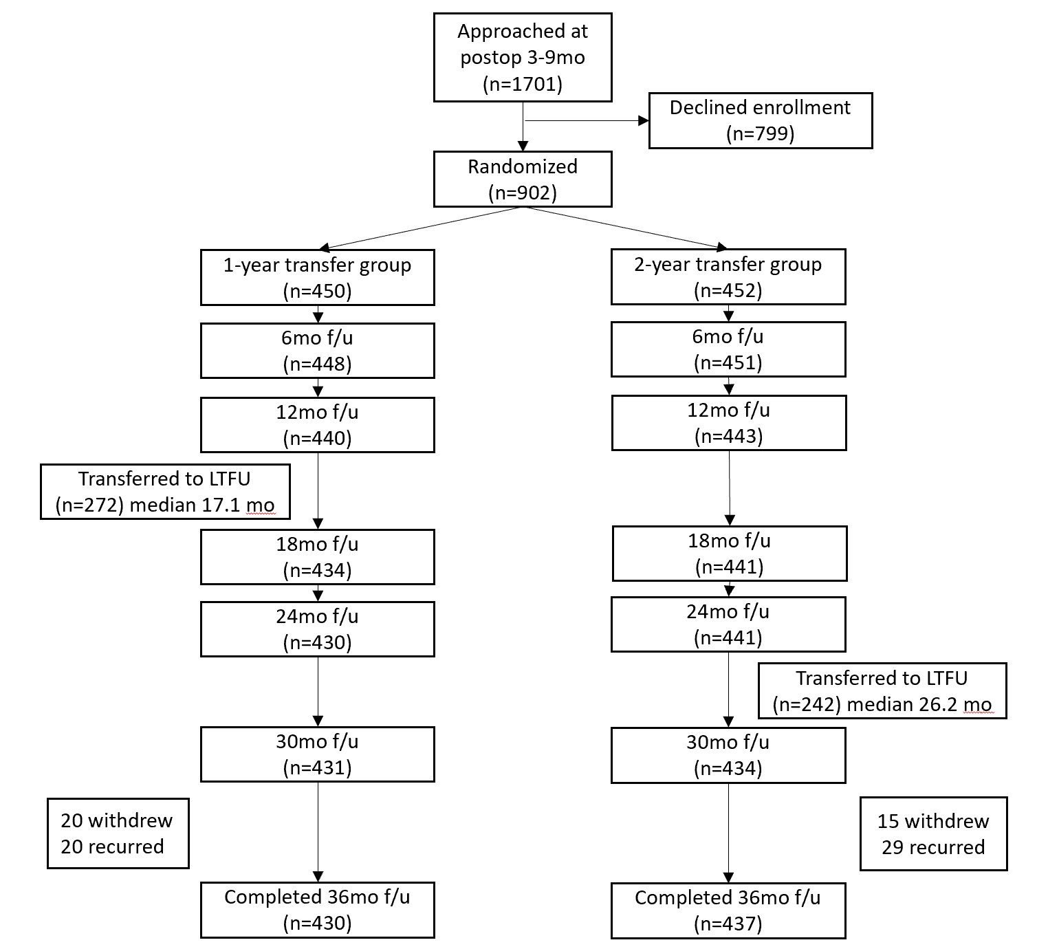
Figure 3 Flow chart of study enrollment and follow-up
The reasons for declining to enroll in the study are shown in Table 1. The main reason was related to reluctance to change physicians having already established trust or relationship. Characteristics of enrolled and declined-to-enroll patients showed significant differences in age and adjuvant therapy (Table 2). Enrolled patients were younger and were more likely to have had chemotherapy and radiotherapy.
Table 1. Reasons for declining to enroll in the study* (N=799), n(%)
Already established trust or relationship with original doctor | 377 (47.2%)
Not ready to transfer, feeling unsafe | 342 (42.8%)
Wish to have original doctor raising the transfer request | 316 (39.6%)
Uncertainty about future, concerning of change in disease status | 197 (24.7%)
Not willing/unable to fill out questionnaires | 188 (23.5%)
Not trusting general practitioners, concerning of not able to detect recurrences early | 30 (3.8%)
Treatment not completed (e.g. Herceptin) | 29 (3.6%)
Will not follow at this hospital | 21 (2.6%)
Not agreed by the original treatment team | 9 (1.1%)
Not suitable due to disease or treatment plan (cancer recurrence, other clinical trials, other cancer) | 4 (0.5%)
Others | 19 (2.4%)
*Multiple answers can be selected.

Table 2. Comparison of enrolled and declined-to-enroll patients
Characteristics |  | Declined (n=799) | Enrolled  (n=902) | P value
Age, mean (SD) |  | 51.6 (9.8) | 48.3 (8.8) | <0.0001
Stage of breast cancer, n (%) |  |  |  | 0.80
 | 0 | 91 (12.0%) | 95 (11.1%)
 | 1 | 304 (40.1%) | 335 (39.1%)
 | 2 | 243 (32.0%) | 296 (34.5%)
 | 3 | 77 (10.1%) | 84 (9.8%)
 | Locally advanced | 44 (5.8%) | 47 (5.5%)
Surgery type - mastectomy, n (%) |  | 341 (45.3%) | 345 (40.5%) | 0.055
Received chemotherapy, n (%) |  | 487 (61.0%) | 606 (67.2%) | 0.007
Received radiation Therapy, n (%) |  | 603 (75.5%) | 722 (80.0%) | 0.023
ER positive, n (%) |  | 622 (83.2%) | 696 (82.3%) | 0.64
HER2-neu over-expressed, n (%) |  | 93 (12.8%) | 102 (12.4%) | 0.22
Bilateral breast cancer, n (%) |  | 36 (4.5%) | 33 (3.7%) | 0.38

Patient characteristics
Patients in the two randomized groups had similar cancer characteristics, demographics, and baseline scores in the majority of survey measures (Table 3). There were borderline differences in age of diagnosis (younger in 1-year group, 47.8 vs 48.9, P=0.06), household income (higher in 1-year group, P=0.04), getting regular care at other hospitals (less in 1-year group, 22.3% vs 27.5%, P=0.07), and bladder control at baseline (better in 1-year group, BCPT score 0.20 vs 0.26, P=0.08).
Table 3. Comparison of the 1-year and 2-year transfer groups, N=902
Characteristics |  | 1-year transfer  (n=450) | 2-year transfer  (n=452) | P value
Age of cancer diagnosis, mean (SD) |  | 47.8 (9.2) | 48.9 (8.3) | 0.06
Stage of breast cancer, n (%) |  |  |  | 0.90
 | 0 | 45 (10.5%) | 50 (11.7%)
 | 1 | 164 (38.2%) | 171 (40.0%)
 | 2 | 155 (36.1%) | 141 (32.9%)
 | 3 | 42 (9.8%) | 42 (9.8%)
 | Locally advanced | 23 (5.4%) | 24 (5.6%)
Surgery type - mastectomy, n (%) |  | 172 (40.6%) | 173 (40.5%) | 0.99
Received chemotherapy, n (%) |  | 303 (67.3%) | 303 (67.0%) | 0.92
Received radiation Therapy, n (%) |  | 365 (81.1%) | 357 (79.0%) | 0.42
Breast cancer side, left, n (%) |  | 240 (53.3%) | 244 (54.2%) | 0.79
Bilateral breast cancer, n (%) |  | 14 (3.1%) | 19 (4.2%) | 0.38
ER positive, n (%) |  | 352 (83.4%) | 344 (81.1%) | 0.39
HER2-neu over-expressed, n (%) |  | 50 (12.2%) | 52 (12.4%) | 0.24
Demographic characteristics, n (%)
Married/Partnered |  | 339 (75.8%) | 326 (72.4%) | 0.43
Has ≥ 1 child |  | 348 (77.9%) | 336 (74.8%) | 0.20
Caregiver when sick: self |  | 109 (24.4%) | 130 (28.9%) | 0.45
Working at least part-time |  | 238 (53.4%) | 216 (51.3%) | 0.71
Smoking or smoked |  | 36 (8.1) | 40 (8.9) | 0.76
Alcohol drinking or drank |  | 88 (19.8) | 90 (20.1) | 0.99
No exercise |  | 142 (31.8%) | 146 (32.4%) | 0.60
Education ≥ college |  | 257 (57.5%) | 248 (55.1%) | 0.82
Lives in northern Taiwan |  | 410 (91.7%) | 410 (91.1%) | 0.29
Household income, > $70,000/mo |  | 254 (60.5%) | 218 (53.7%) | 0.04
No religion |  | 143 (32.2%) | 140 (31.3%) | 0.31
Gets regular care at other hospitals |  | 99 (22.3%) | 123 (27.5%) | 0.07
Often takes health supplements |  | 165 (37.9%) | 165 (36.7%) | 0.92
Often uses Chinese medicine |  | 60 (13.5%) | 47 (10.5%) | 0.18
Often uses folk medicine |  | 12 (2.7%) | 18 (4.0%) | 0.27
Baseline measurements, mean (SD)
PHQ-9 (0-27, lower better) |  | 3.70 (3.67) | 4.01 (3.78) | 0.22
GAD-7 (0-21, lower better) |  | 2.79 (3.41) | 2.65 (3.25) | 0.53
BCPT (0-4, lower better)
Hot flashes |  | 0.62 (0.86) | 0.59 (0.84) | 0.60
Nausea |  | 0.20 (0.45) | 0.22 (0.46) | 0.55
Bladder control |  | 0.20 (0.42) | 0.26 (0.51) | 0.08
Vaginal problems |  | 0.49 (0.80) | 0.43 (0.70) | 0.28
Musculoskeletal pain |  | 0.80 (0.82) | 0.87 (0.88) | 0.24
Cognitive problems |  | 0.68 (0.76) | 0.71 (0.76) | 0.51
Weight problems |  | 0.89 (1.00) | 0.98 (1.00) | 0.22
Arm problems |  | 0.33 (0.64) | 0.29 (0.52) | 0.36
SF36 (0-100, high better)
Physical functioning |  | 84.3 (16.8) | 85.0 (14.5) | 0.57
Role physical |  | 56.2 (40.2) | 55.1 (40.3) | 0.69
Role emotional |  | 79.9 (35.6) | 77.3 (36.8) | 0.29
Social functioning |  | 79.4 (22.2) | 78.1 (23.8) | 0.42
Bodily pain |  | 81.8 (18.2) | 80.7 (18.6) | 0.36
Mental health |  | 72.4 (18.5) | 72.6 (18.2) | 0.85
Energy/fatigue (Vitality) |  | 64.9 (20.6) | 64.9 (20.7) | 0.96
General health perception |  | 66.9 (21.2) | 65.2 (21.3) | 0.23
Change in health from a year ago |  | 36.8 (26.4) | 35.5 (25.2) | 0.47

Study process measures: survey conduction and transfer
Surveys were conducted mostly within the designated months (Figure 4A). However, there was high non-adherence to transfer to the generalist program. At 36 months after surgery, only 514 (57.0%) patients transferred their care to the generalist program. Among the 272 (60.4%) patients in the 1-year transfer group, the mean (SD) time of transfer was 1.59 (0.56) years. Among the 242 (53.5%) patients in the 2-year transfer group, the mean (SD) time of transfer was 2.17 (0.49) years (Figure 4B, Table 4). The reasons cited by the patients for non-adherence to transfer included: wanting to continue with the current doctor (45.1%), wanting a later transfer (18.4%), disease care need (14.7%), opposition of the oncologist (5.6%), insurance reason (2.7%), or wanting to transfer earlier (5.6%).

A B
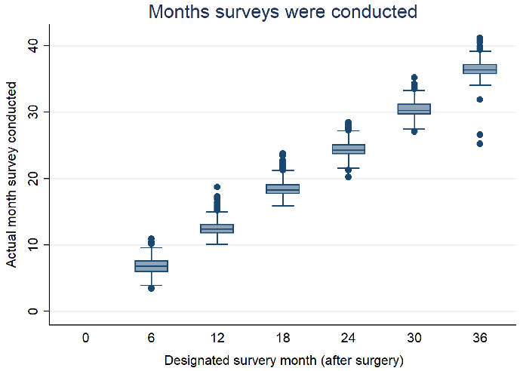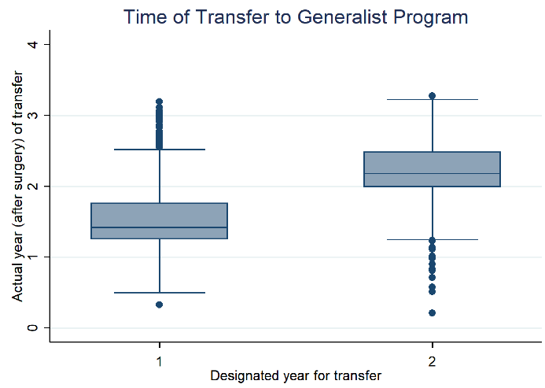
Figure 4. Study adherence. (A) Actual versus designated month for survey conduction (B) Actual versus designated time for transfer to generalist program

Table 4. Time of transfer to generalist program, n=514/902
 | 1-year transfer group (n=272/450) | 2-year transfer group (n=242/452)
Year transferred, mean (SD) | 1.59 (0.56) | 2.17 (0.49)
Month transferred, median | 17.1 | 26.2

Quality of life measures by SF-36
For the primary outcome of HRQoL by SF36 at 24 months, the 1-year transfer group had significantly better performance than the 2-year transfer group in bodily pain (P=0.01), vitality (P=0.03), and general health perception (P=0.03) (Figure 5A-C). The other dimensions: role physical, physical functioning, social functioning, role emotional, and mental health also showed similar trends favoring the 1-year transfer group (Figure 5D-H). There were statistically significant trends of improving quality of life over time after breast cancer treatment in all HRQoL dimensions.

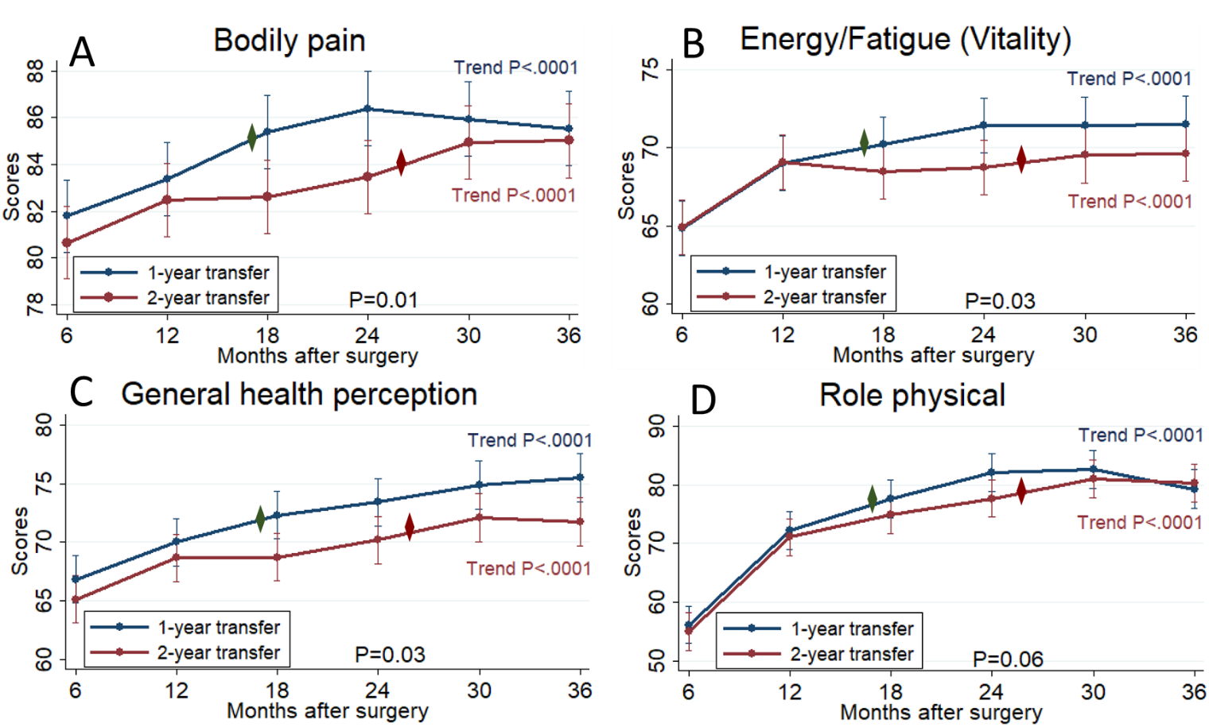
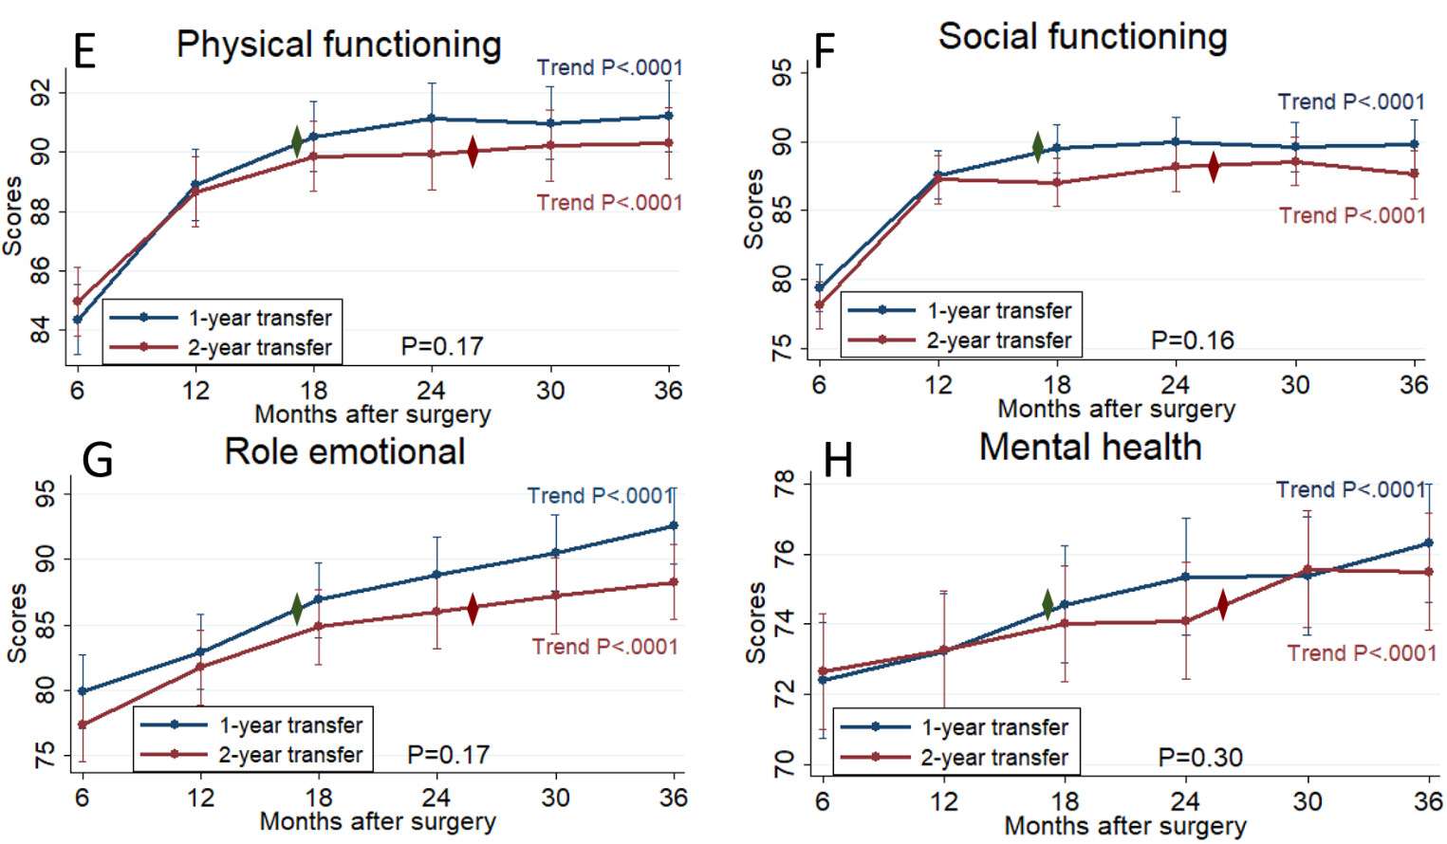
Figure 5. Quality of life dimensions measured by SF36 in the 1-year transfer (navy line) vs the 2-year transfer (red line) groups (intention-to-treat analysis, repeated-measures mixed effect model) (A) Bodily pain (B) Vitality (energy/fatigue) (C) General health perception (D) Role physical (E) Physical functioning (F) Social functioning (G) Role emotional (H) Mental health. The diamond markers mark the respective median transfer time in the two groups. At 24 months after surgery, the statistical significance for the score difference between the two groups were shown as P values above the 24-month marks. Trend P value for each line indicates the statistical significance for score change over time after breast cancer surgery.

Other ways of depicting the comparison for the three significant QoL dimensions are shown in Figure 6. In the ITT analysis (Figure 6A), forest plot using odds ratios for different extent of improvement (≥ 5, 10, 15 points out of 100) or deterioration (≥ 5 points out of 100) showed larger gap between 1-year and 2-year transfer groups at 24 months than at 30 months and 36 months, suggesting maximal benefits after most of the 1-year transfer group have transferred to the generalist physician (LTFU program) while most of the 2-year transfer group have remained with the oncology physician. Due to the large nonadherence-to-transfer rate, per protocol (PP) analysis was done, where the actual transferred-to-LTFU group was compared with the stayed-with-oncology group at different time points (Figure 6B & 6C). The differences between the two groups became much more pronounced than in the ITT analysis, with most odds ratios reaching statistical significance at months 24 & 30, while by month 36, the differences between the two groups diminished.

(A)
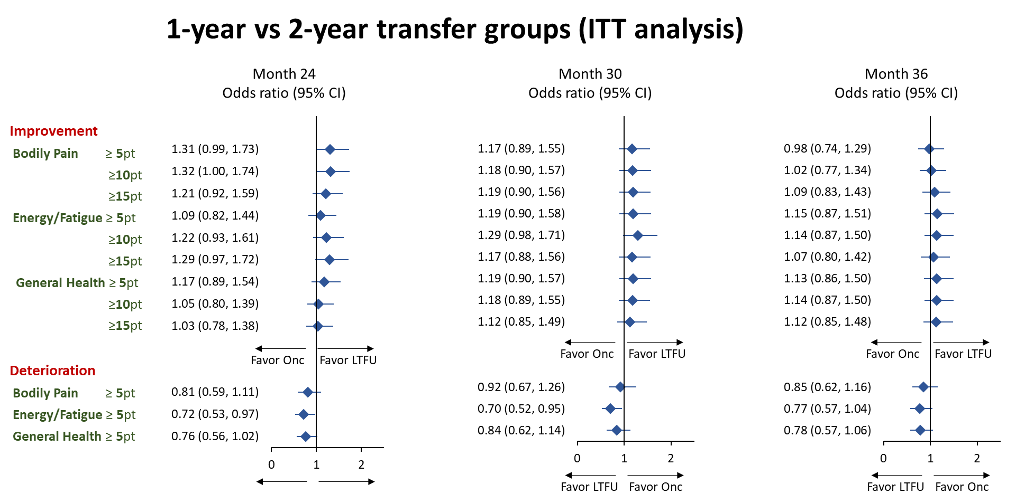
(B)
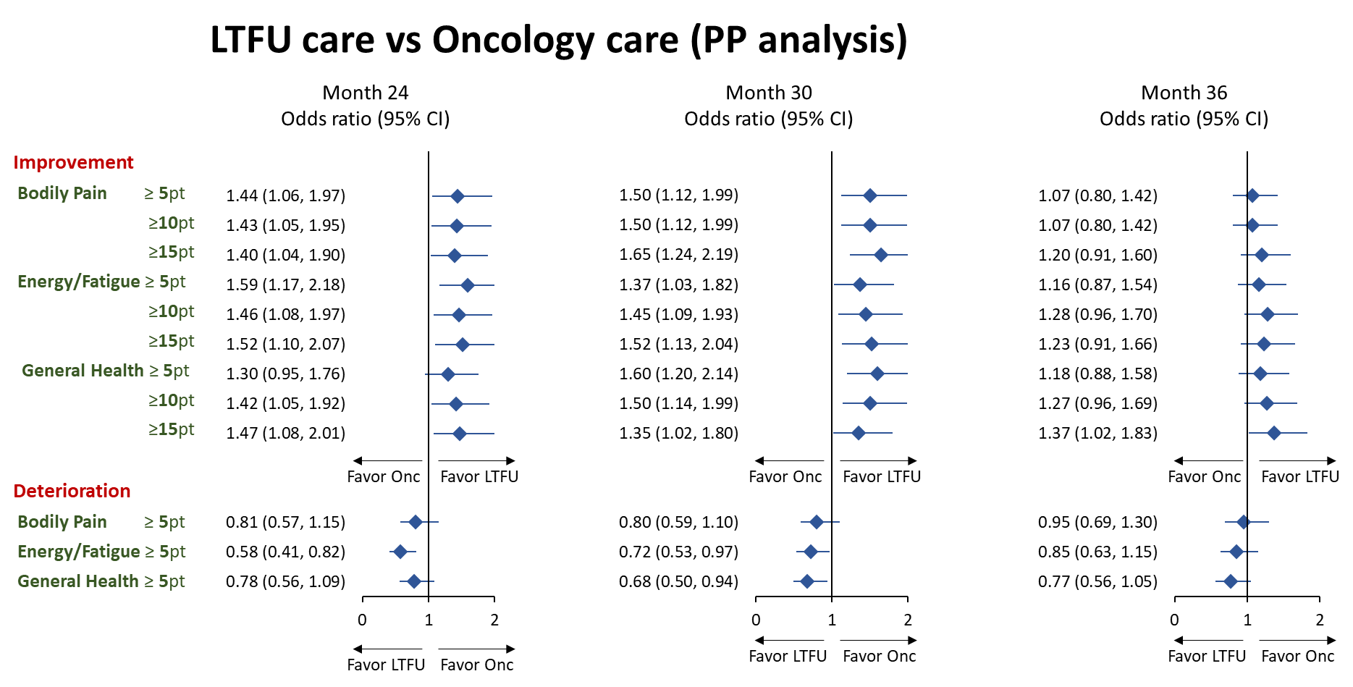
(C)
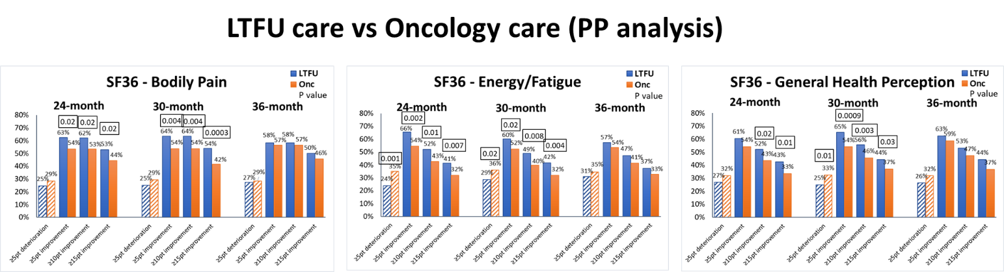
Figure 6. SF36 bodily pain, energy/fatigue, and general health perception dimensions shown by percentages of participants with improvement or deterioration by specific point thresholds (≥ 5, 10, 15 points out of a total of 100 points). Forest plots showing odds ratios (95% confidence interval) for various dimensions and various point thresholds at months 24, 30, 36 comparing the two groups: (A) ITT analysis between the 1-year transfer and 2-year transfer groups, (B) per protocol analysis between LTFU (transferred) and Onc (stayed-with-oncology) groups. (C) Bar graph showing percentages of participants with improvement or deterioration by various point thresholds and significant P values.

Breast cancer treatment specific measures by BCPT
At 24 months, the 1-year transfer group had significantly better performance than the 2-year transfer group in bladder problems (P=0.014) and musculoskeletal pain (P=0.04) (Figure 7A & 7B). However, the 1-year transfer group had borderline better baseline bladder control to begin with (P=0.08 at 6 months). Nausea and cognitive problem dimensions showed trends favoring the 1-year transfer group at 24 months (Figure 7C & 7D). There were no significant differences between the two groups in vaginal problems, hot flashes, arm problems and weight problems (Figure 7E-H). There were trends of improving symptoms over time after breast cancer treatment in most BCPT dimensions except vaginal and bladder problems, suggesting persistent problems in these two areas possibly due to long term hormonal therapy and aging.
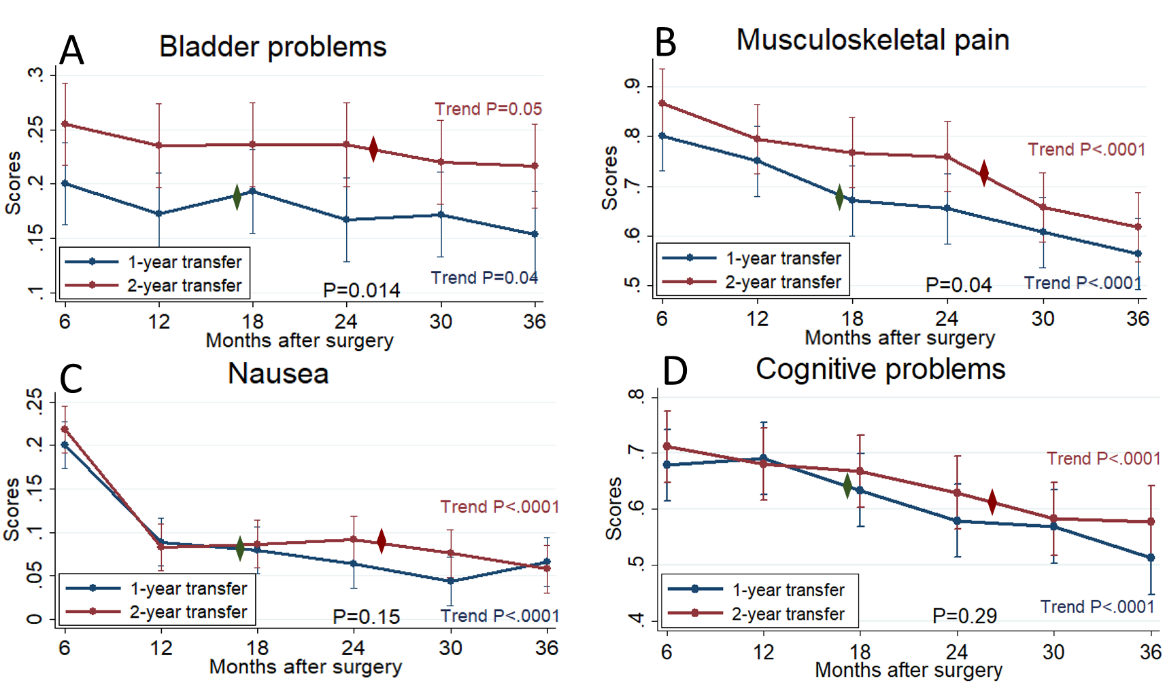
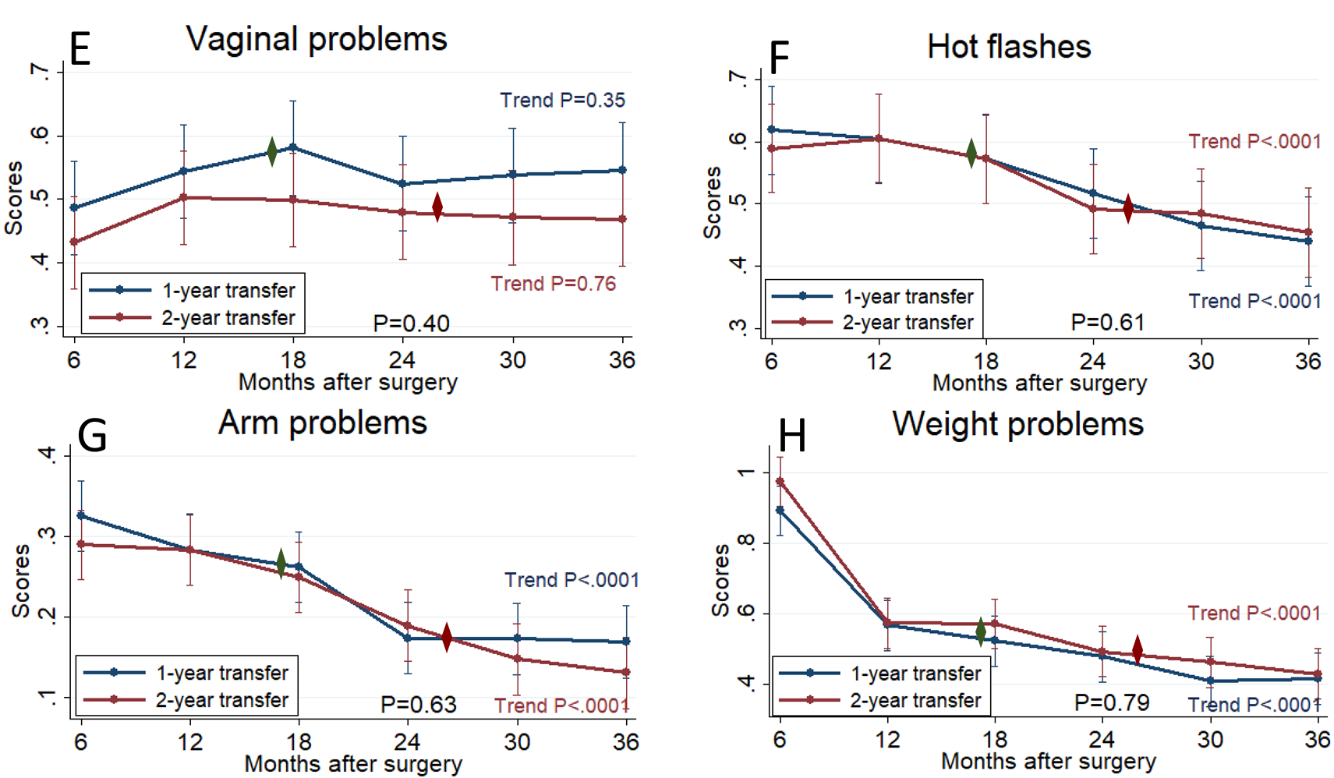

Figure 7. Breast cancer treatment related symptom dimensions measured by BCPT in the 1-year transfer (navy line) vs the 2-year transfer (red line) groups (intention-to-treat analysis, repeated-measures mixed effect model) (A) Bladder problems (B) Musculoskeletal pain (C) Nausea (D) Cognitive problems (E) Vaginal problems (F) Hot flashes (G) Arm problems (H) Weight problems. The diamond markers mark the respective median transfer time in the two groups. At 24 months after surgery, the statistical significance for the score difference between the two groups were shown as P values above the 24-month marks. Trend P value for each line indicates the statistical significance for score change over time after breast cancer surgery.

Other ways of depicting the comparison for the significant BCPT dimensions are shown in Figure 8. In the ITT analysis (Figure 8A), forest plot using odds ratios for different extent of improvement (≥ 0.5, 1.0, 1.5 points out of 4) or deterioration (≥ 0.5 points out of 4) showed benefit trend in the 1-year transfer group at 24 months and 30 months. The benefits in pain and nausea disappeared at 36 months, suggesting that the two groups converged after both groups achieved similar rates of transfer to the generalist (LTFU) program. Due to the large nonadherence-to-transfer rate, per protocol (PP) analysis was done, where the actual transferred-to-LTFU group was compared with the stayed-with-oncology group at different time points (Figure 8B & 8C). The differences between the two groups in nausea, cognitive problem, and arm problem dimensions became significant, with the maximal benefit shown at 24 months, while by month 36, the differences between the two groups diminished.

(A)
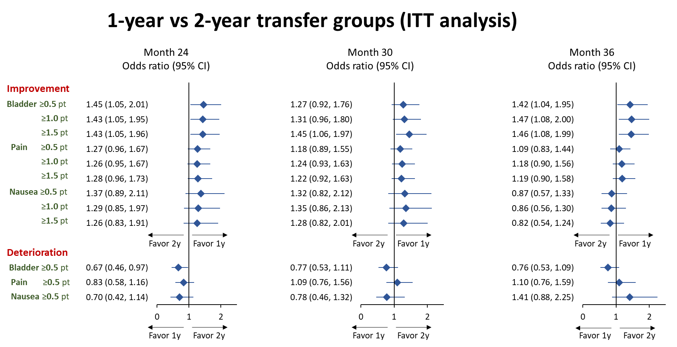
(B)
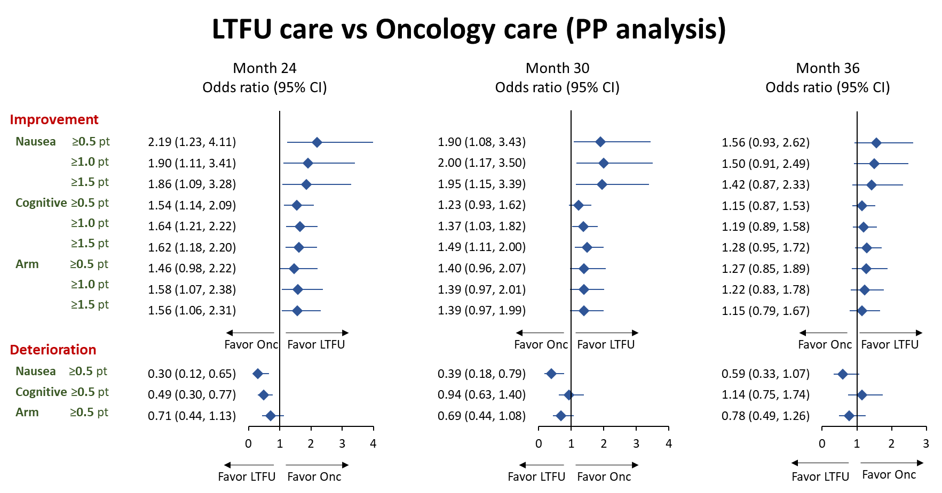
(C)
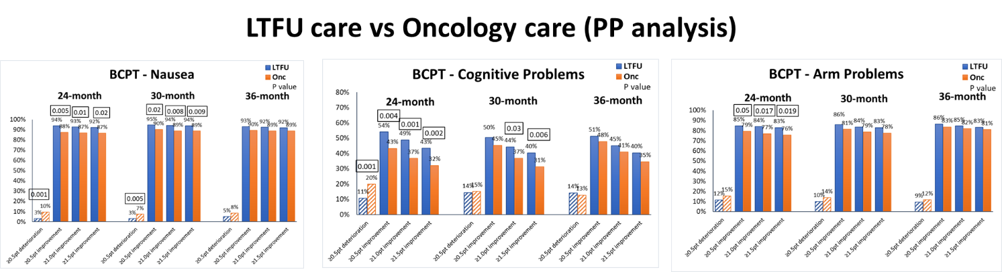

Figure 8. Breast cancer treatment related symptom dimensions measured by BCPT questionnaire shown by percentages of participants with improvement or deterioration by specific point thresholds (≥ 0.5, 1, 1.5 points out of a total of 4 points). Forest plots showing odds ratios (95% confidence interval) for various dimensions and various point thresholds at months 24, 30, 36 comparing the two groups: (A) ITT analysis between the 1-year transfer and 2-year transfer groups, (B) per protocol analysis between LTFU (transferred) and Onc (stayed-with-oncology) groups. (C) Bar graph showing percentages of participants with improvement or deterioration by various point thresholds and significant P values.

Depression and anxiety by PHQ-9 and GAD-7
At 24 months, there were no significant differences between the 1-year and the 2-year transfer groups (Figure 9A & 9B). There were significant trends of improving mood over time after breast cancer treatment for both groups.
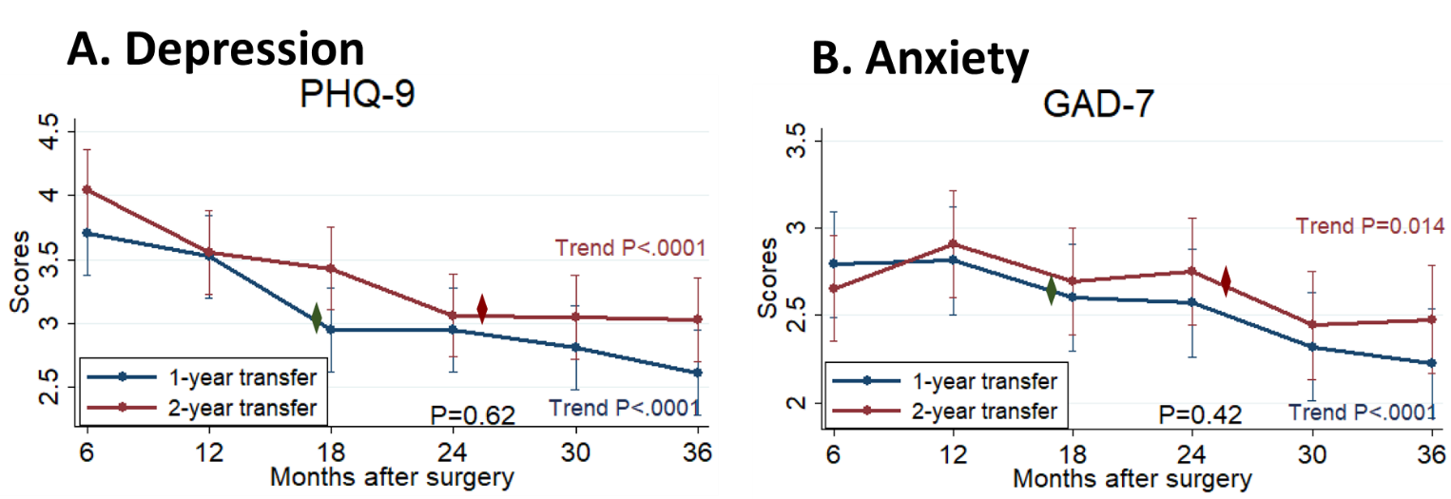Figure 9. Depression measured by PHQ-9 (A) and anxiety measured by GAD-7 (B) in the 1-year transfer (navy line) vs the 2-year transfer (red line) groups (intention-to-treat analysis, repeated-measures mixed effect model). The diamond markers mark the respective median transfer time for the two groups. At 24 months after surgery, the statistical significance for the score difference between the two groups were shown as P values above the 24-month marks. Trend P value for each line indicates the statistical significance for score change over time after breast cancer surgery.

Other ways of depicting comparisons for PHQ-9 and GAD-7 are shown in Figure 10. In the ITT analysis (Figure 10A), forest plot using odds ratios for different extent of improvement (≥ 1, 2, 3 points out of 27 for PHQ-9, 21 for GAD-7) or deterioration (≥ 1 point) showed borderline benefit trend in the 1-year transfer group at 24 months, and no difference at 30 and 36 months. Due to the large nonadherence-to-transfer rate, per protocol (PP) analysis was done, where the actual transferred-to-LTFU group was compared with the stayed-with-oncology group at different time points (Figure 10B & 10C). The differences between the two groups became significant for larger extent improvement (≥ 2, 3 points for PHQ-9, and ≥ 3 points for GAD-7) at 24 months, while the differences diminished at 30 and 36 months.

(A)
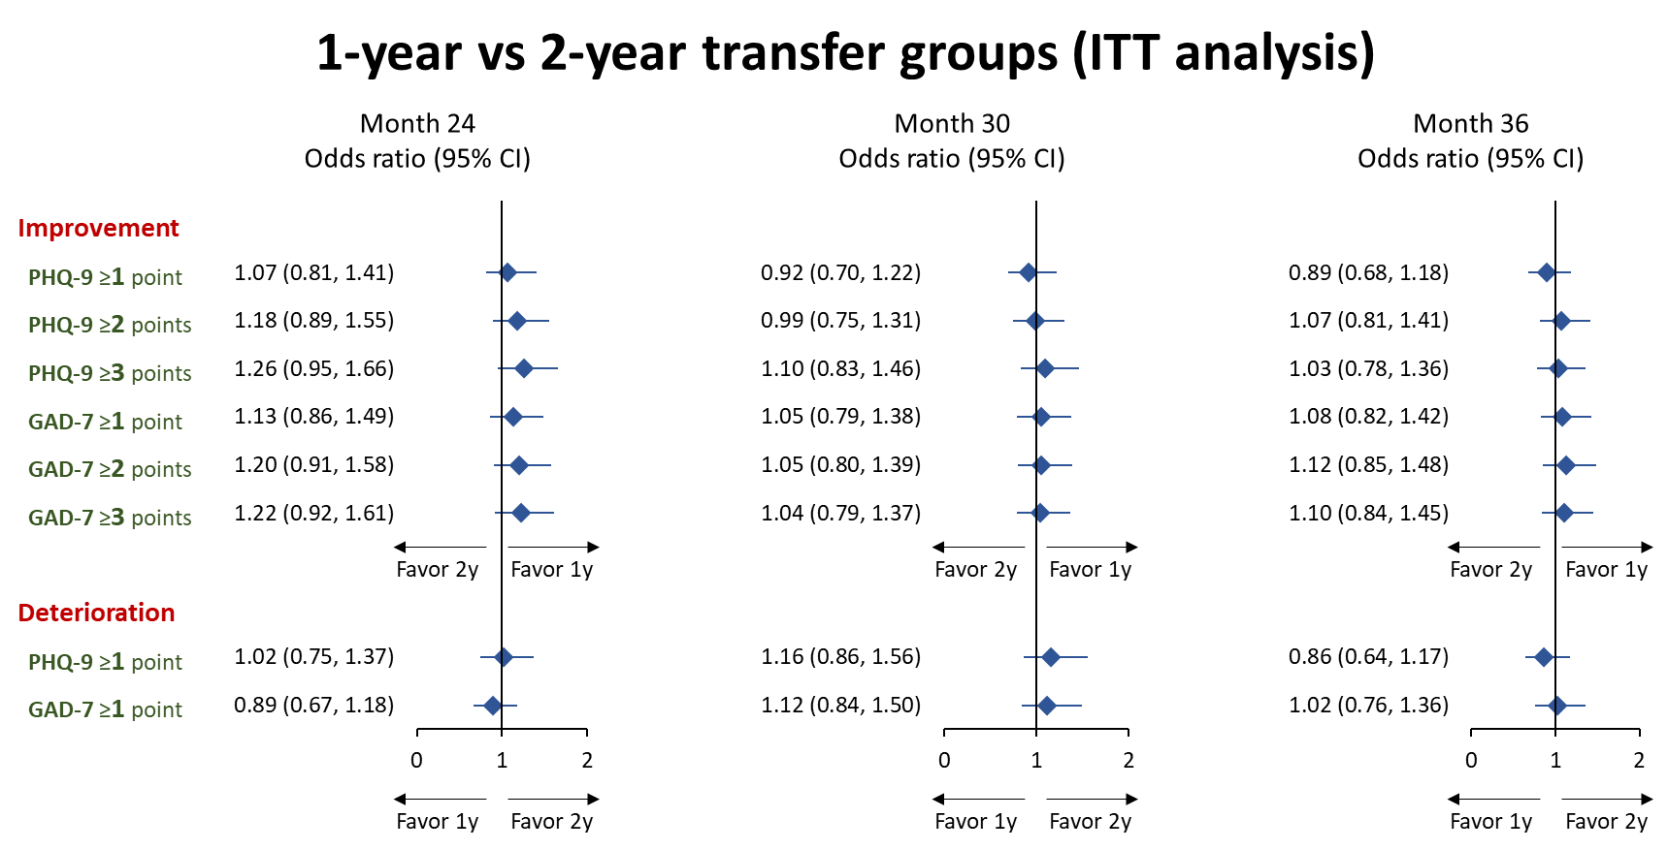
(B)
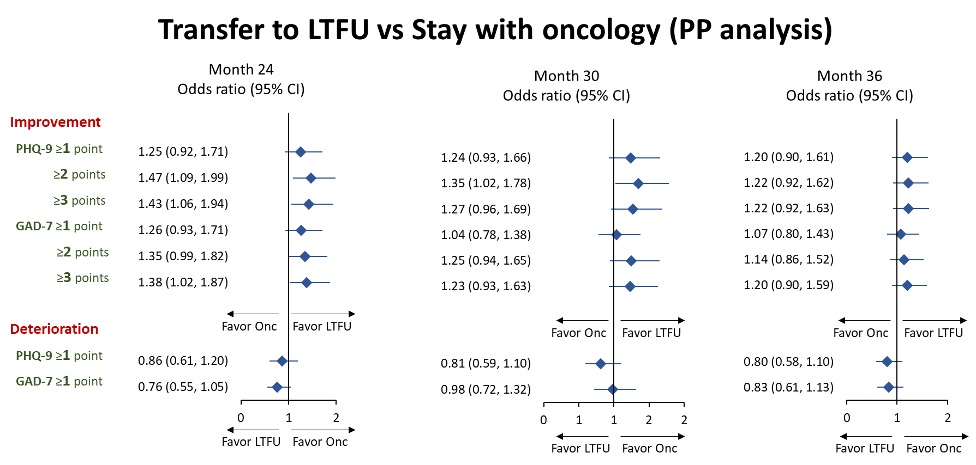
(C)
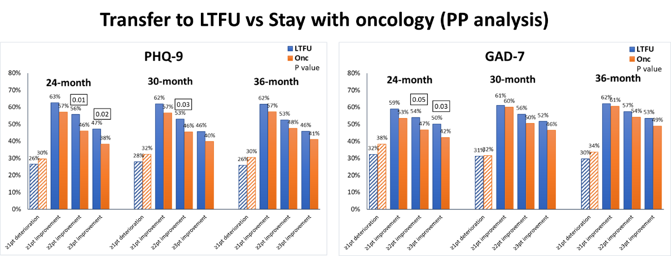

Figure 10. Depression (PHQ-9) and anxiety scores (GAD-7) shown by percentages of participants with improvement or deterioration by specific point thresholds (≥ 1, 2, 3 points out of a total of 27 points for PHQ-9, 21 points for GAD-7). Forest plots showing odds ratios (95% confidence interval) for various dimensions and various point thresholds at months 24, 30, 36 comparing the two groups: (A) ITT analysis between the 1-year transfer and 2-year transfer groups, (B) per protocol analysis between LTFU (transferred) and Onc (stayed-with-oncology) groups. (C) Bar graph showing percentages of participants with improvement or deterioration by various point thresholds and significant P values.

Conclusions:
We evaluated the impact of a generalist breast cancer survivorship program on health-related quality of life, control of cancer-related late effects, and mental health, compared to the conventional oncology care, using a randomized trial design with early- versus late-transfer. Our generalist survivorship care program appeared to show favorable trends in many quality-of-life aspects, including vitality, pain, general health perception, nausea, cognitive problems, arm problems, depression, and anxiety. Many challenges existed in adopting generalist care model in breast cancer survivors; over 40% of the study participants did not transfer at the end of the study (3 years after breast cancer surgery). These challenges can be used for quality improvement in current and future programs. Follow-up analysis can include time to confirmation of recurrence (n=20 vs 29 in the two groups), satisfaction with care, management of co-morbidities, health services utilization, and cost analysis.
With the growing population of cancer survivors, survivorship care by general practitioners is a necessary and possibly desirable health care model, given the oncology workforce shortage and advancement of information decision support for rule-based care. This model of care is perhaps even more necessary in the Taiwan health care system where patients do not commonly have primary care providers. As a cancer center emphasizing patient-centered care, KF-SYSCC has led the effort to build a highly effective model of generalist survivorship care. This study was an integral part of the establishment of the long term follow-up program at KF-SYSCC. Involved physicians, nurses, research staff and administrative staff obtained skills to provide high quality holistic care. The strategies used to train primary care physicians and other health providers in the program, to foster a culture of holistic care, and to encourage evidence-based cost effective health services utilization may be disseminated to other health organizations and/or influence policy change in Taiwan’s health care system.

References
1. Berry DA, Cronin KA, Plevritis SK, Fryback DG, Clarke L, Zelen M, Mandelblatt JS, Yakovlev AY, Habbema JD, Feuer EJ: Effect of screening and adjuvant therapy on mortality from breast cancer. N Engl J Med 353:1784-92, 2005
2. American Cancer Society: Cancer Facts & Figures 2012. Atlanta, American Cancer Society, 2012
3. Bureau of Health Promotion: Taiwan Cancer Registry Annual Report 2010, 2013, http://www.hpa.gov.tw/BHPNet/Portal/File/StatisticsFile/201305061037065219/99%E5%B9%B4%E7%99%8C%E7%97%87%E7%99%BB%E8%A8%98%E5%A0%B1%E5%91%8A.pdf (accessed August 18, 2013)
4. Institute of Medicine: From Cancer Patient to Cancer Survivor: Lost in Transition. Washington, DC: National Academy Press, 2005
5. Montgomery DA, Krupa K, Cooke TG: Alternative methods of follow up in breast cancer: a systematic review of the literature. Br J Cancer 96:1625-32, 2007
6. Grunfeld E, Mant D, Yudkin P, Adewuyi-Dalton R, Cole D, Stewart J, Fitzpatrick R, Vessey M: Routine follow up of breast cancer in primary care: randomised trial. BMJ 313:665-9, 1996
7. Grunfeld E, Levine MN, Julian JA, Coyle D, Szechtman B, Mirsky D, Verma S, Dent S, Sawka C, Pritchard KI, Ginsburg D, Wood M, Whelan T: Randomized trial of long-term follow-up for early-stage breast cancer: a comparison of family physician versus specialist care. J Clin Oncol 24:848-55, 2006
8. Baildam AD, Keeling F, Thompson L, Bundred N, Hopwood P. Nurse-led surgical follow up clinics for women treated for breast cancer – a randomised controlled trial. Breast Cancer Res Treat 2004; 88:S136–S137.
9. Koinberg IL, Fridlund B, Engholm GB, Holmberg L: Nurse-led follow-up on demand or by a physician after breast cancer surgery: a randomised study. Eur J Oncol Nurs 8:109-20; 2004
10. Porter ME, Baron JF, Wang CJ: Koo Foundation Sun Yat-Sen Cancer Center: Breast Cancer Care in Taiwan. Harvard Business School Case 710-425, 2009
11. Erikson C, Salsberg E, Forte G, Bruinooge S, Goldstein M: Future supply and demand for oncologists : challenges to assuring access to oncology services. J Oncol Pract 3:79-86, 2007
12. Etzioni DA, Liu JH, Maggard MA, O'Connell JB, Ko CY: Workload projections for surgical oncology: will we need more surgeons? Ann Surg Oncol 10:1112-7, 2003
13. Wallace AH, Havrilesky LJ, Valea FA, Barnett JC, Berchuck A, Myers ER: Projecting the need for gynecologic oncologists for the next 40 years. Obstet Gynecol 116:1366-72, 2010
14. Institute of Medicine: Delivering High-Quality Cancer Care: Charting a New Course for a System in Crisis. Washington, D.C., The National Academy Press, 2013
15. Shaping the Future of Oncology: Envisioning Cancer Care in 2030, American Society of Clinical Oncology, 2012, http://www.asco.org/sites/default/files/shapingfuture-lowres.pdf (accessed December 18, 2013, 2013)
16. Ganz PA: Survivorship: adult cancer survivors. Prim Care 36:721-41, 2009
17. Howell D, Hack TF, Oliver TK, Chulak T, Mayo S, Aubin M, Chasen M, Earle CC, Friedman AJ, Green E, Jones GW, Jones JM, Parkinson M, Payeur N, Sabiston CM, Sinclair S: Models of care for post-treatment follow-up of adult cancer survivors: a systematic review and quality appraisal of the evidence. J Cancer Surviv 6:359-71, 2012
18. Baena-Canada JM, Ramirez-Daffos P, Cortes-Carmona C, Rosado-Varela P, Nieto-Vera J, Benitez-Rodriguez E: Follow-up of long-term survivors of breast cancer in primary care versus specialist attention. Fam Pract, 2013
19. Virgo KS, Lerro CC, Klabunde CN, Earle C, Ganz PA: Barriers to breast and colorectal cancer survivorship care: perceptions of primary care physicians and medical oncologists in the United States. J Clin Oncol 31:2322-36, 2013
20. Cheung WY, Neville BA, Cameron DB, Cook EF, Earle CC: Comparisons of patient and physician expectations for cancer survivorship care. J Clin Oncol 27:2489-95, 2009
21. Haggstrom DA, Arora NK, Helft P, Clayman ML, Oakley-Girvan I: Follow-up care delivery among colorectal cancer survivors most often seen by primary and subspecialty care physicians. J Gen Intern Med 24 Suppl 2:S472-9, 2009
22. Snyder CF, Frick KD, Kantsiper ME, Peairs KS, Herbert RJ, Blackford AL, Wolff AC, Earle CC: Prevention, screening, and surveillance care for breast cancer survivors compared with controls: changes from 1998 to 2002. J Clin Oncol 27:1054-61, 2009
23. Del Giudice ME, Grunfeld E, Harvey BJ, Piliotis E, Verma S: Primary care physicians' views of routine follow-up care of cancer survivors. J Clin Oncol 27:3338-45, 2009
24. Potosky AL, Han PK, Rowland J, Klabunde CN, Smith T, Aziz N, Earle C, Ayanian JZ, Ganz PA, Stefanek M: Differences between primary care physicians' and oncologists' knowledge, attitudes and practices regarding the care of cancer survivors. J Gen Intern Med 26:1403-10, 2011
25. Sisler JJ, Taylor-Brown J, Nugent Z, Bell D, Khawaja M, Czaykowski P, Wirtzfeld D, Park J, Ahmed S: Continuity of care of colorectal cancer survivors at the end of treatment: the oncology-primary care interface. J Cancer Surviv 6:468-75, 2012
26. Vanhuyse M, Bedard PL, Sheiner J, Fitzgerald B, Clemons M: Transfer of follow-up care to family physicians for early-stage breast cancer. Clin Oncol (R Coll Radiol) 19:172-6, 2007
27. Stanton AL, Bernaards CA, Ganz PA: The BCPT symptom scales: a measure of physical symptoms for women diagnosed with or at risk for breast cancer. J Natl Cancer Inst 97:448-56, 2005
28. Patient Health Questionnaire (PHQ) Screeners, http://www.phqscreeners.com/overview.aspx (accessed December 23, 2013)
29. Ware JE, Jr., Sherbourne CD: The MOS 36-item short-form health survey (SF-36). I. Conceptual framework and item selection. Med Care 30:473-83, 1992
30. Ganz PA, Kwan L, Stanton AL, Bower JE, Belin TR: Physical and psychosocial recovery in the year after primary treatment of breast cancer. J Clin Oncol 29:1101-9, 2011
31. Ware JE, Jr., Snyder MK, Wright WR, Davies AR: Defining and measuring patient satisfaction with medical care. Eval Program Plann 6:247-63, 1983
32. Ware JE, Jr., Hays RD: Methods for measuring patient satisfaction with specific medical encounters. Med Care 26:393-402, 1988

Appendix: Measure Instruments
Appendix A. BCPT Symptom Scales
Appendix B. PHQ 9 and GAD 7
Appendix C. SF-36 Dimensions

