Study Title: The Babies’ Longitudinal Outcomes, ‘Omics, and Milestones Study
Short title: BLOOMS
Protocol version number: Version 1.1
Protocol date: 31/07/2025
IRAS number: 344546
REC number: 25/NS/0084
Sponsor R&D number: A907431
IRSCTN registration number: ISRCTN15896464
KEY STUDY CONTACTS
Chief Investigator: | Professor Catherine Aiken  Department of Obstetrics and Gynecology  University of Cambridge  Clinical Professor of Maternal and Fetal Medicine  University of Cambridge  Email: cema2@cam.ac.uk  Phone: 01223333751
Principle Investigators: | Professor David Rowitch dhr25@cam.ac.uk[Neonatology]  Professor Sam Behjati sb31@sanger.ac.uk [Genetics]  Professor Pasco Fearon pf380@cam.ac.uk [Child development]
Study coordinator  Family/PPIE lead  Laboratory lead  Developmental assessment lead | Dr Heather Pierce (hhp24@cam.ac.uk)  Dr Jon Roberts (jonathan.roberts4@nhs.net)  Dr Iain Kean (irlk2@cam.ac.uk)  Dr Kaili Clackson (kc496@cam.ac.uk)
Sponsors: | Cambridge University Hospitals NHS Foundation Trust & University of Cambridge  Stephen Kelleher, R&D Manager  Cambridge University Hospitals, Hills Road, Cambridge, CB2 0QQ  Tel: 01223 217418  E-mail: research@addenbrookes.nhs.uk
Funder: | The Wellcome Trust (312471/Z/24/Z)  There are no potential conflicts of interest with the funder.

Confidentiality Statement
This document contains confidential information that must not be disclosed to anyone other than the Sponsors, the Investigator Team, HRA, host organisations, and members of the Research Ethics Committee, unless authorised to do so.
Study Title: BLOOMS
Protocol Date: 31/07/25
Protocol Version No: 1.1
Protocol signature page
The undersigned confirm that the following protocol has been agreed and accepted and that the Chief Investigator agrees to conduct the study in compliance with the approved protocol and will adhere to the principles outlined in the Declaration of Helsinki, the Sponsor’s SOPs, and other regulatory requirement.
I agree to ensure that the confidential information contained in this document will not be used for any other purpose other than the evaluation or conduct of the investigation without the prior written consent of the Sponsor
I also confirm that I will make the findings of the study publicly available through publication or other dissemination tools without any unnecessary delay and that an honest accurate and transparent account of the study will be given; and that any discrepancies from the study as planned in this protocol will be explained.
Chief Investigator:
(Please print name) |  | Signature |  | Date

LAY SUMMARY 6
SYNOPSIS 8
FUNDING AND SUPPORT IN KIND 10
ABBREVIATIONS 10
STUDY FLOW CHART 11
BACKGROUND AND RATIONALE 12
OBJECTIVES AND OUTCOME MEASURES 12
STUDY DESIGN 13
PARTICIPANT IDENTIFICATION 13
Study Participants 13
Inclusion/Exclusion Criteria 13
Other research studies 14
PROTOCOL PROCEDURES 14
Recruitment 14
Informed Consent 15
Description of study procedure(s) for consented participants 16
Unique study ID allocation 19
Sample Handling 20
i) Sample Collection 20
ii) Sample transportation and processing 21
iii) Genomic sequencing, data analysis and interpretation 22
Collection of participant personal details 23
Collection of study data 23
Withdrawal of Participants 23
Definition of End of Study 25
DATA MANAGEMENT 25
Data sharing 26
Data archiving 26
DATA COLLECTION 27
Table 4: Schedule of data linkages 29
STATISTICS AND ANALYSIS 29
PROTOCOL DEVIATIONS 31
ETHICAL AND REGULATORY CONSIDERATIONS 31
Declaration of Helsinki 33
Approvals 33
Participant Confidentiality and Data Protection 33
Data sharing and availability 33
Funding 34
Insurance 34
REFERENCES 34

LAY SUMMARY
Every year, over 50,000 babies in the UK spend time in Neonatal Intensive Care Units (NICUs) because they are born early, small, or with health complications. These babies often face a greater risk of complications later in life – including problems with physical health, mental health, learning, and development. Around 30% of children who were in a NICU do not meet national learning goals by the time they start school at age five.
BLOOMS (Babies’ Longitudinal Outcomes, ‘Omics, and Milestones Study) is a new research project designed to understand how we can better support these children as they grow. We are following 1,000 babies who received care in NICUs, along with their parents. This will allow us to explore how genetics, environment, and early life experiences predict and shape future outcomes.
To do this, we will collect many different types of data. These include:
- Multi-omic information like whole genome sequencing (WGS), proteomics, and metabolomics to look at biological signals in the body at birth and in later childhood.
- Clinical and developmental deep phenotyping, which means gathering detailed data on how children grow, behave, learn, and interact.
- Routinely collected national records, such as NHS health data and school records, to track progress over time.
All of this data will be stored securely at the University of Cambridge and the Wellcome Sanger Institute. This will create a long-term resource for researchers and allow us to add new information as the children grow older. We will also make sure families stay involved through regular contact, updates, and feedback.
BLOOMS is committed to being inclusive and diverse. Our recruitment is focused in ethnically and socially diverse cities in the East of England, and the study is co-designed with our Patient and Public Involvement and Engagement (PPIE) team to make sure it meets families’ needs.
The aims of BLOOMS are to:
- Improve how we use information, including clinical, biological and genetic factors, to identify children who could benefit most from learning support
- Discover early warning signs (biomarkers) that could help doctors and teachers provide support before problems become serious.
- Understand the root causes of poor health and developmental outcomes – so we can work to prevent them.
By identifying the children most at risk and learning how to help them sooner, BLOOMS aims to give every baby who started life in intensive care the best chance to grow, thrive, and reach their full potential.

SYNOPSIS
Study Title | Babies’ Longitudinal Outcomes, ‘Omics, and Milestones Study
Short title / acronym | BLOOMS
Study Design | Longitudinal observational cohort study with data linkage
Research questions | Can we predict the early life antecedents of poor health and neurodevelopmental outcomes, including school readiness?
Objectives | - Use multi-omics data to predict adverse health and neurodevelopmental outcomes  - Identify biomarkers associated with not meeting expected early developmental milestones  - Use early-life data to predict poor educational outcomes in childhood
Study Endpoints | - Developmental milestones between birth – 5 yrs  - Health and growth outcomes between birth – 16 yrs  - Educational attainment aged 5 – 16 yrs
Study Participants | Babies admitted to tertiary neonatal intensive care units (NICUs) in the East of England
Sample Size | 1,075 babies (plus ~2150 parents)
Summary of eligibility criteria | Inclusion criteria for babies:  - Currently admitted to a tertiary level NICU in the East of England  - Admitted to a tertiary level NICU for ≥48hrs  - Has an adult with parental responsibility available to sign consent  Inclusion criteria for parent(s):  - Aged 18 years or above  - Is willing and able to give informed consent for participation in the study  Exclusion criteria  - No adult with parental responsibility who can consent in English  - Does not meet inclusion criteria
Planned Study Period | Total length of the project: 18 years  Duration of families’ involvement: 5 years  Duration of data linkage: 16 years
Planned Recruitment period | Start date: January 2026  End date: January 2028
Procedures: | Screening & invite | Clinical teams invite families to take part in the study whilst their baby is in NICU
Procedures: | Time-point 1  (in NICU) | Participant screening (inclusion/exclusion criteria)  Informed consent  Blood sampling collection from babies and parents  Completion of family questionnaires (medical history, demographics, socio-economic factors, etc)  Data extraction from baby and mother medical records  Further sampling from baby: blood sample and stool samples
 | Time-point 2  (9 months, remote) | Completion of electronic questionnaires (e.g. developmental milestones, growth information, family health and well-being)  Data extraction from baby and mother medical records
 | Time-point 3  (2 years, remote) | Completion of electronic questionnaires (e.g. developmental milestones, speech sample, growth information, family health and well-being)  Remote video recording of parent-child interactions  Linkage to child health records
 | Time-point 4  (3 years,  in person) | Blood/stool sampling  Height/weight measurements  EEG  Developmental assessments  Completion of questionnaires  Stool sampling instructions given to parents
 | Time-point 5  (4 years,  remote) | Completion of electronic questionnaires (developmental milestones, growth information, family health and well-being) and remote online developmental assessments
 | Time-point 6  (5 years,  remote) | Completion of electronic questionnaires (developmental milestones, speech sample, growth information, family health and well-being) and remote online developmental assessments  Linkage to baby educational records commences  End of planned contact with study team

FUNDING AND SUPPORT IN KIND
Funder(s) | FINANCIAL AND NON-FINANCIAL SUPPORT GIVEN
Wellcome Trust | Discovery grant, 312471/Z/24/Z, award letter 11th April 2025

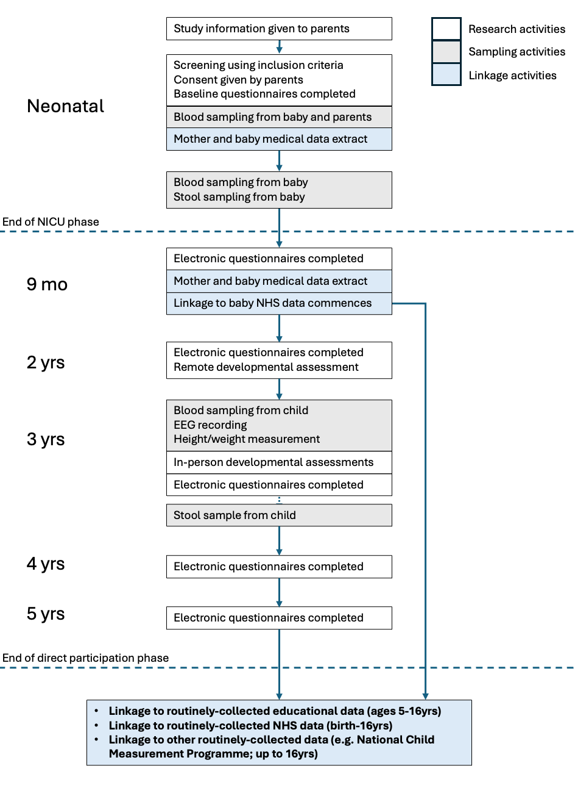
STUDY FLOW CHART
Figure 1: study flow chart

BACKGROUND AND RATIONALE
A global challenge, especially against a backdrop of accelerating climate change and deprivation, is improving developmental outcomes and physical-mental health in children and young people. The UK witnessed an 11% rise in children with special educational needs (SEN) in 2023-2024 (>500,000 children in total affected), with corresponding increased pressures on scarce resources. The urgent need for new interventions to target the growing crises in childhood health has been articulated by the UK government and other health systems.

We have previously shown that whole genome sequencing (WGS) in the neonatal intensive care unit (NICU) improves early diagnosis of complex health conditions. However, we currently lack reliable predictive power to use WGS and other multi-omic data for early detection of health and special educational needs (SEN) risks. There is a need to enhance our mechanistic understanding to develop targeted health or learning interventions. We will tackle this challenge by identifying the pathways that lead to adverse health and developmental outcomes in babies at risk.

We will develop a genomically-informed cohort of ~1000 infants admitted to NICU, who are at high risk of (i) adverse health outcomes and (ii) not meeting school-readiness standards aged 5. Indeed, ~30% of NICU graduates are not ready for school according to national UK metrics aged 5, which may be due to the isolated or synergistic impacts of preterm birth, neonatal brain injury, environment, and/or genetic factors. Taking a meticulous, multi-dimensional, repeated-measures approach to studying these infants at scale will provide important new insights that will advance population health and development. Our study will generate key knowledge to bridge the gap between the potential inherent in neonatal WGS and clinical utility for optimising health and development in at-risk infants. This proposal has undergone rigorous scientific peer review and was selected for funding by a Wellcome Trust Discovery Award (312471/Z/24/Z; awarded Feb 2025).

OBJECTIVES AND OUTCOME MEASURES
- To discover links between biomarkers, genome, and long-term outcomes that can provide insight into fundamental developmental mechanisms, early origins of disease, and learning disability/special educational needs.
- To stratify the risks of adverse outcomes using early markers, thus paving the way for precision-targeting of interventions, for example learning support, and development of new interventions.

Outcome measures:
To discover links between biomarkers, genome, and long-term outcomes that can provide insight into fundamental developmental mechanisms, early origins of disease, and learning disability. | - Whole genome sequences (WGS) from baby and parents  - Other multi-omic data from baby and parents, e.g. proteome, methylome, microbiome  - Demographic, socio-economic, family health and circumstances, other relevant life-style information  - Developmental skills, abilities, and wellbeing between birth – 5 yrs; assessed via in-person and remote developmental assessments and questionnaires  - Data extracted from the locally held medical records of the baby and mother at birth and 9 months of age  - Health and growth outcomes between birth – 16 yrs; assessed via linkage to routinely-collected data sources, including NHS (e.g. HES, primary care data) and national childhood measurement programme
To stratify the risks of adverse educational outcomes using early markers, thus paving the way for precision-targeting of interventions, for example learning support, and development of new interventions. | - Educational attainment aged 5 – 16 yrs; assessed via linkage to the National Pupil database
Table 1 Study objectives and outcome measures

STUDY DESIGN
We will recruit 1,000 baby/parent trios with minimal ascertainment bias and exclusions from NHS Level 3 NICUs across the East of England (Cambridge, Norwich, Luton). The Neonatal Operations Delivery Network means that the highest risk infants born anywhere in the region will be available for recruitment. Any baby admitted for ≥48hrs will become eligible for recruitment at 48hrs. Participants will not be stratified for recruitment purposes; stratification for analytic purposes will occur retrospectively. Families will be asked to consent to three study elements: (i) sampling of blood/stool for generation of multi-omic data, (ii) remote and in-person developmental assessments up to age 5, and (iii) permission for ongoing remote data linkage to routinely-collected sources until the child turns 16 years old. Families will actively participate in the study for up to 5 years, which will include two in-person study contacts: at recruitment in NICU and when the child is 3 yrs old (see study flow chart Fig 1). They will also be asked to provide information and participate in remote study contacts at annual intermediate time-points. We will also ask for consent to contact participants at other times, for example to send birthday presents to the children or to provide information about other studies.

PARTICIPANT IDENTIFICATION

Study Participants
The study will recruit babies meeting the inclusion criteria and, wherever possible, both parents. Consent will be given by an adult with parental responsibility for the baby.

Inclusion/Exclusion Criteria
Inclusion criteria for babies:
- Admitted to a tertiary level neonatal unit (NICU) in the East of England
- Admitted to a tertiary level NICU for ≥48hrs
- Has an adult with parental responsibility available to sign consent
Inclusion criteria for parent(s):
- Aged 18 years or above
- Is willing and able to give informed consent for participation in the study

Exclusion criteria
- There is no adult with parental responsibility for the baby who can consent in English
- Does not meet inclusion criteria

Other research studies
Participants who are already enrolled in other research studies remain eligible to be recruited to BLOOMS. This is important as many babies in NICU benefit from clinical trial participation, and the primary focus of BLOOMS is on long-term outcomes. Participants will remain eligible for recruitment to other studies (where applicable) whilst part of the BLOOMS cohort.

PROTOCOL PROCEDURES
Procedures | Visit 1 | Visit 2* | Visit 3* | Visit 4 | Visit 5* | Visit 6*
Procedures | Neonatal | 9mo | 2yrs | 3yrs | 4yrs | 5yrs
Informed consent | X
Questionnaires | X | X | X | X | X | X
Parental speech sample |  |  | X |  |  | X
Blood sampling (baby) | X |  |  | X
Stool sampling (baby) | X |  |  | X
EEG |  |  |  | X
Height/weight |  |  |  | X
Developmental assessments |  |  |  | X
Home activities e.g.  activity monitor, reading book |  |  | X | X
Blood sampling (parents) | X
Table 2 Sample schedule of study procedures. *Denotes remote/virtual visit

Recruitment
Clinicians at the three sites will identify families who meet the inclusion criteria and give them written information about the study during their NICU stay. Sites will be asked to keep a record of the number of families given written information.
The clinical team will give potential participants the study information. They will avoid giving information to families whose clinical situation makes them inappropriate as participants, for example those whose babies’ are being palliated or are in the care of social services. The clinical team will advise the study team if it is an appropriate time to approach the family and will verbally confirm with families that they consent to be approached by the study team. This will be recorded in the baby’s medical notes.
The study team will approach families to discuss participation. For families that do not wish to participate, they will be thanked for considering the study and asked whether they would be willing to provide a reason as to why they don’t want to participate. Those who express interest will be followed up either in-person or via phone call by the research team to discuss the study in more detail and assess eligibility (visit 1). If families would like additional time to consider their participation, then a follow-up visit or call will be arranged during their baby’s hospital stay.
Families will also be alerted to the study through other means. For example, we will place posters in prominent areas of the neonatal and maternity unit, we will put a notice on the hospital websites, and we may also use other local channels e.g. maternity networks and social media sites to make staff and families aware of the study.

Informed Consent
Informed consent will be discussed by a member of the research study team at visit 1, which will be held face-to-face, usually in the NICU or elsewhere in the maternity unit as appropriate. The consent discussion will include a description of:
- Study procedures in detail
- Sampling procedures; how discomfort will be minimized
- Genome sequencing, data handling, and feedback mechanism
- On-going assessments over the family’s 5-year involvement period
- Permission for linkage to data sources (health, social care, education)
- Access to medical records pre-birth and first year post-birth for mother
- Permission for future contacts
- Their baby’s GP will be informed of their participation in the study
The following key points will be raised during the consent discussion:
• Participation in the study is voluntary, consent can be withdrawn at any time during the study, and withdrawal will not affect their routine care.
• The purpose of the study.
• Families will not be informed of the results of the genetic sequencing directly by the study team. However where research genetic data reveals information that might be important for the clinical management of their neonate and this would not otherwise be discovered by the testing performed by their clinical team (e.g. an R14 genetic test), we will let their clinical team know. The clinical team will then decide how to take this information forward, e.g. by ordering additional genetic tests on stored samples, and will be responsible for communication with families as appropriate
• All information will be treated as strictly confidential.
• Participation will involve research staff accessing medical notes and linking electronic clinical records to their research data, including longer term outcomes (such as health and educational outcomes)
• Their personal identifiable information will be held securely. Their clinical and research data will only be shared with other researchers if we are certain that it is anonymous and that they cannot be identified.
• They are providing broad consent for analysis of their blood and other samples. These will be used in ways that enhance our understanding of antenatal or neonatal life and complications, and how this influences health and wellbeing in later life.
• These analyses will include genetic studies and could also include studies done by commercial entities or overseas.
• Participation in the study will not affect their routine care, except that their medical teams could order additional testing if they have any findings as described above.
Written informed consent will be obtained by means of participant dated signature and dated signature of the person who presented and obtained the informed consent (either paper or electronic format). The person obtaining consent will be suitably qualified and experienced in the care of families under stressful situations in the NICU, for example genetic counsellors/research nurses with NICU experience. All research team members will have undertaken Good Clinical Practice (GCP), Good Research Practice, and study-specific consent training. A copy of the signed informed consent will be (i) appended to the study eCRF, (ii) given or emailed to the participant, and (iii) a note will be filed in the participant’s medical record.
Families will be allowed as much time as they wish to consider the information, and the opportunity to ask questions to the research team, their clinician, or discuss with other independent parties to decide whether they will participate in the study. Where families wish to participate in the study, an adult with parental responsibility must sign and date the latest approved version of the consent form on behalf of the baby. Participating parents must also personally sign and date the consent form for themselves.
At subsequent visits with families, a verbal consent re-check will be undertaken prior to any study procedures being carried out. This will be recorded electronically for all questionnaires.
At the time of consent, parents will also be asked regarding their preferred method of contact and for their permission to contact them by any of the methods. Possible methods of contact will include text messaging, email, telephone contact, or via post. The study information and study team contact details will be available on the study website for reference throughout the study and will also be sent to participants via their preferred contact method. Information about how to withdraw from the study will be available at all times.

Description of study procedure(s) for consented participants
Collection of information via questionnaires: At all visits questionnaires will be used to collect a variety of types of information about the family (e.g. demographic information, socio-economic information, social support, parenting styles), family health and well-being (e.g. Edinburgh post-natal depression scores), and childhood development (e.g. CREDI or equivalent at various ages), including measures of language development and socio-emotional well-being. Where possible, we will include standardised measures that are peer reviewed, published and validated for research or clinical use (e.g. GAD-7 scores, British Ability Scales, BRIEF-P), as well as study-specific questions. The questionnaires will be electronic and presented in formats suitable for completion on mobile devices. Participants will receive links to complete the questionnaires via text message and/or via email. Electronic forms will permit save and return to the data entry for participants. The electronic questionnaires will link directly to the secure eCRF. Paper versions will be available with stamped addressed envelopes for return for any participants who prefer this method of contact, or they can be read out via telephone if necessary. All study questionnaires will be trialled with a PPIE panel for clarity and language prior to rolling out for participants.
Visit 1 (in NICU)
Following the signing of informed consent, parental blood sampling will be undertaken by a member of the research team. If either parent is not present, they will have their sample taken by arrangement with the research team at a later date.
The baby will have their initial blood sample taken by a member of the clinical team as soon as feasible after consent for the study is obtained. The volume of blood taken will be carefully calculated based on minimizing risk of neonatal anaemia. A second blood sample will be taken by the clinical team at the next suitable opportunity. Both samples will be aligned with clinically indicated sampling where possible to minimize unnecessary sampling and handling; in very small or sick babies this may not be possible due to the need to minimise duration of handling and maintain blood volume. For all babies, the timing and volume of samples will be decided by the clinical team caring for the baby, taking into account parental preference. Where babies are moved out of NICU to post-natal wards or transitional care prior to sampling being completed, sampling will be completed by the clinical team in these alternative locations.
Two stool samples will be obtained by the clinical team during routine care (nappy changes) for the baby.
Visit 2: 9-mo (corrected gestational age) remote assessment:
Participants will be contacted by the study team via telephone to introduce the follow-up aspect of the study. They will be re-orientated to the study information. Ways to facilitate their participation will be discussed and re-confirmed, including their preferences about receiving study materials (text message, email, post) and information (phone, text message, email, etc). Electronic questionnaire links will be sent via the participant’s preferred method.
Visit 3: 2 yr (corrected gestational age) remote assessment
Electronic questionnaire links will be sent via the participant’s preferred method at 2 years following birth.
The study team will phone the parents to talk through arrangements for home recording of a parent and child playing together. Parents will be given clear instructions on using their phone (or another electronic device if they prefer) to film this. They will be given step-by-step guidance on uploading photos or videos to the secure study eCRF. Parents will also be sent a link to an online survey, which will include updates on key demographic and family information recorded at 9 months, as well as new parent-reported developmental measures, suitable for this age group (e.g. language development, including vocabulary, cognition development, motor development, social and emotional development and behavioural problems, and early autism traits). Parents will also be asked to complete questionnaires regarding their parental style and activities to support the child’s learning and development in the home, assessments of the child’s height and weight, as well as early childhood education and care provision.
Visit 4: 3 yr (postnatal age) in-person assessment
All children will be invited to attend for an in-person study visit at the lead study site in Cambridge. Parents will be contacted by text message, email, or phone to arrange a suitable time and day with the study team. Parking and travel expenses related to the visit will be reimbursed. Children will undergo standardised and validated developmental assessments (Table 3 for provisional schedule, subject to pilot testing) that will collectively take ~35-45 minutes. Families will be encouraged to have breaks during the visit, and suitable snacks, drinks and toys will be provided in a low-stress, child-friendly environment. Parents will also be asked to complete electronic questionnaires at suitable points when the child is engaged with the research team. Parents and children will always remain together and attempts to complete assessments will be abandoned if a child becomes distressed or dis-engaged. Children will be given stickers during the assessment tasks to thank them and keep them engaged.
EEGs will be for research purposes only; these are not medical EEGs and will not be overseen by a paediatric neurologist. No clinical findings will be detectable from the data generated or reported. EEG will be recorded in resting state, with visual and audio stimuli (social and non-social), executive function and language tasks.
On arrival at the study visit, anaesthetic cream will be offered to be placed at suitable sampling locations on the children. This will facilitate painless blood sampling after the developmental assessments are complete. The blood sample will be taken by a suitably trained member of the research team with assistance of other support team members and parents as required according to the study SOP.
Parents will also be given a stool sampling kit at the in-person visit. Clear instructions will be provided by the study team on how to obtain a sample and post the kit back to the research team.
Children and parents will be thanked for participating, and children will receive a certificate that will include space for the research team to record the child’s height and weight, which we find from other studies is appreciated by parents. They will also receive a small present from the study team at the end of the session. The entire visit will take approximately 3 hours including regular breaks between activities as needed.
For participants who are unable to travel to Cambridge for developmental assessment, we will offer a limited number of similar assessment sessions at Norwich to ensure inclusion in the study follow-up. Due to resource and budget constraints it will not be possible to see all local children in these sessions, which will be reserved for families with mobility and logistical barriers to attending in Cambridge.

Assessment | Details | Duration
BAS-III (British Ability Scales) | Selected sub-scales only | ~10 mins
CELF Preschool-2 (Clinical Evaluations of Language Fundamentals – preschool) | Basic Concepts subtest | ~5 mins
Executive Function tasks | Go-No-Go  Corsi blocks task | ~10 mins
Bracken School Readiness Assessment (BSRA-3) | Assesses various areas of cognitive and language development to give measure of school readiness. | ~15 mins
Movement Assessment Battery for Children (Movement ABC) | Adapted sub-test: fine motor coordination | ~5 mins

Table 3: Schedule of developmental assessments at 3yr visit

Visit 5 &6: 4 yr and 5 yr (postnatal age) remote assessments
Electronic questionnaire links will be sent via preferred method of communication at the relevant time points. Reminders will be sent by email and/or text, and parents will be offered the opportunity to complete the survey over the telephone if they do not initially respond the online survey or would prefer to complete it in this way.

No response protocols:
Where no response to a study contact is received, the study team will follow up with a text/email reminder after 1 week, and a phone call after 2 weeks. A final text/email reminder will be sent 1 month after the first attempt to contact the participant for any questionnaire. For any participant who has not opted out, the same protocol will be followed at each subsequent planned contact (i.e. non-response for a given contact will not be treated as withdrawal from the study). For participants who have only consented to a limited number of contact methods, the no-response protocol will use the same number and spacing of contacts using only their consented methods. At each contact, parents will be given the opportunity to update their contact details and preferred contact methods. We will follow our standard procedure from other similar studies of inviting parents to supply details of other trusted individuals they would be willing for the study team to contact in the event that they lose contact with the study e.g. because of a house move or change of telephone number.

Unique study ID allocation
Study participants will each be allocated a unique alpha-numeric study ID that follows the format BLxyyyA, where x will be the numerical site code (1 = Cambridge, 2 = Norwich, 3 = Luton), yyy will be the study number allocated sequentially per site, and A will be a letter allocated to participants within a family group (A = baby, B = mother, C = father, E = twin 2, F = triplet 3).
Unique sample IDs will be allocated for each bio-sample and all derivatives that are linked to the unique participant IDs. These will identify the sample by visit number, sample type, and vial number.

Sample Handling
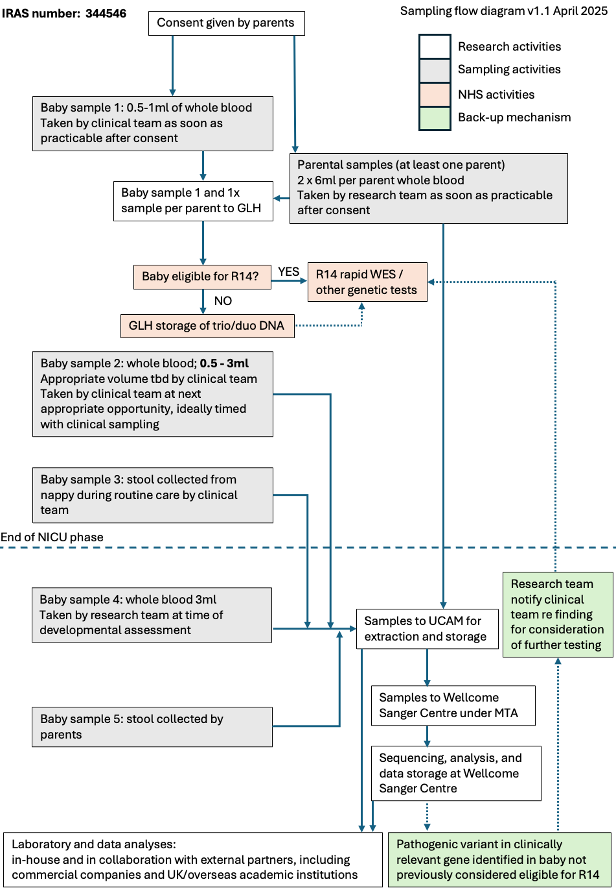
Figure 2: Sample handling and processing

Sample Collection
Blood samples will be collected by a suitably qualified and experienced person following local guidelines after informed consent has been given and re-confirmed. Local site procedures will be followed regarding the arrangement of neonatal blood tests. For the 3yr visit, which will be conducted in Cambridge, a sampling SOP will be followed including the provision and application of anaesthetic cream as per family preference.
The first blood sample taken at visit 1 (0.5-1ml in NICU) will be sent to the local Genomics Laboratory Hub (GLH), an accredited NHS laboratory service, for processing or DNA storage, depending on the clinical status of the child. All GLH requirements for blood sample collection and transportation of samples for rare and inherited disease WGS testing will be followed. These samples must be labelled with the participants’ clinical details (first name and surname, date of birth and NHS number / hospital number). A specimen barcode label that encodes the external specimen ID can be used and is recommended to ensure it can be scanned without the opportunity for human transcription error. Where a clinician requests WGS for a baby on clinical grounds (the R14 test) this will be ordered by the clinical team and sent out for testing by the recruiting site’s assigned GLH. For other babies in the study, the GLH will undertake DNA storage only (see Sampling Flow Diagram).
The subsequent neonatal blood sample will be taken by a member of the clinical team. The volume (0.5-3ml) and precise timing of the sample will be determined on clinical grounds by the baby’s local care team.
A study-specific barcode will be used to track samples through processing at site, storage at site, transport to the central study storage (-80C in bar-coded tubes) at Cambridge, and subsequent processing/analysis.
Stool samples from visit 1 will be collected by the clinical team and stored at -80C in bar-coded tubes at site, pending transport to Cambridge.
Stool samples collected by parents following visit 4 (3-year visit) will use standard commercially available collection kits. They can be collected either from a nappy or on wiping. Parents will be given clear instructions to post the samples back using a commercially available kit that complies with Packing Instructions 650 for category B substances.

Sample transportation and processing
At site, blood samples will be spun in an Eppendorf R5427 centrifuge or similar for 15 minutes at 2000g, plasma separated and stored in -80c freezers. The study laboratory team at Cambridge will be responsible for ensuring that the basic laboratory equipment at each clinical site is maintained, e.g. freezer temperature log maintained. Batches of samples will be transported from sites (Norwich, Luton) via a designated approved courier using appropriate packaging for transport at -80C. Samples will be tracked and receipted at both sending and receiving sites according to the study SOP and sample manifests.
On arrival at the central laboratory site in Cambridge, samples will be further aliquoted then processed to DNA, RNA, etc. All processing will utilise standard laboratory SOPs. Risk assessments will be completed and approved by the departmental biological safety committee prior to commencing the work. Tracking of bio-samples at Cambridge will use an electronic bar-coded sample management system. The freezers in which the samples are stored will be locked and will be located in areas where access is limited (by locks or badge entry systems) to authorised personnel only. Freezers will be connected to a remote monitoring system for urgent notification in case of e.g. power failure. Empty back-up freezers will be available for urgent sample transfer in the event of freezer failure.
Processed samples will subsequently be either analysed on site or transported to other facilities (e.g. the Wellcome Sanger Institute) as required for analysis under appropriate MTAs and in accordance with the study SOP. Samples may be passed on to third parties, including commercial entities and overseas collaborators for specialised analyses, for example different types of large-scale ‘omic analysis (e.g. proteome, peptidome, lipidome, metabolome). In this event, tubes will have all identifiers removed and the sample will be identified via a unique pseudonymised coded identifier based on study ID. The code linking the sample to the identifiers of the given participant will be stored securely at the University of Cambridge, as described for other patient identifiable data.
Quality assurance of sample processing
All measurements will be made using CE certified laboratory equipment, using CE certified reagents. The expiry date of reagents will be checked and only kits within their useable life will be employed. Analysers and processing equipment will be kept in a laboratory which confirms to the environmental requirements of the system. All machines will be calibrated and serviced according to the manufacturer’s recommended schedule for clinical applications. Staff using laboratory equipment will be trained, their training will be documented, and all assays will be performed according to Standard Operating Procedures for the study. The file of laboratory SOPs and training logs will be maintained by the study laboratory lead.

Genomic sequencing, data analysis and interpretation
Participant biomaterial including (but not confined to) nucleic acid, liquid tissue, solid tissue, excrements, that have been pseudonymised by study ID, will be sent to the Wellcome Sanger Institute under MTA. These samples will be used to generate nucleic acid readouts and other analyses including, but not confined to, whole genome sequencing (WGS). All storage and processing will follow SOPs in place at the institute. WGS (over 30× coverage in aligned reads), quality control, read alignment to the human reference genome build 38, and variant calling will be performed at the Wellcome Sanger Institute. WGS data will be processed (including storage) at the Wellcome Sanger Institute and securely deposited in the European Genome-phenome Archive (EGA) as required by the funder (Wellcome Trust). Both raw sequence data and research reports will be covered by a bidirectional DTA between the University of Cambridge and the Wellcome Sanger Institute.
Genetic variants detected will be interpreted and reported following the latest international variant interpretation guidelines (American College of Medical Genetics and Genomics/Association for Molecular Pathology) and national guidelines (Association of Clinical Genomic Science). Research reports for each baby will be generated by the study team and these will be used for research purposes only. Where a pathogenic variant relevant to the neonatal clinical presentation is detected in a child who was not deemed eligible for NHS R14 genetic testing, the research report will be issued to the referring clinician. The clinical team may then decide, after consultation with the parents, to initiate genetic testing via the local GLH, where suitable DNA samples from the family will already exist. We will take a phenotype-based approach (as opposed to a genetic screening approach) by reporting only variants that may be relevant to the clinical condition of the neonate. No other reporting of results to families or clinicians will be undertaken, and no timescale is specified for generating the research report. Families will be clearly informed during the consent process that their clinical teams will only receive genetic information that may be directly relevant to the clinical condition of the baby in the NICU and only if genetic testing has not been initiated by their clinical team on the R14 (rapid newborn WGS) clinical pathway (see additional document ‘Results Leaflet for Families’).
Pathogenic, likely pathogenic, and selected variants of uncertain significance from research reports may be submitted to the public variant database ClinVar, with pathogenicity and high-level phenotype information. Variants in candidate genes of uncertain significance may be submitted to GeneMatcher.

Collection of participant personal details
In order to:
- Maintain ongoing contact with participating families as described in the study schedule
- Retrieve information from health records and link to other data sources
- Contact families, for example inviting them to join future REC-approved studies
families will be asked to provide the following details for each participant:
            - Surname
            - Given names
            - Date of Birth (DOB)
            - Sex at birth
            - Home Address
            - NHS number
            - Phone number
            - Email address
All data will be kept in the Study Link Table, where it will be linked to participants’ unique study ID numbers. Access to the Study Link Table will be restricted to the PIs and study coordinators for the purpose of the above activities.

Collection of study data
The study data will be captured in an eCRF using a clinical trial-grade system, for example RedCap. On entry to the study, the eCRF record (identified by study number) will be initiated and populated with demographic data pertaining to each child. Demographic and clinical data will be entered by a member of the research team using information from parents, clinicians, and derived from the medical record for mother and baby. Information from electronic questionnaires and direct data entry (e.g. during developmental assessments) from subsequent study visits will be added to the eCRF as the study progresses. Other data generated, e.g. speech samples from parents and videos, can also be appended to the eCRF. Genetic and multi-omics data will be stored separately, but dummy variables derived from these data will be entered into the eCRF.

Withdrawal of Participants
Families will be able to withdraw from the study at any time. They can contact the study team by phone, text message or email, all of which will be available on the study literature and on the website. A member of the study team will follow the study SOP for the withdrawal. The study team will follow up withdrawal requests by phone call to ensure that participant’s wishes are fully understood. They will be asked to specify whether (i) data already collected can be retained for analysis, (ii) biological samples already collected can be retained for analysis, and (iii) their routinely collected data may continue to be linked to their existing study record. Where any of these are declined the study team will ensure this is actioned in accordance with the participant’s wishes.
Families will also be asked why they are withdrawing (to help understand ways in which this and future studies could be improved) but will not be required to provide a reason or justify their reason if one is given. They will be assured that their decision will not affect any element of their child’s future care.
Confirming vital status of participants
We will use the Personal Demographics Service (PDS) to determine the vital status (alive or deceased) of all children annually prior to each planned contact or data linkage. This process is essential to avoid causing distress to families.
PDS is the national electronic database of NHS patient demographic information, maintained by NHS England, and provides up-to-date information including date of death (where applicable). This service will be used solely to confirm whether an individual is alive or deceased at the point of look-up, in order to:
- Ensure that we do not further contact families of children who have died
- Record the deaths in the cohort for analysis
- Maintain up-to-date cohort records in a respectful and legally compliant manner
The lookup process will be carried out via the NHS Spine Mini Service in accordance with NHS England’s Information Governance standards and local Data Protection policies. The lookup will be via NHS number, using other identifiers, e.g. date of birth, to confirm that the correct child has been identified.
Members of the study team with appropriate information governance training will conduct these annual lookups, and results will be used only to update the vital status (alive/deceased) field in the study dataset and to update contact information as necessary.
The legal basis for this data processing falls under Article 6(1)(e) and Article 9(2)(j) of the UK GDPR, as the processing is necessary for the performance of a task carried out in the public interest and for scientific research purposes. All processing will adhere to the principles set out in the UK Data Protection Act 2018 and the Caldicott Principles.

Definition of End of Study
The direct participation phase of the study will end at six months after each participant turns 5 years old (to allow for completion of the 5-yr old questionnaires). The data-linkage phase will end in the year when each participant turns 16 years old.

DATA MANAGEMENT
Institutional guidance on research data management will be used to ensure adherence to guidelines and best practice.
The CI, or delegated members of the study team, will maintain an electronic trial master file with access restricted to authorised members of the study team. Sites will maintain an electronic study site file with access restricted to individuals who are on the delegation log for that site.

Handling of personal identifying information
On all study documents, other than the signed consent form, the participant will be referred to by a unique study ID number. Participants will be informed about data handling procedures in the study guide. All personally identifiable data (PID), including names, dates of birth, NHS numbers, and contact details, will be stored securely at each study site in accordance with the UK General Data Protection Regulation (UK GDPR) and the Data Protection Act 2018.
The study sites (Cambridge, Norwich and Luton) will ensure that:
- PID is stored in locked cabinets (for paper records) or password-protected, access-restricted electronic systems (for digital records).
- Only authorised study personnel will have access to identifiable information.
- All data transfers from study sites to the central site for analysis will be conducted using secure, encrypted channels.
- PID will be stored separately from research data using the study ID number to maintain confidentiality.
- Data will be retained at study sites only as long as necessary and in line with the study sponsor’s retention policy.

The central Study Link Table, a spreadsheet linking PID to their unique study ID number, will be stored in the University of Cambridge Secure Computing Research Platform (SRCP) separate to all other study data. The SRCP is an ISO27001 Certified Platform Service adhering to the highest standards of data privacy and security and is compliant with the NHS Data Security and Protection Toolkit. It provides a secure, isolated, and controlled environment for data storage, processing, and analysis that has access controls (strong authentication, authorization controls, and access logging) to manage access to the platform. Access to identifiable study data in the SRCP will be controlled by the CI in conjunction with the study data scientist and project manager.
Any paper versions of forms, questionnaires, etc will initially be stored in a secure, locked location and will be accessible only to the members of the study needing to use them in fulfilling their role. Before the end of the study any paper forms will be scanned and saved in electronic form into the electronic study master file. The paper documents will then be destroyed as confidential paper waste.
The electronic questionnaires will be administered online via the eCRF. Data will either be entered by families directly into the eCRF or, where necessary, responses given by families will be entered by a member of the study team. Where the data is entered by a member of the study team, another member of the study team with permission to view the information will check it to ensure that there are no data entry errors. Access to the eCRF will be granted only to approved members of the study team who require this for the conduct of the study (e.g. data entry or checking).
The audio and video recordings collected will be stored securely in the University of Cambridge SRCP. They will be stored separately from the study link table and from other pseudonymised data. Access will only be granted to approved members of the study team and this data will not be shared with collaborators either in the UK or internationally. The transcription will be carried out internally by the study team, and the pseudo-anonymised transcripts will be saved on the University of Cambridge network for analysis purposes. To ensure transcription accuracy and consistency, 20% of the recordings will be double coded.
Data generated by the GLH, including DNA sample data and HPO terms, will be stored indefinitely as NHS data on cloud-based systems according to standard NHS and GLH processes and policy. The research team will access clinical test results via the electronic medical record, including results from any genetic investigations.
WGS data will be processed (including storage) at the Wellcome Sanger Institute and securely deposited in the European Genome-phenome Archive (EGA). Where it will be analysed at the University of Cambridge, it will be transferred to the Secure Computing Research Platform (SRCP), in Very High Impact (Level 3) security storage which is for sensitive or confidential data.
All data sets except for the raw WGS data, large ‘omic data (e.g. proteome), and participant identifiers will be collated into master datasets for analysis purposes. Research data collected into the eCRF will be deposited in the University of Cambridge SRCP for analysis. After the end of the study, the pseudo-anonymised data will be pushed to secure University of Cambridge cold storage.

Data sharing
Anonymised data will be made accessible to bona fide and authorised medical researchers upon request at the discretion of the chief investigator. We may send anonymised data collected as part of the study (e.g. questionnaire responses, genomic findings, interview transcripts, DNA) outside the European Economic Area (EEA). The data can only be used by organisations and researchers to conduct research in accordance with the UK Policy Framework for Health and Social Care Research, and the participants’ data could be used for research in any aspect of health or care.

Data archiving
At the end of the study (after 18 years; 16 years after the recruitment of the final participant), all electronic study data (including the master data sets and Study Link Table) and study samples will be stored indefinitely. If no further approval has been given for use of the samples at the end of the study then they will be deposited in an appropriate licensed tissue bank at the University of Cambridge or Cambridge University Hospitals NHS Foundation Trust (joint sponsors). As our aim is to follow this cohort longitudinally, it is anticipated that this data resource will continue to yield important insights, and that future ethical applications may be made to extend data collection through re-consent. If the data is no longer in use by 10 years following the study end, it will be fully anonymised and archived securely at the University of Cambridge. Prior to archiving, all files will be locked (made read-only) and password-protected if this has not already been done. The CI will be responsible for the archived data. WGS data will be stored securely in the Wellcome Sanger Institute for the 18 years study duration and, if no longer in active use, securely archived thereafter.
Recordings (audio or video) will be retained until 10 years beyond the study end and will be accessible only to approved members of the research team. Recordings will not be shared with collaborators either in the UK or internationally.

DATA COLLECTION
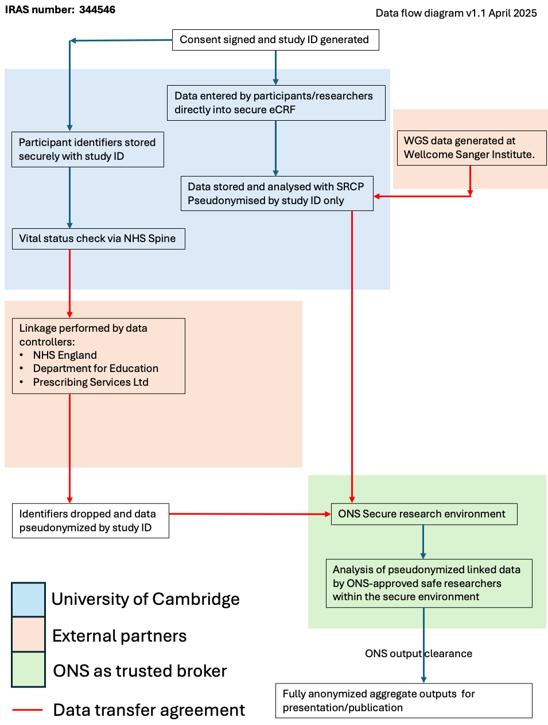
Figure 3: Data flow diagram
Retrieval of information from medical records
Research staff at each site will access the medical records of the mothers and babies to obtain outcome data during the first year following birth. For the mother, information retrieved will include her pregnancy information, e.g. antenatal ultrasound findings, routine blood test results etc, any complications during pregnancy, and details of the baby’s birth. Information will be entered into standardised forms in the research database. Outcome data will be collected from the different clinical software packages used by participating hospital trusts to store clinical information. This may include download of information from sources such as EPIC (e.g. laboratory records, vital signs, point of care testing, and notes for free text searching), antenatal ultrasound data (e.g. Astraia), and neonatal outcome data (e.g. Badgernet). For babies, we will build up a meticulous and detailed picture of the neonatal phenotype through the local medical record.
Routine data linkage
Data linkage to routinely collected sources will be performed annually. Participants who have opted out further data linkage will not be included. Children for whom the vital status of the child is not ‘alive’ or cannot be confirmed will not be included in the linkage.
Annual linkage analysis will be performed by supplying identifiable data via secure, approved routes to external agencies (e.g. NHS England, Department of Education, Prescribing Services Ltd, Public Health England), under an agreed contract or data transfer agreement (DTA). Data will be returned in pseudonymised form where participants are identified only by study ID, creating a linked dataset for analysis. Analysis will be performed on the pseudonymised data within secure data environments provided by the relevant data controller (e.g. currently these are via the Office for National Statistics for data provided by the DFE and NHSE, and via a bespoke environment for Prescribing services Limited).
Annual data linkages will be performed for each child from birth until the child turns 16. Therefore there will be 16 annual linkages (Table 4). Identifiers that will be supplied for linkage analysis include:
- Child’s first name and surname
- Previous names by which the child has been known, if relevant
- Child’s date of birth
- Child’s NHS number
- Child’s address, region of birth or geographical location
- Child’s sex assigned at birth
- Child’s study ID

Child’s age | NHS England (via Data Access Request Service |  |  | Department for Education | Prescribing Services Ltd
 | Hospital episode statistics | Community services data set | National Childhood Measurement Programme | National Pupil database | SystmOne data
1 year | X | X
2 years | X | X |  |  | X
3 years | X | X |  |  | X
4 years | X | X |  |  | X
5 years | X | X | X | X | X
6 years | X |  |  | X
7 years | X | X |  | X
8 years | X |  |  | X
9 years | X | X |  | X
10 years | X |  |  | X
11 years | X | X | X | X | X
12 years | X |  |  | X
13 years | X |  |  | X
14 years | X |  |  | X
15 years | X |  |  | X
16 years | X |  |  | X | X

Table 4: Schedule of data linkages

STATISTICS AND ANALYSIS
We will use standard methods for the analysis of observational data. Continuous variables may be summarized by the median and inter-quartile range and comparisons made by the Kruskal Wallis test. Univariate comparisons of dichotomous data may be made using the chi-square test and chi-square test for trend, as appropriate. The risk of events may be modelled using logistic regression. Variables will be treated as binary, ordinal or continuous as appropriate. The statistical significance of interactions may be assessed using the Wald test.
We will apply analysis strategies including regression modelling, decision trees, and support vector machines to predict health and educational outcomes in our multi-dimensional dataset. We will also utilize unsupervised learning to identify hidden structures and subgroups and deploy deep-learning models to analyse complex interactions between various features. These features will primary be hypothesis-derived but will have additional data-driven elements. We will employ causal inference techniques to determine the directionality of relationships and use interpretability tools, e.g. SHAP values, to elucidate the contributions of different features, making the findings actionable for clinicians and educators. In the final stages, we will aim to implement ensemble learning methods to combine model predictions, enhancing robustness and accuracy by integrating insights from diverse models.
Candidate predictive models for longitudinal outcomes will be compared using the area under the receiver operating characteristic curve (AUC), estimated by leave-pair-out cross validation, to address over-fitting. We will also estimate Akaike’s Information Criteria (AIC) and the Bayesian Information Criteria (BIC), which assess model goodness of fit and complexity.
All analyses will be performed using appropriate statistical packages, such as Stata (Stata, College Station, TX, USA) or R for Statistical Computing. Reporting of results will be in line with STROBE (Strengthening the Reporting of Observational Studies in Epidemiology) guidelines, ensuring transparency and completeness in the reporting of observational study findings. The statistical methods and data analysis plans have been reviewed by a statistician within the University of Cambridge who is not a member of the research team.
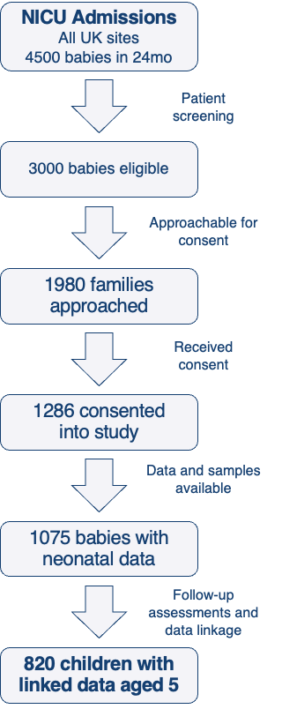
Figure 4: Schematic of projected recruitment
The projected recruitment is based on the study team’s previous experience of recruiting families during their stay in the tertiary NICU in Cambridge, and other NICUs in the East of England.
Power calculations
Estimates of power are based on our previous work linking a Cambridge birth cohort to educational outcomes aged 5. We successfully linked data from 92% of eligible participants, with an opt-out rate <2%. We anticipate similar or better rates of linkage for the current cohort design. 20% of our Cambridge population-based cohort did not meet school readiness standards, which will be higher in a NICU cohort, conservatively ~30%. From 1,075 recruited babies with neonatal data, we would expect to link school readiness data for ~820 children. For any exposure affecting ≥5% children (n=41, e.g. a genetic variant or clinical phenotype) we would have 80% power (setting alpha at 0.05; two sided) to detect a 2-fold difference in the risk of not attaining school readiness. For exposures affecting ≥10% of children, we will detect a 1.53-fold increase, which is in line with the effect-magnitude observed for antenatal exposures.

Qualitative speech sample data will be transcribed by the study team, coded and then analysed using QSR NVivo 12. All transcripts will be reviewed and coded by two researchers to allow for full data immersion. We will utilize an inductive approach to thematic analysis as a methodological framework. This will allow theories to be applied flexibly without a priori theoretical assumptions about what might be learned from the data. Video recordings of parent-child interaction will be coded using standard protocols (e.g., NICHD Sensitivity Scales), with 20% double coded for reliability purposes.

PROTOCOL DEVIATIONS
A study related deviation is a departure from the approved study protocol or other study document or process (e.g. consent process) or from GCP or any applicable regulatory requirements. Any deviations from the protocol will be documented in a protocol deviation form and filed in the study master file.

ETHICAL AND REGULATORY CONSIDERATIONS
Genetic reporting
Families will be informed that the purpose of the research is to better understand the factors that predict life-course health for children who are admitted to tertiary-level NHS NICUs and to discover potential ways to improve outcomes. Families are not expected to benefit directly from participation. However, there may be benefit to families where there is a finding of a genetic difference linked to the clinical condition of the neonate. All cases where the genetic research report reveals a pathogenic or likely pathogenic variant potentially linked to the neonatal phenotype will be reviewed at a multi-disciplinary team meeting that includes:
- Study investigator with previous experience of leading large-scale studies where research variants are fed back to clinical teams
- Clinical scientist with training in secondary variant annotation
- Consultant clinical geneticist
- Genetic counsellor
- Representative from a GLH
If the variant is confirmed by consensus as meeting the conditions of being (i) pathogenic or likely pathogenic and (ii) likely linked to the neonatal phenotype, then the clinical team will be informed. The responsibility for acting on this result lies with the clinical team and would require, in the first instance, validation of the test result in a clinical accredited lab (GLH). No timescale is specified for this feedback. The clinical team will not be notified of any genetic results that are not linked to the clinical condition of the neonate and there will be no direct feedback of any results from the study team to participating families. For babies where an R14 rapid newborn WGS result has already been requested by the clinical team, no research results will be returned to clinical teams as the R14 results would super-cede research findings. Our approach is thus a pragmatic phenotype-based failsafe mechanism to ensure that results that would benefit the care of the baby are available to clinicians, while avoiding generating genotype-based screening results that may cause undue concern or distress to families. This approach was supported by the families approached in NICU, community genetics clinics, and in maternity services during our PPIE for the study design phase.
The information generated during the study is intended for research rather than clinical purposes. Research samples will not be handled as per NHS protocols, and the information generated in the study will not be suitable for making medical diagnoses. Similarly, the developmental assessments performed will not be administered by clinicians, and are not undertaken as part of a wider clinical assessment. Providing feedback on these research-only findings risks raising concerns unnecessarily for some families and providing inappropriate reassurance for others. We will therefore not feedback the results from individual biological or developmental testing to families. No incidental findings or findings related to phenotype beyond the neonatal phase will be reported to either families or clinicians. This will be explained to families, and an additional participant leaflet (see document ‘Results leaflet for Families’) will be provided to families specifically for further information on this point.
Three types of genetic information could potentially arise during BLOOMs:
- Genetic information that could be relevant for the care of babies in NICU: in this case, the clinical team will be advised of the genetic findings. They can then decide whether to undertake genetic testing within the NHS (if this has not already been performed). We cannot make clinical diagnoses directly and therefore will not feedback results to families directly.
- Genetic information that could be relevant for a child later in life: genetic variants relevant to neurodevelopmental delay, intellectual disability or a later-presenting phenotype may be present. However a full medical assessment of the child would be needed before these links can be made. The study team will not have the required clinical assessments to make these links, therefore we will not feedback genetic results about problems that develop after the baby has left the NICU.
- Genetic information that could be relevant for parents: we may find incidental genetic variations in parents. Because the study scope and resourcing is focused on acute issues relating to the child, we will not provide information about incidental findings to participants in BLOOMS.

Parents will be able to request their child’s data from the study, including DNA data. If such a request is made the study team will oversee the process on a case-by-case basis. We will ensure appropriate context for interpreting the information and respond to any questions, while emphasising that this is not a route for medical diagnosis or treatment.
The study will involve ongoing contact with the research team beyond discharge from NICU. Parents and carers are able to ask questions or relate concerns they may have about their child’s development at any stage, and the study team will field questions (under the guidance of Professor Fearon). We will advise that any parent with concerns about their child’s health or development discusses these with their GP or their child’s specialist team, who are ideally placed to investigate these issues. Where appropriate, the study team will help to facilitate these referrals.
Ongoing consent for data linkage

Consent for data linkage will be gained at the start of the study when the baby is in the NICU. Throughout the study we will regularly remind parents of their rights and how they can withdraw consent for data linkage if they choose to. Information about not participating further in the study will also be available at all times via the study website. We have developed a clear withdrawal protocol to make this process as straightforward as possible. Although we will regularly remind families that they may withdraw consent, we will not specifically re-consent participants for data linkage. In order to maintain the scientific validity of the study, it is essential to retain both power and generalisability. A re-consent process would inevitably introduce attrition bias that the study is specifically designed to avoid. We will inevitably lose contact with a number of families, despite our best engagement efforts, over a 5 year period. These are most likely to be families with significant socio-economic challenges, those from groups under-served by research, and with children who have complex health conditions. It would undermine the study's key goals to exclude these families from the data linkage outcomes, and represent a significant missed opportunity to understand health and educational outcomes in this population.

Inclusion and diversity
Our study sites (Luton, Norwich, and Cambridge) each have distinctive features that enrich the cohort for ethnic and socio-economic diversity. Recruitment will be in all 3 East of England hospitals with a tertiary NICU, hence all the sickest babies in the East of England will be available for recruitment, regardless of where the parents live or where the baby is delivered.

The sites have the following demographics:
- Luton: top 25% most deprived UK local authorities, with a pre-dominantly urban ethnically diverse population (10% Black, 37% Asian, 6% other)
- Norwich: serves rural and under-resourced coastal communities with multiple overlapping inequalities leading to poor health outcomes
- Cambridge: the most socio-economically divided city in the UK

We will seek greater participation of underserved populations by maximising accessibility of the study information. Where digital poverty precludes completing research assessments via electronic device, we will take participants through questions via telephone or send paper copies where this is the family’s preference.

The study is carefully designed integrating the PPIE feedback gathered during the design phase to minimise travel, thus maximising participation of families who live in geographically remote locations, have transport challenges, and need to manage the needs of young children. We will not recruit families where there is no adult who feels confident to complete the consent process in English. This is to ensure that all families who participate have the ability to complete validated and standardised questionnaires remotely in English. Direct translation of standardised assessment tools to other languages will invalidate them for research purposes, unless they have been specifically validated in other languages, which is rare for instruments used to assess development in young children.

Our PPIE leadership team will work on community-informed strategies for engagement, inclusion and retention of underserved groups, for example holding community events, advertising the study via local groups and social media accounts, and ensuring that we listen to and address specific barriers to participation.

Cohort engagement
The full schedule of assessment and cohort design includes regular contact with participants to ensure ongoing engagement with the study. The study design and participant-facing materials have been reviewed by our PPIE participants comprising: 6 parents with a baby currently in a tertiary level NICU, 4 parents with a child who was a NICU graduate, 8 healthcare professionals working with NICU babies, 2 teachers with responsibility for special educational needs, 2 parents of children with special educational needs. Their input was key in devising the study goals, schedule of events, optimal schedule for visits, and sampling protocols.

Travel costs for in-person study visits will be fully funded. Participants will be offered incentives in the form of vouchers (£10 per time-point) for completion of electronic questionnaires. Birthday presents for the child will be sent annually from the study team up to the 5th birthday (e.g. placemats, growth charts, picture books etc). Retention of the study cohort will be maximized by leveraging our team’s expertise in remote assessments, both questionnaires and observations of children in their own environments playing and interacting via filming (on parental phones). Not only does this minimize recall bias, increasing the likelihood of ongoing participation of families with financial and mobility challenges, but also promotes a more relaxed and typical parent-child interaction to get a fully representative picture of the developmental phenotype. Bio-sampling has been minimized to birth and 36-mo, in accordance with PPI feedback, and minimises the procedures children will undergo. Our PPIE team will produce regular newsletters with summaries of the study findings for participants and will run local family events.

Declaration of Helsinki
The study team will ensure that this study is conducted in accordance with the principles of the Declaration of Helsinki.

Approvals
Following approval of the study via the REC/HRA and Sponsor, the study team will submit and, where necessary, obtain approval for all substantial amendments to the original approved documents.

Participant Confidentiality and Data Protection
The study will be guided by the appropriate sections of the NHS IG Toolkit, ISO27001, data protection legislation (General Data Protection Regulation (GDPR) and Data Protection Act 2018 (DPA 2018)), the Information Commissioner Office recommendations, and best practice in IT security technologies. GDPR/DPA 2018 requires data to be de-identified as soon as it is practical to do so. The processing of the personal data of participants will be minimised by making use of a unique participant study number on all study documents and any electronic database(s) immediately following consent. All documents, both paper and electronic, will be stored securely and only accessible by study staff and authorised personnel. The study staff will safeguard the privacy of participants’ personal data.
All samples, including DNA, will be stored securely by the GLH, University of Cambridge, and the Wellcome Sanger Institute and in accordance with the DPA 2018, GDPR and the Human Tissue Authority (HTA), as relevant.

Data sharing and availability
Extracts of the data may be passed on to third parties, such as approved commercial entities or research collaborators, including those overseas. Whenever data is passed on, participants will be identified by study ID only to preserve anonymity. It will be impossible for external collaborators to identify individuals on the basis of the data. All transfers of data will require completion of a Data Transfer Agreement. This requires the recipient of the data to adhere to a series of conditions in relation to the anonymised extract. A signature will be required from a representative of the institution or company that is receiving the data who is deemed appropriate to take responsibility for the terms of the DTA.
Protocols, methodological advances, and results will be published as they are generated. Study information will be available via the project website. Protocols, methods, and results will be published online via open access routes. Fully annotated code will be published alongside results where applicable, or available on request. Data linked to routinely collected sources managed by other data controllers, e.g. NHS England/Department for Education will not be shared and all outputs will be cleared by statisticians at the ONS Secure Research Service prior to publication or presentation. Raw qualitative data will not be shared due to the potential for reidentification.

Funding
The study is funded by a Discovery Award from the Wellcome Trust (312471/Z/24/Z). Further funding may be sought from additional sources to augment funding over the course of the project.

Insurance
The study is jointly sponsored by Cambridge University Hospitals NHS Foundation Trust and the University of Cambridge. Cambridge University Hospitals NHS Foundation Trust, as a member of the NHS Clinical Negligence Scheme for Trusts, will accept full financial liability for harm caused to participants in the study caused through the negligence of its employees and honorary contract holders. There are no specific arrangements for compensation should a participant be harmed through participation in the study, but no-one has acted negligently. The University of Cambridge will arrange insurance for negligent harm caused as a result of protocol design and for non-negligent harm arising through participation in the study (HVS/2024/4484).

REFERENCES
1. French, C.E., Dolling, H., Mégy, K., Sanchis-Juan, A., Kumar, A., Delon, I., Wakeling, M., Mallin, L., Agrawal, S., Austin, T., et al., Rowitch, D.H., Raymond, F.L (2022). Refinements and considerations for trio whole-genome sequence analysis when investigating Mendelian diseases presenting in early childhood. HGG Adv 3, 100113. https://doi.org/10.1016/j.xhgg.2022.100113.
2. Wright, C.F., Campbell, P., Eberhardt, R.Y., Aitken, S., Perrett, D., Brent, S., Danecek, P., Gardner, E.J., Chundru, V.K., Lindsay, S.J., et al., Firth H.V., DDD study (2023). Genomic Diagnosis of Rare Pediatric Disease in the United Kingdom and Ireland. N Engl J Med 388, 1559–1571. https://doi.org/10.1056/NEJMoa2209046.
3. Bethlehem, R. a. I., Seidlitz, J., White, S.R., Vogel, J.W., Anderson, K.M., Adamson, C., Adler, S., Alexopoulos, G.S., Anagnostou, E., Areces-Gonzalez, A., et al., Rowitch, D.H., et. al. (2022). Publisher Correction: Brain charts for the human lifespan. Nature 610, E6. https://doi.org/10.1038/s41586-022-05300-0.
4. Bethlehem, R. a. I., Seidlitz, J., White, S.R., Vogel, J.W., Anderson, K.M., Adamson, C., Adler, S., Alexopoulos, G.S., Anagnostou, E., Areces-Gonzalez, A., et al., Rowitch, D.H., et. al. (2022). Brain charts for the human lifespan. Nature 604, 525–533. https://doi.org/10.1038/s41586-022- 04554-y.
5. Tomlinson, M., Skeen, S., Melendez-Torres, G.J., Hunt, X., Desmond, C., Morgan, B., Murray, L., Cooper, P.J., Rathod, S.D., Marlow, M., et al., Fearon, P. (2022). First 1,000 days: enough for mothers but not for children? Long-term outcomes of an early intervention on maternal depressed mood and child cognitive development: follow-up of a randomised controlled trial. J Child Psychol Psychiatry 63, 261–272. https://doi.org/10.1111/jcpp.13482.
6. Olga, L., Sovio, U., Wong, H., Smith, G., and Aiken, C. (2023). Association between antenatal diagnosis of late fetal growth restriction and educational outcomes in mid-childhood: A UK prospective cohort study with long-term data linkage study. PLoS Med 20, e1004225. https://doi.org/10.1371/journal.pmed.1004225.
7. Moffitt, T.E., Arseneault, L., Belsky, D., Dickson, N., Hancox, R.J., Harrington, H., Houts, R., Poulton, R., Roberts, B.W., Ross, S., et al. (2011). A gradient of childhood self-control predicts health, wealth, and public safety. Proc Natl Acad Sci U S A 108, 2693–2698. https://doi.org/10.1073/pnas.1010076108.
8. Olga, L., Sovio, U., Wong, H., Smith, G.C., and Aiken, C.E. (2024). Association between maternal hemoglobin concentration and educational attainment in mid-childhood in a high-resource obstetric setting: a prospective cohort study. Am J Obstet Gynecol MFM, 101357. https://doi.org/10.1016/j.ajogmf.2024.101357.
9. French, C.E., Delon, I., Dolling, H., Sanchis-Juan, A., Shamardina, O., Mégy, K., Abbs, S., Austin, T., et al., Firth, H., NIHR BioResource—Rare Disease, Next Generation Children Project, Rowitch, D.R., Raymond, F.L. (2019). Whole genome sequencing reveals that genetic conditions are frequent in intensively ill children. Intensive Care Med 45, 627–636. https://doi.org/10.1007/s00134- 019-05552-x.
10. Sakura, F., Noma, K., Asano, T., Tanita, K., Toyofuku, E., Kato, K., Tsumura, M., Nihira, H., Izawa, K., Mitsui-Sekinaka, K., et al. (2023). A complementary approach for genetic diagnosis of inborn errors of immunity using proteogenomic analysis. PNAS Nexus 2, pgad104. https://doi.org/10.1093/pnasnexus/pgad104. Page 5 of 40
11. Costanzo, M., Zacchia, M., Bruno, G., Crisci, D., Caterino, M., and Ruoppolo, M. (2017). Integration of Proteomics and Metabolomics in Exploring Genetic and Rare Metabolic Diseases. Kidney Dis (Basel) 3, 66–77. https://doi.org/10.1159/000477493.
12. Nazzari, S., Fearon, P., Rice, F., Ciceri, F., Molteni, M., and Frigerio, A. (2020). Neuroendocrine and immune markers of maternal stress during pregnancy and infant cognitive development. Dev Psychobiol 62, 1100–1110. https://doi.org/10.1002/dev.21967.
13. Bernardi, M., Fish, L., van de Grint-Stoop, J., Knibbs, S., Goodman, A., Calderwood, L., Mathers, S., Deepchand, K., Ferguson, C., et al., Fearon, P. (2023). Children of the 2020s : first survey of families at age 9 months : Research report : November 2023. https://assets.publishing.service.gov.uk/media/65b11dbb160765000d18f7fb/Cot20s_age_9_months_r esearch_report.pdf.
14. Bowler, A., Arichi, T., Fearon, P., Meaburn, E., Begum-Ali, J., Pascoe, G., Johnson, M.H., Jones, E.J.H., and Ronald, A. (2024). Phenotypic and Genetic Associations Between Preschool Fine Motor Skills and Later Neurodevelopment, Psychopathology, and Educational Achievement. Biological Psychiatry 95, 849–858. https://doi.org/10.1016/j.biopsych.2023.11.017.
15. Cheung, R.W., Austerberry, C., Fearon, P., Hayiou-Thomas, M.E., Leve, L.D., Shaw, D.S., Ganiban, J.M., Natsuaki, M.N., Neiderhieser, J.M., and Reiss, D. (2023). Disentangling genetic and environmental influences on early language development: The interplay of genetic propensity for negative emotionality and surgency, and parenting behavior effects on early language skills in an adoption study. Child Dev. https://doi.org/10.1111/cdev.14021.
16. McElroy, E., Villadsen, A., Patalay, P., Goodman, A., Richards, M., Northstone, K., Fearon, P., Tibber, M., Gondek, D., and Ploubidis, G.B. (2020). Harmonisation and Measurement Properties of Mental Health Measures in Six British Cohorts. https://www.closer.ac.uk/wpcontent/uploads/210715-Harmonisation-measurement-properties-mental-health-measures-britishcohorts.pdf.
17. Henderson, S., Sugden, D., and Barnett, A. (2007). Movement assessment battery for children-2 [Movement ABC-2] Second Edition. (The Psychological Corporation).
18. MCS - Age 3 - BAS II Naming Vocabulary CLOSER. https://closer.ac.uk/cross-study-dataguides/cognitive-measures-guide/mcs-cognition/mcs-age-3-bas-ii-naming-vocabulary/.
19. Schoemaker, M.M., Niemeijer, A.S., Flapper, B.C.T., and Smits-Engelsman, B.C.M. (2012). Validity and reliability of the Movement Assessment Battery for Children-2 Checklist for children with and without motor impairments. Dev Med Child Neurol 54, 368–375. https://doi.org/10.1111/j.1469- 8749.2012.04226.x.
20. Smits-Engelsman, B.C.M., Niemeijer, A.S., and van Waelvelde, H. (2011). Is the Movement Assessment Battery for Children-2nd edition a reliable instrument to measure motor performance in 3 year old children? Res Dev Disabil 32, 1370–1377. https://doi.org/10.1016/j.ridd.2011.01.031.
21. Camacho, C., Straatmann, V.S., Day, J.C., and Taylor-Robinson, D. (2019). Development of a predictive risk model for school readiness at age 3 years using the UK Millennium Cohort Study. BMJ Open 9, e024851. https://doi.org/10.1136/bmjopen-2018-024851.
22. McElwain, N.L., Hu, Y., Li, X., Fisher, M.C., Baldwin, J.C., and Bodway, J.M. (2021). Zoom, Zoom, Baby! Assessing Mother-Infant Interaction During the Still Face Paradigm and Infant Language Development via a Virtual Visit Procedure. Front Psychol 12, 734492. https://doi.org/10.3389/fpsyg.2021.734492.
23. Shin, E., Smith, C.L., and Howell, B.R. (2021). Advances in Behavioral Remote Data Collection in the Home Setting: Assessing the Mother-Infant Relationship and Infant’s Adaptive Behavior via Virtual Visits. Front Psychol 12, 703822. https://doi.org/10.3389/fpsyg.2021.703822.
24. Ensor, R., and Hughes, C. (2008). Content or connectedness? Mother-child talk and early social understanding. Child Dev 79, 201–216. https://doi.org/10.1111/j.1467-8624.2007.01120.x.

