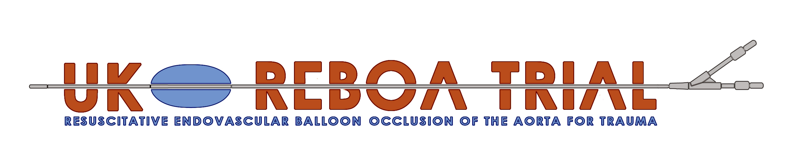

Protocol

Funded by the National Institute for Health Research (NIHR)
Health Technology Assessment (HTA) Board
Reference 14/199/09

Co-Sponsors
University of Aberdeen
Research and Development Office
Foresterhill Annexe
Foresterhill
Aberdeen AB25 2ZD
Grampian Health Board
Research and Development Office
Foresterhill Annexe
Foresterhill
Aberdeen AB25 2ZD

Co-Chief Investigators

Clinical CI
Jan Jansen
Senior Lecturer
Health Services Research Unit
University of Aberdeen
Email: jan.jansen@abdn.ac.uk
Tel: +44 (0) 1224 438140

Co-CI
Marion Campbell
Professor of Health Services Research
Health Services Research Unit
University of Aberdeen
Health Sciences Building
Foresterhill
Aberdeen AB25 2ZD
Email: m.k.campbell@abdn.ac.uk
Tel: +44 (0)1224-437944

Trial office
UK-REBOA Trial Office
Centre for Healthcare Randomised Trials (CHaRT)
Health Services Research Unit (HSRU)
University of Aberdeen
Health Sciences Building
Foresterhill
Aberdeen AB25 2ZD
Email: reboatrial@abdn.ac.uk
Tel: +44 (0)1224-438140

Funder
NIHR Health Technology Assessment Programme
Reference: 14/199/09
Start date: 1 April 2017
End date: 30 March 2021

Trial registration
ISRCTN: TBC
REC reference: 17/NW/0352
REC protocol number: 3.039.16
IRAS project ID: 226135

Signatures

By signing this document I am confirming that I have read, understood and approve the protocol for the above study.

Jan Jansen (Clinical CI): | 
Date: | 20 July 2017

Marion Campbell (co-CI): | 
Date: | 20 July 2017

Graeme MacLennan (Statistician): | 
Date: | 20 July 2017

Version history
Amendment no. | Protocol version no. | Description of changes  (incl. author(s) of changes) | Date of protocol
 | Version 1 | New Document | 11 May 2017
1 | Version 2 | - New Version Number and Date  - Change of contact details for CI  - Omission of ‘including an abnormal laboratory finding’ under the adverse event subsection of 12.1 in line with TSC recommendation  - Removal of text ‘As this study is recruiting in trauma patients with life-threatening injuries, it is expected that many of the patients will experience events that are the consequence of the patient’s life-threatening injuries, resulting critical illness, and treatment’ under section 12.2.2 and insertion of it under section 12.2 instead.  - Removal of reference to Appendix E in Figure 7  - In order to simply section 12.1: Removal of the sentence “The word ‘event’ is used for untoward medical occurrences not related to the investigational device. The word ‘effect’ is used for occurrences related to or caused by the investigational device.”  Removal of the word ‘Two day’ from the section about training ( 17.2.1. ) to allow us some flexibility for altering the length of the training course in the future should be need it | 20 July 2017

Contents

1. Protocol summary 11
Question addressed 11
Eligible population 11
Interventions 11
Outcome assessment 11
Co-ordination 11
2. Glossary 12
Aortic occlusion balloon/catheter 12
Angioembolisation 12
Definitive haemorrhage control 12
Non-compressible torso haemorrhage 12
Resuscitative thoracotomy 12
Temporary haemorrhage control 12
Zone I REBOA 12
Zone III REBOA 12
3. Abbreviations 13
4. Trial personnel 15
Clinical Chief Investigator 15
Co-CI 15
Grant Holders 15
Statistical Consultants 15
Qualitative Evaluation Lead 15
Health Economics Consultant 15
Patient Representatives 16
Trial Office Team 16
Project Management Group (PMG) 16
Trial Steering Committee (TSC) Members 16
Data Monitoring Committee (DMC) Members 16
5. Introduction 17
5.1 Background 17
5.2 Resuscitative Endovascular Balloon Occlusion of the Aorta (REBOA) 17
5.3 Rationale for trial 19
6. Aim 19
7. Trial Design and Processes 19
7.1 Design 19
7.2 Intervention to be evaluated 21
7.3 Control treatment 25
8. Trial recruitment 25
8.1 Setting 25
8.2 Inclusion and exclusion criteria 25
8.3 Recruitment and random allocation of participants 26
8.4 Consent 27
8.4.1 Research without prior consent 27
8.4.2 Subsequent informed consent 28
8.4.3 Patients who have capacity 29
8.4.4 Patients who lack capacity 29
8.4.5 Participants who regain capacity 30
8.4.6 Specifics of consent 31
8.4.7 Patients who die before consent can be obtained 31
9. Data collection and processing 33
9.1 Initial data collection (randomisation and REBOA) 33
9.2 Subsequent in-hospital data collection 33
9.3 TARN and other routine data collection 33
9.4 ONS and HES data 34
9.5 Informing third parties of inclusion in trial 34
10. Outcomes 34
10.1 Primary outcomes 34
10.2 Secondary outcomes 34
10.3 Data collection schedule 35
10.4 Recruitment rates and expected throughput 35
11. Trial phases and progression criteria 36
11.1 Phase 1: Feasibility assessment 36
11.2 Progression (stop/go) criteria 36
11.3 Phase 2: Full trial 37
11.4 Trial timetable 37
12. Safety 37
12.1 Definitions 37
12.2 Procedures relating to adverse events/device effects 39
12.2.1 Adverse event/device effects reporting period 39
12.2.2 Expected complications 39
12.2.3 Adverse event/device effect reporting 41
12.2.4 Serious adverse event/device effect reporting 41
12.2.5 Grading of severity of adverse events 41
12.2.6 Assessment of seriousness 42
12.2.7 Assessment of causality 42
12.2.8 Assessment of expectedness 43
12.2.9 Follow-up procedures 43
12.2.10 Adverse event/device effect: Reportable events flowchart 43
12.2.11 Recording and reporting of urgent safety measures 44
13. Sample size 44
14. Statistical analysis 45
15. Qualitative investigation 46
16. Economic evaluation 46
16.1 Within trial analysis 46
16.2 Longer term analysis 47
17. Organisation: trial management and oversight arrangements 48
17.1 Trial office in Aberdeen 48
17.2 Local organisation in sites 48
17.3 Project Management Group (PMG) 49
17.4 Trial Steering Committee (TSC) 49
17.5 Data Monitoring Committee (DMC) 50
18. Research governance, data protection and sponsorship 50
18.1 Research Governance 50
18.2 Data protection 50
18.3 Sponsorship 51
18.4 Relationship with the manufacturer of the ER-REBOATM balloon 51
19. Ethics and regulatory approvals 51
19.1 Protocol compliance and amendments 51
20. Quality assurance 52
20.1 Risk assessment 52
21. Finance and insurance 52
22. End of trial 52
23. Data handling, record keeping and archiving 52
24. Satellite studies 53
25. References 53
Appendix A Embedded Qualitative Evaluation (REBOA-Qual) 57
Appendix B Timetable 63
Appendix C UK-REBOA Trial authorship policy 65

Protocol summary

Question addressed
Does the use of REBOA, in addition to standard major trauma centre treatment, increase 90-day survival of trauma patients suffering from exsanguinating torso haemorrhage, and is it cost-effective?

Eligible population
Adult trauma patients (aged, or believed to be aged, 16 years or older) with confirmed or suspected life-threatening torso haemorrhage, which is thought to be amenable to adjunctive treatment with REBOA, who present to a major trauma centre.

Interventions
Standard major trauma centre treatment plus REBOA, compared with standard major trauma centre treatment alone.

Outcome assessment
The primary clinical outcome will be 90-day mortality (defined as death within 90 days of injury, before or after discharge from hospital). The primary economic outcome will be lifetime incremental cost per QALY gained, from a health and personal social services perspective.

Co-ordination
Local: By local emergency department staff including trauma team lead, local research nurses, or recruitment officers.
Central: By Trial Office in Aberdeen.
Overall: By the Project Management Group, overseen by the Trial Steering Committee and the Data Monitoring Committee.

Glossary

Aortic occlusion balloon/catheter
A device used to occlude the aortic lumen, from within the vessel.

Angioembolisation
Bleeding control by endovascular means, by occluding vessels from the inside, using foam or coils.

Definitive haemorrhage control
Thoracotomy or laparotomy involving removal of injured organs, vascular ligation or repair, or packing; or angioembolisation.

Non-compressible torso haemorrhage
Haemorrhage which originates from within the thorax, abdomen, or pelvis, and can therefore not be controlled by external pressure.

Resuscitative thoracotomy
A thoracotomy performed for the purpose of occluding the descending thoracic aorta, to limit blood loss, and redistribute the remaining blood volume to the brain and heart.

Temporary haemorrhage control
REBOA or open aortic occlusion, by means of thoracotomy, or laparotomy.

Zone I REBOA
Placement of REBOA balloon catheter in the descending thoracic aorta (between left subclavian artery and coeliac axis).

Zone III REBOA
Placement of REBOA balloon catheter in the distal abdominal aorta (between most distal renal artery and aortic bifurcation).

Abbreviations
ADE | Adverse device effect
AE | Adverse Event
CEAC | Cost-Effectiveness Acceptability Curve
CHaRT | Centre for Healthcare Randomised Trials
CI | Chief Investigator
CONSORT | Consolidated Standards of Reporting Trials
CRF | Case Report Form
CTU | Clinical Trial Unit
DMC | Data Monitoring Committee
ED | Emergency Department
EQ-5D | EuroQol Group’s 5 dimension health status questionnaire
EudraCT | European Union Drug Regulating Authorities Clinical Trials
EVPI | Expected Value of Perfect Information
EVPPI | Expected Value of Perfect Partial Information
FDA | Food and Drug Administration
GCP | Good Clinical Practice
GOS | Glasgow Outcome Scale
GOS-E | Extended Glasgow Outcome Scale
HEAP | Health Economics Analysis Plan
HERU | Health Economics Research Unit
HRQoL | Health Related Quality of Life
HSRU | Health Services Research Unit
HTA | Health Technology Assessment
IB | Investigator Brochure
ICER | Incremental Cost-Effectiveness Ratio
ICU | Intensive Care Unit
ISF | Investigator Site File
ISRCTN | International Standard Randomised Controlled Trial Number
ISS | Injury Severity Score
ITP | Implementation and Training Package
MHRA | Medicines and Healthcare products Regulatory Agency
MRC | Medical Research Council
MTC | Major Trauma Centre
NCTH | Non-Compressible Torso Haemorrhage
NHS | National Health Service
NHSG | National Health Service Grampian
NIHR | National Institute of Health Research
NRES | National Research Ethics Service
ONS | Office for National Statistics
OR | Odds Ratio
PI | Principal Investigator
PIL | Patient Information Leaflet
PMG | Project Management Group
PQ | Participant Questionnaire
P-REBOA | Partial REBOA
PROMS | Patient Reported Outcome Measures
QALY | Quality Adjusted Life Year
RCT | Randomised Controlled Trial
REBOA | Resuscitative Endovascular Balloon Occlusion of the Aorta
REC | Research Ethics Committee
R&D | Research and Development
SADE | Serious Adverse Device Effect
SAE | Serious Adverse Event
SAP | Statistical Analysis Plan
SD | Standard Deviation
SOP | Standard Operating Procedure
TARN | Trauma Audit and Research Network
TMF | Trial Master File
TSC | Trial Steering Committee
TTL | Trauma Team Leader
UK | United Kingdom
UKCRC | United Kingdom Clinical Research Collaboration
UoA | University of Aberdeen
USADE | Unanticipated Serious Adverse Device Effect
VOI | Value of Information

Trial personnel

Clinical Chief Investigator
Mr Jan Jansen
Consultant in General/Trauma Surgery & Intensive Care Medicine

Co-CI
Prof Marion Campbell
Professor of Health Services Research
Health Services Research Unit
University of Aberdeen
Health Sciences Building
Foresterhill
Aberdeen AB25 2ZD

Grant Holders
Mr Dwayne Boyers
Prof Karim Brohi
Dr Tim Harris
Prof Fiona Lecky
Dr Robbie Lendrum
Mr Graeme Maclennan
Prof Chris Moran
Mr Jonathan Morrison
Prof Alan Paterson
Colonel Nigel Tai
Mr Nick Welch

Statistical Consultants
Prof Thomas Jaki
Prof John Norrie
Dr Philip Pallman

Qualitative Evaluation Lead
Dr Katie Gillies

Health Economics Consultant
Dr Graham Scotland

Patient Representatives
Ms Victoria Le Brec
Ms Josie Horton

Trial Office Team
Chief Investigators
Trial Manager
Trial assistant/junior trial manager
Data Co-ordinator
Senior Trial Manager
Senior IT Manager
Trial statistician
QA manager

Project Management Group (PMG)
This Group is comprised of the grant holders along with representatives from the Trial Office team.

Trial Steering Committee (TSC) Members
The membership of this Committee comprises independent members along with the Chief Investigators (Jan Jansen/Marion Campbell) or a nominated delegate. The other REBOA grant-holders and key members of the Trial Office team (e.g. the trial manager) may attend TSC meetings.

Data Monitoring Committee (DMC) Members
This Committee is comprised of independent members, and the trial statistician contributes as appropriate. The CI and/or a delegate may contribute to the open session of the meetings as appropriate.

Introduction

Background
Trauma is the leading cause of death in the first four decades of life, accounting for more than 1.3 million deaths per year globally. Haemorrhage is the most common cause of preventable death after injury. Bleeding is responsible for approximately one-third of trauma deaths, and between 16-29% of such deaths are thought to be preventable.^{1,2}
The natural history of uncontrolled haemorrhage is of cardiovascular collapse with consequent cerebral and myocardial hypoperfusion, ultimately leading to death.³ Haemorrhage originating from within the torso is particularly challenging, as bleeding generally cannot be controlled without surgery or angio-embolisation.⁴ In patients in whom haemorrhage is either unrecognised or torrential, exsanguination and death occur prior to definitive hemostasis.² However, when haemorrhage is controlled expeditiously, patients often recover.⁵
Temporary aortic occlusion can limit haemorrhage and help to maintain perfusion to the heart and brain, and is associated with improved survival.⁶⁻⁹. An adjunctive intervention to temporarily control haemorrhage is thus conceptually attractive, and could reduce the number of haemorrhage-related deaths.

Resuscitative Endovascular Balloon Occlusion of the Aorta (REBOA)
REBOA is a novel technique whereby a percutaneously inserted balloon is deployed in the aorta, providing a relatively quick means of controlling haemorrhage, by obstructing flow into the distal circulation, until definite control of haemorrhage can be attained. (See figures 1-3.)
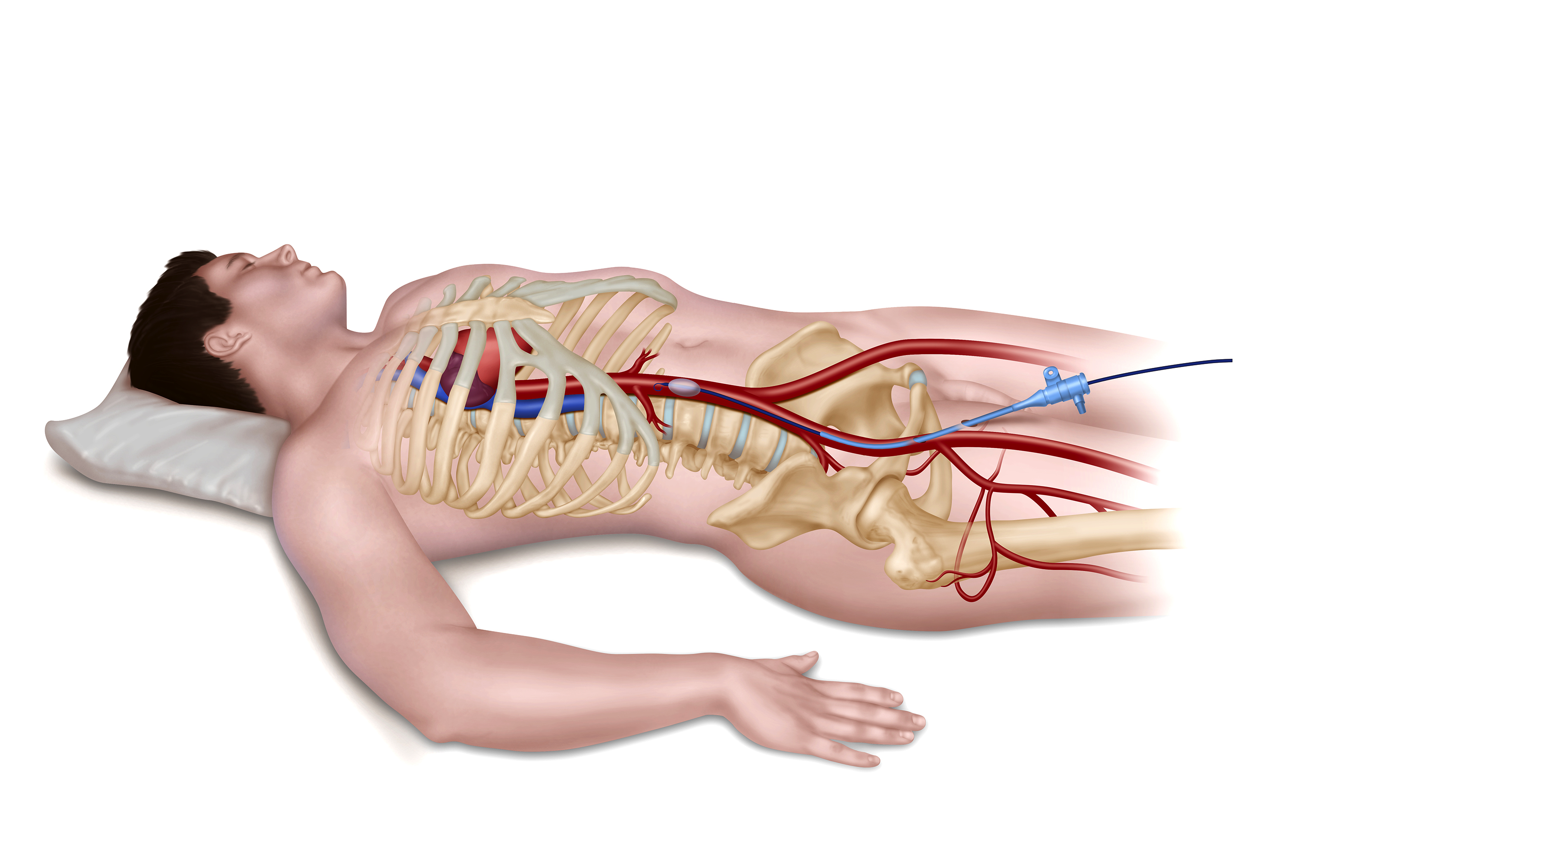
Figure 1. REBOA, deployed via the right common femoral artery

The balloon can be deployed in the descending thoracic aorta (referred to as “zone I”) or the distal abdominal aorta (referred to as “zone III”). (Figures 2 and 3.)
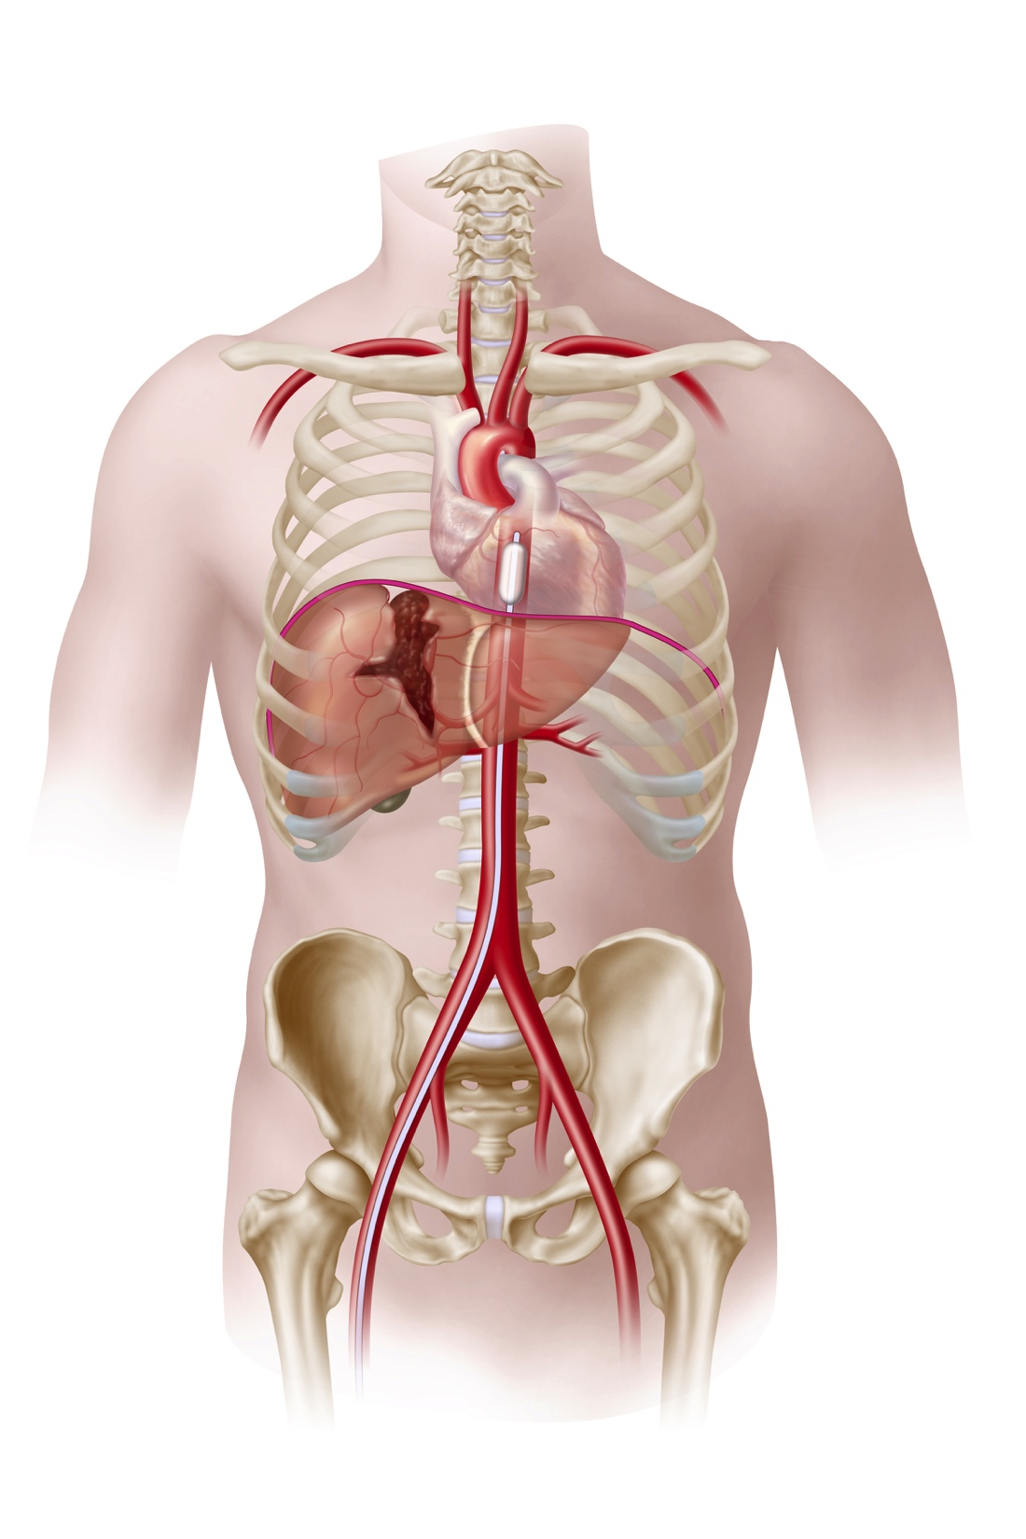 | 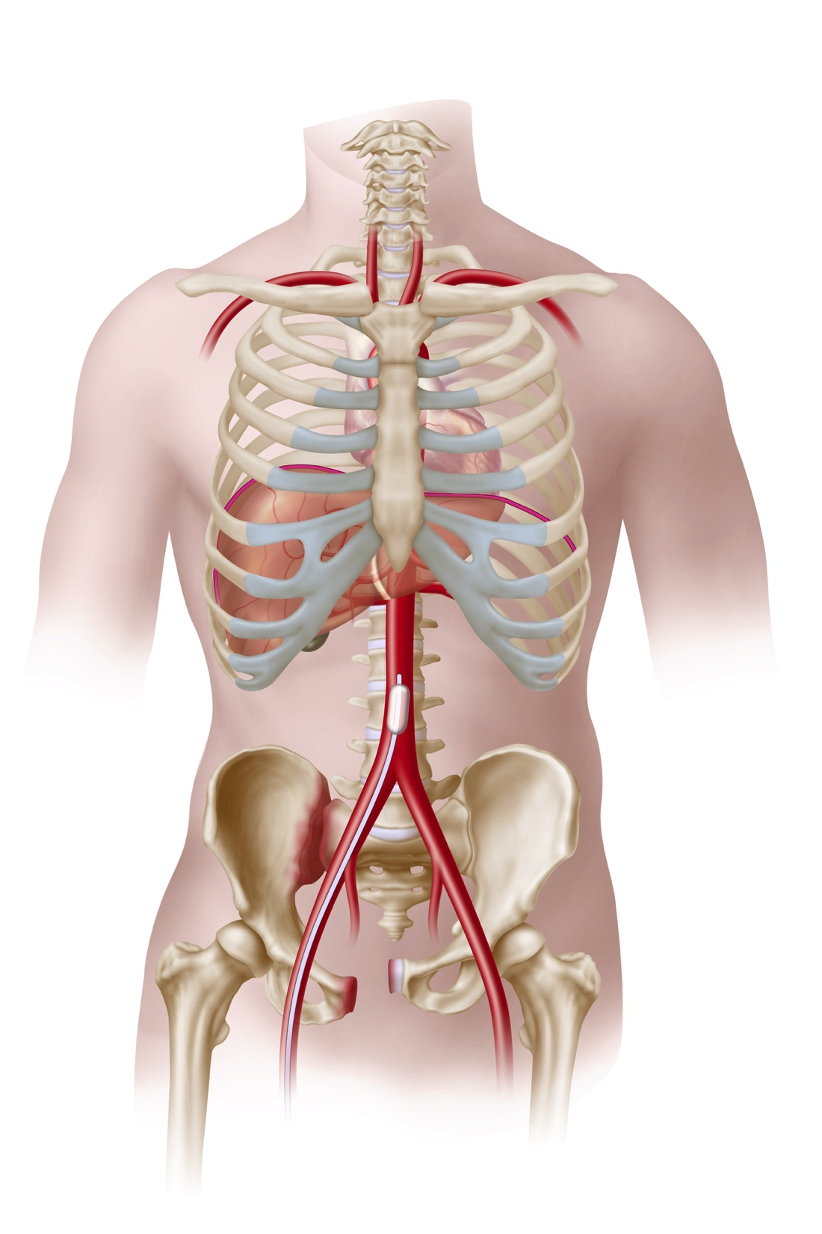
Figure 2. Zone I deployment | Figure 3. Zone III deployment

REBOA increases cardiac afterload and proximal aortic pressure, and improves perfusion of the heart and brain, and large animal models of uncontrolled haemorrhage have shown REBOA to be highly effective.¹⁰⁻¹⁶
The current evidence for REBOA in injured humans is, however, limited and conflicting. There are a number of case series, but only a few studies, all non-randomised, which have attempted to compare patients who have been treated with, and without, REBOA.
A propensity-matched retrospective cohort study of 1807 patients from Japan, of whom 351 received treatment with REBOA, showed that REBOA may be associated with a lower chance of survival (odds ratio 0.30, 95% confidence interval 0.23-0.40). The authors surmised that the excess mortality observed among REBOA-treated patients may signal a ‘‘last ditch’’ effort, based on a degree of injury severity not otherwise identified in the retrospectively recorded data. It is also worth noting that the application of REBOA in Japan seems to differ from the way it is employed in North America and Europe, in that the reported times to definitive care (although not further defined) and to first transfusion were markedly longer than would be expected in our setting (in excess of three hours and two hours, respectively).¹⁷
A further retrospective cohort study of 96 patients, from the United States, showed that patients who underwent REBOA (24 patients) were more likely to survive (37.5%) than those who underwent resuscitative thoracotomy (72 patients, 9.7%).¹⁸ However, the characteristics of patients in the two groups differed. Furthermore, the patients in this study were probably even more severely injured than those in the Japanese study, accounting for the differences in baseline mortality.
Lastly, the “AORTA” study, also from the United States, prospectively recorded data on 114 patients who underwent aortic occlusion by means of REBOA (46 patients), or thoracotomy or laparotomy, with aortic cross-clamping (68 patients). Again, the characteristics of patients in the two groups differed. Open aortic occlusion patients were more likely to be male and have sustained penetrating mechanisms of injury. They were also less likely to have been intubated in the pre-hospital environment than REBOA counterparts. Overall survival was 21.1%, with no significant difference between patients treated with REBOA (28.2%) and open aortic occlusion (16.1%, p=0.120).

Rationale for trial
The observational designs of the studies described above make them inherently susceptible to selection bias. Given the ready availability of aortic balloon occlusion devices, there is a real risk of rapid proliferation of the technique, without a formal appraisal of its safety and effectiveness. Several authorities have therefore called for a more robust evaluation.¹⁹

Aim
The UK-REBOA trial aims to establish the clinical and cost-effectiveness of REBOA, as compared with standard treatment alone, for the management of uncontrolled torso haemorrhage caused by injury, in specialist trauma centres.

Trial Design and Processes

Design
Pragmatic, multicentre, Bayesian, group-sequential, randomised controlled trial (RCT), comparing standard major trauma centre treatment plus REBOA with standard major trauma centre treatment alone, for trauma patients with suspected life-threatening torso haemorrhage.
At present, REBOA is only used in a single major trauma centre, the Royal London Hospital, in the UK. Experience has shown that using REBOA in trauma patients is technically and organisationally challenging. The trial therefore includes a managed implementation component, whereby we systematically train centres and manage the introduction of REBOA into clinical practice at each site. In addition, given the challenging nature of the clinical setting, it is currently unclear how randomisation can be successfully integrated into the clinical pathway. The trial therefore includes a feasibility phase to ensure that enrolment, randomisation and data collection features are optimised, before proceeding to the full trial. (Figure 4)
Figure 4. CONSORT Flow diagram
As the number of patients potentially eligible for REBOA is likely to be relatively small, we have adopted a Bayesian inferential framework for this trial. The design of RCTs in small populations has received considerable attention over recent years. Statistical commentators²⁰⁻²² and agencies such as the Food and Drug Administration (FDA)²³ have recommended the use of a Bayesian framework when numbers are particularly constrained. The design of this trial was developed in conjunction with the Adaptive Designs Working Group of the Medical Research Council Network of Hubs for Trials Methodology.

Intervention to be evaluated
The intervention to be evaluated is REBOA. This is a pragmatic trial, which aims to evaluate REBOA as it is used in practice.
REBOA refers to the insertion – usually via the femoral artery – of a compliant balloon, which is advanced into the distal thoracic or abdominal aorta, and then inflated, thereby obstructing flow into the distal circulation, with the aim of reducing further blood loss, increasing cardiac afterload and proximal aortic pressure, and increasing myocardial and cerebral perfusion.
The trial seeks to evaluate the technique of REBOA rather than a specific brand of device.
Currently, two devices are specifically licensed for the purpose of “large vessel occlusion”. These are the ER-REBOATM (Prytime MedicalTM, Texas) and the Coda® (Cook® Medical, Ireland) balloons.
The ER-REBOATM is a second-generation device, which has recently received CE Mark approval (CE 650182). It is smaller in diameter, requiring a 7F sheath (rather than 12F, as required for the Coda®), which can be removed without surgical closure of the arterial puncture site. The device also does not require a guidewire, making it potentially easier and safer to use.
Some centres have also used a LeMaitre® embolectomy catheter. It requires a 7F sheath (same as the ER-REBOATM), but does also require a guidewire. A further device, the Tokai RescueBalloon, which also relies on a 7F sheath, is expected to receive CE Mark approval in the near future.
The ER-REBOA catheter (figure 5) is available to major trauma centres participating in the trial, for training and clinical use. However, the use of this particular device is not mandatory, and individual centres are free to use their brand of choice. Details of which devices are used will be recorded. The MHRA have confirmed that the use of the devices for the purpose of REBOA, regardless of their intended use, is exempt from medical device regulations.

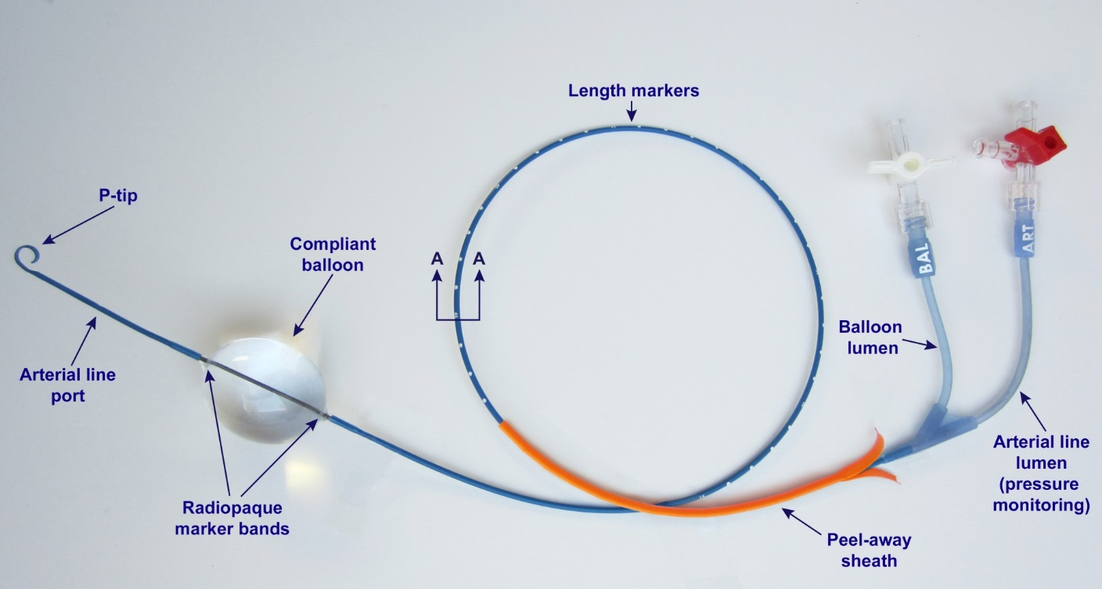
Figure 5. ER-REBOA catheter
REBOA is usually performed percutaneously, with ultrasound guidance (as shown in Figure 6), although some operators have chosen to surgically cut down onto the femoral artery, before cannulating it. Either method can be used for the trial.
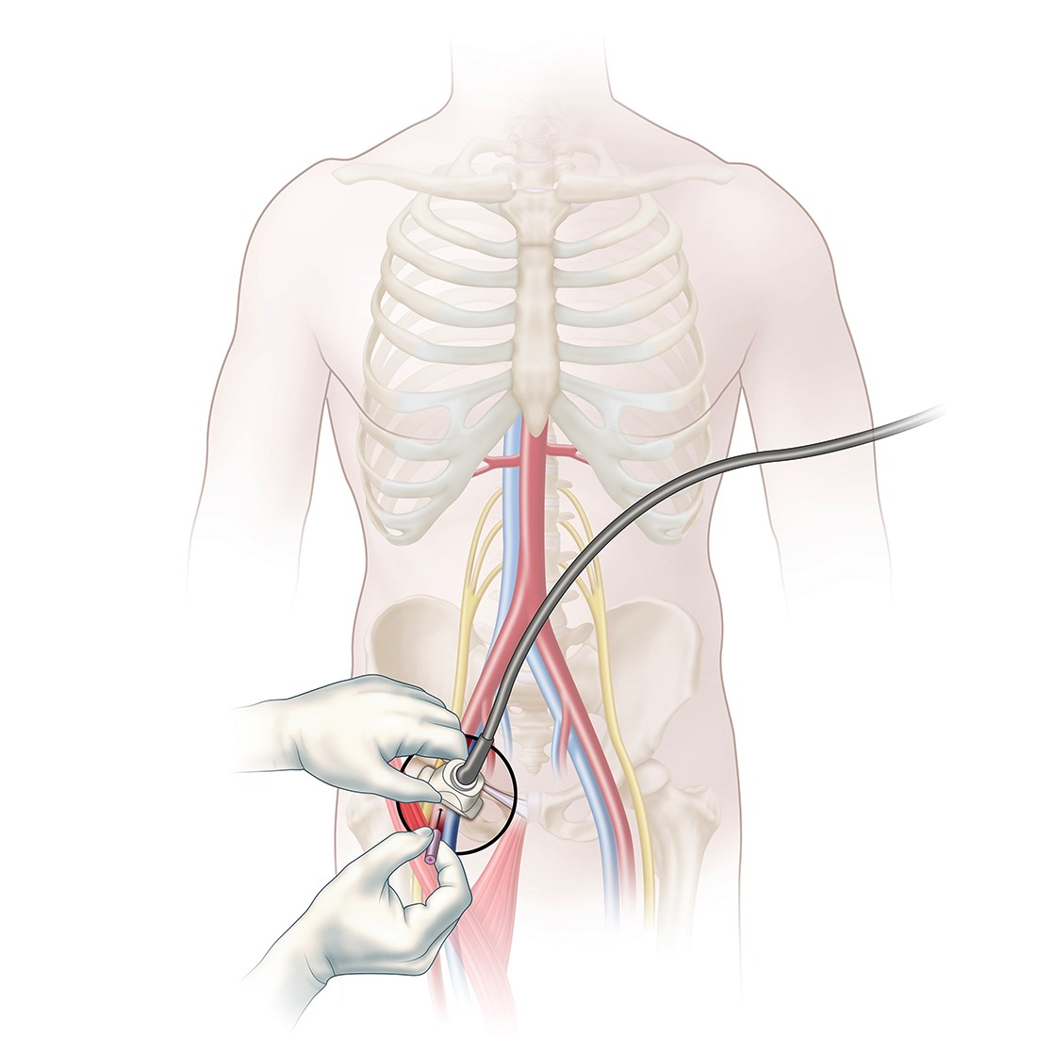
Figure 6. Percutaneous access of femoral artery, using ultrasound guidance.
Once arterial access has been established, an arterial sheath is inserted, to facilitate the subsequent insertion of the balloon device (Figure 7).
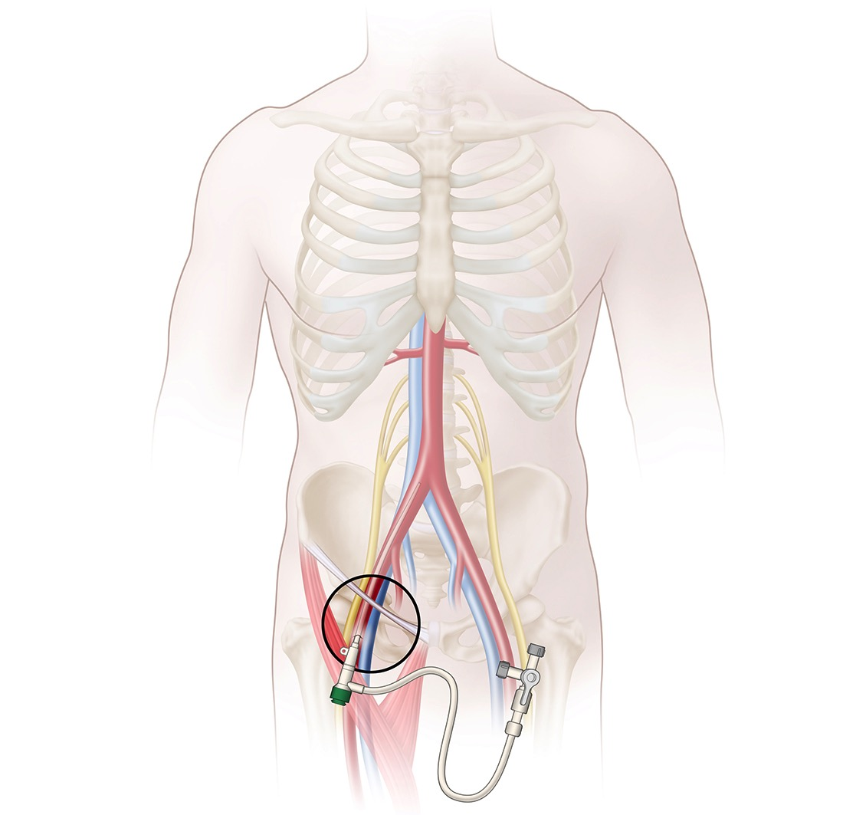
Figure 7. Placement of arterial sheath
The balloon device is then inserted through the sheath, and advanced into the abdominal or thoracic aorta (Figure 8). Blood pressure is measured both above and below the balloon.
In some centres, it has become commonplace to insert a femoral arterial line (usually 18G or 20G), or sometimes even a larger arterial sheath (7F), early on in the patients’ course, for blood pressure monitoring, and to secure arterial access for subsequent insertion of a REBOA catheter, if required. Enrolment into the trial can take place at any time, and neither the insertion of a femoral arterial line, nor sheath, preclude subsequent enrolment into the trial.
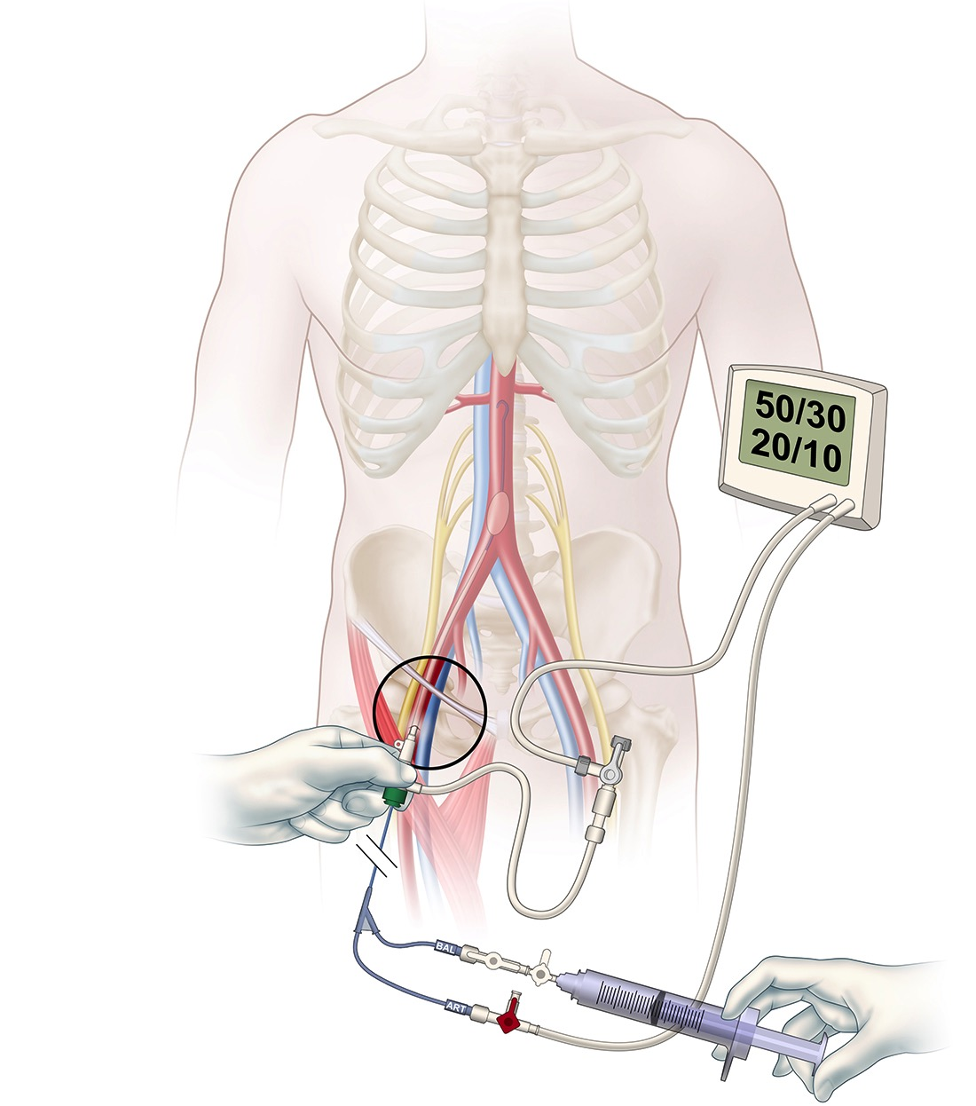
Figure 8. Balloon catheter insertion and inflation (with proximal and distal blood pressure measurement).
Partial REBOA (P-REBOA) is a strategy which aims to mitigate against the effects of distal ischaemia, by allowing some blood to flow past the balloon, and trying to balance haemodynamics and metabolic consequences. As this is a pragmatic trial, which aims to evaluate the practice of REBOA, rather than a particular method, trauma team leaders and operators may choose to use P-REBOA as part of the trial if desired. All information on specifics of REBOA use is recorded.
Aortic occlusion invariably results in distal ischaemia. The extent of this ischaemia, and the subsequent reperfusion injury, depends on the level, duration, and completeness of the aortic occlusion, and probably also the duration and depth of the preceeding shock state. It is therefore not possible to give precise maximum permissible occlusion times. However, every effort should therefore be made to minimise the duration of balloon inflation (or aortic cross-clamping). As a rough guide, based on animal research, zone III occlusion times of more than 90 minutes, and zone I occlusion times of more than 45 minutes, are more likely to be injurious and associated with fatal outcomes.
Treatment with REBOA is part of an overall treatment strategy. The addition of REBOA to current treatment is intended to provide earlier, temporary haemorrhage control, to facilitate further investigation, or transfer to an operating room or interventional radiology suite. Participating major trauma centres will, as part of the training and implementation, and in conjunction with the investigators, draw up local guidelines for the use of REBOA. These guidelines will take cognisance of local circumstances, and ensure that the use of REBOA ties in with existing practices regarding the reception of major trauma patients, “code red” activation, massive haemorrhage protocols, etc.

Control treatment
The control arm of the study comprises standard treatment of patients with life-threatening torso haemorrhage, in the setting of a major trauma centre, which includes a rapid, consultant-led assessment; as well as consultant-delivered anaesthesia and surgical care. Depending on the injuries, the receiving team includes emergency medicine physicians, anaesthetists, general and vascular surgeons, orthopaedic surgeons, radiologists, intensivists, as well as nursing and ancillary staff.
Life-saving interventions such as intubation of the airway, respiratory support, blood product transfusion, and imaging, are directed by protocols and guidelines, and aimed at minimising the time to control of haemorrhage, by surgical or endovascular means.

Trial recruitment

Setting
The trial is conducted in major trauma centres in England. It does not consider the prehospital use of REBOA.

Inclusion and exclusion criteria
Inclusion criteria: Adult trauma patients (aged, or believed to be aged, 16 years or older) with confirmed or suspected life-threatening torso haemorrhage, which is thought to be amenable to adjunctive treatment with REBOA (zone I or zone III) can be included. Exclusion criteria: Women known or thought to be pregnant at presentation, children (aged, or believed to be aged 15 or younger) and patients with injuries which are deemed unsurvivable on clinical grounds will be excluded.

Recruitment and random allocation of participants
The recruitment of participants is the responsibility of trauma team leaders. One of the key roles of TTLs is to assess any injured patient (particularly those in whom bleeding is obvious or suspected) regarding the need for immediate intervention, which may take the form of an operation, angioembolization, or adjunctive treatments, such as REBOA (if available). This assessment commences as soon as the patient enters the emergency room. In the context of the trial, eligible patients will be identified by Trauma Team Leaders, assessing individual cases against the UK-REBOA Trial eligibility criteria.
Recruitment is by means of a dedicated and secure website, designed to be accessed on devices such as smartphones. This mechanism takes cognisance of the extreme acuity with which eligible patients will present, and the need to not burden trauma team leaders – whose priority will be to ensure optimal clinical care – with filling in forms, accessing computers, or making telephone calls. The website has been developed and is hosted by the Centre for Healthcare Randomised Trials (CHaRT) at the University of Aberdeen.
The website is accessible from any brand of handheld device, including smartphones (the preferred option) and tablets (one of which will be provided for each centre). The website permits the pre-population of fields such as site and name of trauma team leader (when used on individually-owned devices).
Recruitment of a participant only requires the trauma team leader to enter the patient’s hospital number. This information, together with the site’s and TTL’s details (as previously entered) then links directly to CHaRT’s online randomisation system (which will adopt randomisation by blocks of randomly varying length), which returns the patient’s allocation, to either standard major trauma centre treatment, or standard major trauma centre treatment plus REBOA.
The process of enrolling a patient in this way takes less than 30 seconds, and is therefore very unlikely to interfere with patient care.

Consent

Research without prior consent
Emergency research poses its own set of challenges in terms of providing information about the research and obtaining consent. The Health Research Authority (HRA) defines emergency research as when:²⁴
- Treatment needs to be given urgently, and
- It is necessary to take urgent action for the purposes of the study.
The occurrence of trauma is unpredictable, and patients who are eligible for inclusion in the trial will be incapacitated. The HRA further notes that, in some emergency situations:²⁴⁻²⁶
- Potential participants may lack capacity to give consent themselves, and
- Obtaining consent from a legal representative/consulting others is not reasonably practicable.
Patients who are incapable of giving consent in emergency situations are an established exception to the general rule of informed consent in clinical trials. This is also acknowledged in the Declaration of Helsinki:²⁷
“Research involving subjects who are physically or mentally incapable of giving consent, for example, unconscious patients, may be done only if the physical or mental condition that prevents giving informed consent is a necessary characteristic of the research population. In such circumstances the physician should seek informed consent from the legally authorized representative. If no such representative is available and if the research cannot be delayed, the study may proceed without informed consent provided that the specific reasons for involving subjects with a condition that renders them unable to give informed consent have been stated in the research protocol and the study has been approved by a research ethics committee. Consent to remain in the research should be obtained as soon as possible from the subject or a legally authorized representative.”
In the context of life-threatening haemorrhage caused by trauma, treatment must start immediately in an attempt to save the person’s life. It is therefore not practicable to ask a consultee for their opinion without placing the potential participant at risk of harm from delaying emergency treatment. The legal basis for conducting medical device research in these circumstances is provided by the Mental Capacity Act (2005).
There is precedent for this type of trial: the PARAMEDIC and PARAMEDIC-2 trials, for example, randomised patients who had suffered a cardiac arrest.^{28,29} The clinical condition of patients who will be entered into the UK-REBOA Trial will be similar, in that a traumatic cardiac arrest is either deemed imminent, or may even have occurred. Seeking advice from a consultee is not reasonably practictable in this situation, and randomisation will therefore take place without consent.

Subsequent informed consent
Recent guidance, albeit from the paediatric setting, recommends that researchers should explain what has happened at the earliest appropriate opportunity, which is likely to be after the initial emergency situation has passed. ³⁰ In keeping with the PARAMEDIC-2 trial, ³¹ we believe that the earliest practicable and appropriate time to approach trauma patients and relatives is once the patient is discharged from HDU/ICU, and is on a hospital ward. Transfer to a ward indicates that the initial emergency has passed and the patient’s condition has stabilised. It is also more likely that the patient has regained consciousness by this stage, and will avoid any confusion or additional distress of making an approach while the patient remains critically ill.
Consent will relate to continuation in the trial, and the use of data, including linked data and future follow-up, as the intervention phase of the trial will have been completed long before patients or their consultees have been approached. (The duration of REBOA treatment will rarely, if ever, exceed 90 minutes duration.)
Once discharged to a ward, research nurses and treating clinicians will assess whether the patients has the capacity to consent. The result of this assessment will determine the consent pathway, which is summarised in Figure 9:
Figure 9. Consent pathways.

Patients who have capacity
If a patient has regained capacity, the researcher will provide the patient with the Patient Information Leaflet, explaining the trial. The patient will be given the time required to consider the information, have the opportunity to ask questions and discuss it with others. Patients may ask at this stage, or any stage thereafter whether they received REBOA as part of their treatment and trial staff are obliged to provide this information. The researcher will then ask when the patient would like someone from the local UK-REBOA Trial team to come back to discuss participation further and potentially take consent.
Once the patient has had the opportunity to consider and ask any questions, the researcher will invite the patient to sign the UK-REBOA Trial Consent Form and will then countersign it. A copy of this form will then be placed in the patient’s medical notes and a copy filed in the Investigator Site File (ISF). The patient may decide that they do not want to be involved in which case their feelings will be respected and their decision about continuing in the trial will be recorded in the medical notes, and any data collected to date will not be used.

Patients who lack capacity
If a patient lacks capacity to consent, the researcher will work with the hospital team to identify a consultee. In the context of “intrusive research other than Clinical Trials of Investigational Medicinal Products” (which includes medical device trials) in England and Wales, consultees are:
Personal consultees: Defined as a person who cares for the adult lacking capacity, or is interested in that person's welfare, but is not doing so for remuneration, or acting in a professional capacity.²⁶
If a personal consultee is not available or unwilling to give advice then a nominated consultee, defined as a professional who is independent of the study can do so.²⁶
Personal consultees, if available, are very likely to have been identified, as part of normal clinical practice, during the critical care phase of treatment.
Consultees are not asked to give consent on behalf of the adult, but rather to provide an opinion on the views and feelings of the potential participant.²⁶ The provision of information to consultees will be conducted in line with the General Medical Council’s guidance on handling patient information in patients who lack capacity.³²
The consultee will be approached and be provided with a Consultee Information Leaflet explaining the trial and the options for their and the patient’s involvement, including the need for them to give an opinion on the views and feelings of the potential participant. Consultees will be made aware that if patients regain capacity at a later stage of their hospital stay, consent will be sought in the usual way.
The consultee will be given the time required to consider the information provided. The researcher will ask when the consultee would like someone to come back to discuss participation further and complete the consultee declaration form.
The consultee may decide it is not an appropriate time to discuss the trial or they may decide that the patient would not want to take part in which case their feelings will be respected and their decision about taking part will be recorded, and any data collected to date will not be used.
Once the consultee has had the opportunity to consider and ask any questions, the researcher will invite the consultee to sign the UK-REBOA Trial Consultee Declaration Form and will then countersign it. A copy of the form will be placed in the patient’s medical notes and a copy filed in the Investigator Site File (ISF).

Participants who regain capacity
If participants regain capacity during their stay on a normal ward, consent will be sought in the usual way. (See section 8.4.3.). Patients will also be permitted to know (if they so wish) whether REBOA formed part of their treatment. Patients who are ‘unblinded’ in this way will be noted on the trial database.

Specifics of consent
The research team will be fully trained on informed consent and assessing capacity, GCP guidelines, relevant legislation and the trial-related procedures around consent. In keeping with recent recommendations,³⁰ the initial approach may, however, be made by clinical teams, who will have established a rapport with patients and their families/friends. The process – regardless of whether consent is sought from patients, or an opinion from consultee – will emphasise that follow-up is through routinely collected data, including a postal questionnaire relating to patient reported outcome measures (PROMS), and ask for explicitly permission to:
- Allow TARN to supply all details of hospital treatment for their injury, as well as outcome (including patient-reported) over the trial follow up period to the investigating team.
- Allow the investigating team to have access to identifiable data (name, address, NHS number, date of admission to hospital and hospital name), via TARN, Hospital Episode Statistics (HES) and Office for National Statistics (ONS), to enable data linkage and follow up.
- Allow survival to 90 days and 6 months on ONS to be supplied to the investigating team (via TARN or linkage to ONS).

Patients who die before consent can be obtained
Around one-third of trauma patients who suffer from exsanguinating haemorrhage will not survive. Suffering the sudden unexpected loss of a loved one due to injury is a distressing event that frequently leads to symptoms of anxiety, depression and post-traumatic stress in relatives and friends. Careful consideration therefore needs to be given to how, when and if the relatives of non-survivors are informed about participation in the trial. The PARAMEDIC trials ^{28,31} have explored this in detail, and the PARAMEDIC-2 trial protocol summarises the issues very clearly:
“By the time the patient’s death has occurred the trial intervention will have been implemented and no further follow up will occur. Thus there is no requirement to or utility in seeking consent to continue. The purpose of any communication with the family/next of kin of the deceased is therefore to inform them about the patient’s involvement in the trial. Informing the family about the trial ensures that the process of trial recruitment is open and transparent. It reduces the likelihood that family members will discover at a later date that their relative was involved in a trial without their knowledge. However, knowledge of the trial participation after the event may also place a significant burden on the next of kin at a time of heightened emotional distress due to the loss of their relative or friend. Any strategy to inform family or next of kin following a patient’s death needs to carefully balance the need for transparency with the need to minimise their distress.”³¹
The PARAMEDIC-2 investigators have categorised the approaches to informing relatives as passive or active.³¹
Passive methods include the placing of information about the trial in publically accessible places, such as the emergency department and intensive care unit waiting areas. Such information would contain brief details about the study and a contact telephone number and address for further information. The advantage of this method is that it allows people to make a choice about whether they wish to seek further information, and when. The disadvantage is that one cannot be certain that relatives of all participants will see the information displayed. The passive approach has been used successfully in a number of trials.³¹
Active strategies involve making direct contact with relatives, by posting or hand-delivering a participant information leaflet, organising a meeting, or by telephone call. Concerns about the potential burdens, and the practicalities of this approach mean that it has not been used widely in UK trials of emergency care.³¹
There are practical barriers to providing information actively. The sudden and unpredictable nature of trauma means that the relatives/next of kin of the deceased are neither universally present nor identifiable at the time of death. Other disadvantages are that active approaches remove the relatives’ choice about whether they wish to receive information about the trial, or be reminded about the final stages of the deceased person’s life, and the risk that the receipt of such information causes additional distress.³¹
We have carefully considered the different approaches to informing the relatives of the deceased of their inclusion in the UK-REBOA trial. Our assessment of the benefits and burdens is very similar to that carried out by the PARAMEDIC-2 investigators: We believe that the burden of actively informing relatives outweighs the potential benefits. We will therefore inform relatives through passive communication, including posters in emergency departments and intensive care units. We have discussed this in detail with our patient and public representatives (one of whom has a particular interest in ethics) and have their support for this approach.

Data collection and processing

Initial data collection (randomisation and REBOA)
The initial data collection (in the emergency department ± theatre/interventional radiology suite), which includes information about recruitment and randomisation (see section 8.3) and details of how REBOA was used (if randomised to this arm), is conducted using a dedicated website, on a mobile phone or tablet, as described previously (see section 8.3). The amount of data collected in this way is minimal, comprising the time the balloon was inflated and deflated, and whether intermitted or partial REBOA was utilised.

Subsequent in-hospital data collection
Research nurses enter subsequently collected in-hospital data directly onto the trial website. Staff in the Trial Office will work remotely with local research nurses to ensure the data are as complete and accurate as possible.
Individual users are set up with an account to permit access to the website, which requires entry of a username and password. Each account can be allocated a number of ‘roles’ that control which features on the site are available to each user. Users are normally restricted to access details only for the participants recruited at their own site. The Trial Manager requests new users or can update user details via the website, using the User Admin feature. In addition to this, the People Admin feature on the site can be used to record everyone involved with the Trial including users permitted to log in.

TARN and other routine data collection
All major trauma patients routinely have specific data (including outcomes of interest to the trial, such as length of stay and mortality, as well as PROMS) collected and logged, as part of the national Trauma Audit conducted by the Trauma Audit and Research Network (TARN). PROMS data collection (including EQ-5D-5L and GOS-E) is initiated in-hospital, usually by TARN audit staff, with follow-up questionnaires administered by a third party organisation, at six months post-injury. Results are then returned to TARN.
Both data directly collected by TARN, as well as PROMS data, will be linked to trial data. Data collected from TARN will be used to determine payment tariffs for the initial hospital episode of care for each trial participant.
The consent process will take cognisance of the use of routinely collected data, and specifically ask patients (or consultees) to agree to the use of such data.

ONS and HES data
TARN will also provide 90-day mortality data, obtained through linkage to ONS. This linkage is part of TARN’s routine reporting. In addition to data collected through TARN, the trial dataset will be linked to hospital episode statistics (HES) to enable collection of data relating to subsequent secondary care visits over follow up and to ONS to enable collection of mortality data for the economic analyses.
Provision of these data will also require specific consent.

Informing third parties of inclusion in trial
The patient’s general practitioner is informed of a patient’s inclusion in the trial, regardless of whether the patient survived or not.

Outcomes

Primary outcomes
The primary clinical outcome is 90-day mortality (defined as death within 90 days of injury, before or after discharge from hospital). This outcome is intended to capture any late harmful effects.
The primary economic outcome is lifetime incremental cost per QALY gained, from a health and personal social services perspective.

Secondary outcomes
Secondary clinical outcomes include:
- In-hospital mortality
- 6-month mortality
- Length of stay (in hospital and intensive care unit)
- 24h blood product use (from injury)
- Need for haemorrhage control procedure (operation or angioembolisation), defined as whether such a procedure was required (from time of injury)
- Time from admission to commencement of haemorrhage control procedure (REBOA, operation, or angioembolisation), defined as time to balloon inflation, incision, or first angiogram
- Complications
- Functional outcome (measured using the extended Glasgow Outcome Score) at 6 months
Secondary economic outcomes include:
- 6-month costs from an NHS and from a patient and social services perspective
- Quality of life at 6-month follow up (measured using EQ-5D-5L)
- Incremental cost per QALY gained at 6 months

Data collection schedule
 | 24h | ICU discharge | Hospital discharge | 90 days | 6 months
Mortality
Length of stay
Blood product use
Need for haemorrhage control procedure
Time to commencement of haemorrhage control procedure
EQ-5D-5L
GOS-E
Resource use and costs
Complications

The data are obtained from the following sources:
- 24h mortality, blood product use, need for haemorrhage control procedure, time to commencement of haemorrhage control procedure: Obtained from CRF
- ICU discharge: Obtained from TARN
- Hospital discharge: Obtained from TARN
- 90-day discharge: Obtained from ONS (via TARN)
- Resource use and cost: Obtained from TARN / HES data linkage
- EQ-5D-5L: Obtained from TARN (PROMS questionnaire)
- GOS-E: Obtained from TARN (PROMS questionnaire)
- Complications: Obtained from CRF

Recruitment rates and expected throughput
Through a retrospective study of national Trauma Audit and Research Network (TARN) data, ³³ we estimate that 10 high-volume major trauma centres will receive approximately 80 patients who might benefit from REBOA per year. This equates to approximately eight patients per major trauma centre per year. However, this estimate is based on an analysis of diagnostic codes and admission physiological parameters, rather than the clinical impression on which the decision to use REBOA (and enrol patients in the trial) is based. Anticipated recruitment rates, based on actual clinical decision making, will be assessed during the feasibility assessment phase of the project (see section 11.1). However, based on the best data currently available, we estimate being able to recruit 120 patients over the duration of the trial.

Trial phases and progression criteria
The trial will be conducted in two phases: An initial feasibility assessment, followed by the full trial.

Phase 1: Feasibility assessment
The feasibility assessment phase will last 15 months, and will be conducted in five major trauma centres. It will allow for
- The managed implementation of REBOA in these sites, through the systematic training of staff and introduction of REBOA into clinical practice at each site (first six months).
- The full testing of the enrolment, randomisation and data collection processes prior to progression to any full trial (subsequent nine months).
This empirical evidence will be used, in conjunction with formal progression (stop/go) criteria (see section 11.2), to determine whether to progress to the full trial. The feasibility analysis includes a concurrent qualitative exploration of the acceptability of the trial in general, and the feasibility of randomly allocating patients; and the barriers and facilitators to introducing REBOA into mainstream clinical practice, in a major trauma centre. This aspect of the study is described in more detail in appendix A. A first version of the economic model will be developed concurrently alongside the feasibility assessment to ascertain key model parameters and data requirements for the long term projection of cost-effectiveness.

Progression (stop/go) criteria
The feasibility phase will be evaluated in terms of the number of eligible patients; the proportion of patients enrolled; and the proportion of patients randomised. There is a single decision point, at 15 months, at which stop/go criteria will be assessed. Criteria for successful progression to the full trial will include:
- All five initial major trauma centres to have enrolled and randomly allocated patients
- At least a further five major trauma centres to have agreed to participate in full trial
- Feasibility of randomisation:
If more than 30 patients have been randomised, we will proceed with the full trial as planned.
If between 15-30 patients have been randomised, we will re-evaluate the trial design, and re-calculate the Bayesian operating characteristics.
If fewer than 15 patients have been randomised, progress to the full trial will be stopped.
- Technical feasibility: At least 75% of attempted REBOA insertions completed.

Phase 2: Full trial
The full trial will last a further 24 months, and involve at least five additional trauma centres. These centres will be provided with the same training and implementation guidance as the original centres.

Trial timetable
The trial timetable and milestones can be found in appendix B.

Safety

Definitions
Adverse Event (AE): Any untoward medical occurrence, unintended disease or injury or any untoward clinical signs in subjects, users or other persons whether or not related to the investigational medical device.
NOTE 1: This includes events related to the investigational device or the comparator.
NOTE 2: This includes events related to the procedures involved.
NOTE 3: For users or other persons this is restricted to events related to the investigational medical device.
Adverse Device Effect (ADE): Adverse event related to the use of an investigational medical device.
NOTE 1: This includes any adverse event resulting from insufficiencies or inadequacies in the instructions for use, the deployment, the implantation, the installation, the operation, or any malfunction of the investigational medical device.
NOTE 2: This includes any event that is a result of a use error or intentional misuse.
Serious Adverse Event (SAE): Any adverse event that:
- Led to a death
- Led to a serious deterioration in health that either
- resulted in a life threatening illness or injury, or
- resulted in a permanent impairment of a body structure or a body function, or
- resulted in patient hospitalisation or prolongation of existing hospitalisation, or
- resulted in medical or surgical intervention to prevent life threatening illness or injury or permanent impairment to a body structure or a body function.
- Led to fetal distress, fetal death, or a congenital abnormality of birth defect
NOTE 1: This includes device deficiencies (defined as inadequacy of a medical device related to its identity, quality, durability, reliability, safety or performance, such as malfunction, misuse or use error and inadequate labelling) that might have led to a serious adverse event if a) suitable action had not been taken or b) intervention had not been made or c) if circumstances had been less fortunate. These are handled under the SAE reporting system.
NOTE 2: A planned hospitalisation for pre-existing condition, without a serious deterioration in health, is not considered to be a serious adverse event.
Serious Adverse Device Effect (SADE): Adverse device effect that has resulted in any of the consequences characteristic of a serious adverse event.
Unanticipated Serious Adverse Device Effect (USADE): Serious adverse device effect which by its nature, incidence, severity or outcome has not been identified in the current version of the independent risk assessment has been carried out by the sponsor.
NOTE: Anticipated: an effect which by its nature, incidence, severity or outcome has been previously identified in the list of expected adverse events.

Procedures relating to adverse events/device effects

Adverse event/device effects reporting periodAs this study is recruiting in trauma patients with life-threatening injuries, it is expected that many of the patients will experience events that are the consequence of the patient’s life-threatening injuries, resulting critical illness, and treatment.
All adverse events/device effects occurring between randomisation and discharge are recorded.

Expected complications
Death and a number of expected complications (including some which result in life-threatening illness, permanent impairment of structure or function, additional medical or surgical intervention, or prolonged hospital stay) are pre-specified outcomes and will therefore not be reported as SAEs/SADEs. Only unexpected SAEs/SADEs will be reported to the sponsor.

Adverse events related to REBOA
The following adverse events can potentially be expected to occur as a result of using REBOA:
Access-related adverse device effects (ADEs)
- External haemorrhage at insertion site requiring treatment other than simple pressure
- Pseudoaneurysm
- Arteriovenous fistula
- Dissection of artery
- Extremity ischaemia
- Stenosis of artery
- Distal embolism
- Air embolism
- Infection requiring surgical intervention
- Need for patch angioplasty (surgical repair)
- Need for arterial bypass
- Need for amputation
Other adverse device effects (ADEs)
- Balloon rupture
- Aortic rupture
- Side branch cannulation

Adverse events related to standard treatment
The following adverse events can potentially be expected to occur as a result of standard aortic occlusion, by means of a thoracotomy or laparotomy:
Adverse events (AEs) related to external thoracic aortic occlusion
- Descending thoracic aortic injury
- Lung injury/bronchopleural fistula
- Cardiac injury
- Oesophageal injury
- Empyema
- Wound infection requiring surgical intervention
- Sternal non-union
- Rib fractures
- Extremity ischemia
- Distal embolism
- Infection requiring antibiotics only
- Infection requiring surgical intervention
Adverse events (AEs) related to external abdominal aortic occlusion
- Abdominal aortic injury
- Wound infection requiring surgical intervention
- Extremity ischemia
- Distal embolism
- Infection requiring antibiotics only
- Infection requiring surgical intervention

Adverse events Common to both treatments
Adverse events (AEs) related to impaired organ perfusion
- Acute kidney injury requiring renal replacement therapy
- Mesenteric ischaemia requiring surgical intervention
- Paraplegia (permanent)
- Paraplegia (temporary)
- Acute respiratory distress syndrome
- Stroke (embolic or hypoperfusion-related)
- Multi-organ failure

Adverse event/device effect reporting
The PI or their delegated investigator is responsible for recording and reporting of AEs/ADEs observed during the study period.
The PI must assess severity, seriousness, causality, and expectedness for any AEs/ADEs in keeping with regulatory requirements (see below).
The investigator should attempt, if possible, to establish a diagnosis based on the subject’s signs and symptoms. When a diagnosis for the reported signs or symptoms is known, the investigator should report the diagnosis as the AE/ADE, rather than reporting the individual symptoms. All AEs/ADEs should be treated appropriately.
The appropriate event report page in the CRF will be completed and submitted to CHaRT to meet the timelines stated in the CRF Submission Schedule. All AEs/ADEs should also be recorded in the patient medical notes.

Serious adverse event/device effect reporting
All events meeting the definition of a serious adverse event (SAE) or serious adverse device effect (SADE) will be entered onto the Serious Adverse Event/Serious Adverse Device Event reporting form and submitted to CHaRT within 24 hours of the investigator becoming aware of the event.
The PI should not wait until all information about the event is available before notifying CHaRT of an SAE/SADE. Information not available at the time of the initial report must be documented on a follow up SAE/SADE Form. Follow up information should be sought and submitted as it becomes available. The follow up information should describe whether the event has resolved or persists, if and how it was treated and whether the patient continues on the study or has been withdrawn from treatment.
Once received, seriousness, causality and expectedness will be confirmed by the Chief Investigator (or delegated clinical lead).
Unanticipated Serious Adverse Device Effect (USADE): SAEs that are deemed to be related to the study device or any of the research procedures and are unanticipated will be notified to the sponsor and Research Ethics Committee (REC) within 15 days of CHaRT becoming aware of the event.

Grading of severity of adverse events
The PI or designee will assess the severity for each AE using the following criteria:
Mild: The adverse event/device effect does not interfere with the participant’s daily routine, and does not require intervention; it causes slight discomfort.
Moderate: The adverse event/device effect interferes with some aspects of the participant’s routine, or requires intervention, but is not damaging to health; it causes moderate discomfort.
Severe: The adverse event/device effect results in alteration, discomfort or disability which is clearly damaging to health.
Life threatening: An adverse event/device effect that has life threatening consequences; urgent intervention indicated.
Fatal: An adverse event/device effect that results in death.
Note: the term ‘severe’, used to describe the intensity, should not be confused with ‘serious’ which is a regulatory definition based on participant/event outcome or action criteria.

Assessment of seriousness
The PI or designee should make an assessment of seriousness i.e is this an event that fulfils the criteria as defined in section 12.1. Please note that, as explained in section 12.2.2, death and a number of expected complications (including some which result in life-threatening illness, permanent impairment of structure or function, additional medical or surgical intervention, or prolonged hospital stay) are pre-specified outcomes and will therefore not be reported as SAEs/SADEs.

Assessment of causality
The PI or designee should make an assessment of the causality (i.e. relationship to trial device) for each event. Events which are possibly, probably or definitely related to the device are reported as related. This will be determined as follows:
Definitely: There is clear evidence to suggest a causal relationship, and other possible contributing factors can be ruled out.
Probably: There is evidence to suggest a causal relationship, and the influence of other factors is unlikely.
Possibly: There is some evidence to suggest a causal relationship (e.g. the event occurred within a reasonable time after using the device). However, the influence of other factors may have contributed to the event (e.g. the patient’s clinical condition, other concomitant events).
Unlikely: There is little evidence to suggest there is a causal relationship (e.g. the event did not occur within a reasonable time after administration of the trial medication). There is another reasonable explanation for the event (e.g. the patient’s clinical condition, other concomitant treatments).
Not related: There is no evidence of any causal relationship.
Not assessable: Unable to assess on information available.

Assessment of expectedness
The PI or designee should make an assessment of expectedness for each SAE/SADE regardless of the causal relationship to the trial device.

Follow-up procedures
All AEs/ADEs assessed by the PI or designee as possibly, probably or definitely related to the device and all SAEs/SADEs that occur during this time will be followed until they are resolved or are clearly determined to be due to a patient’s stable or chronic condition or intercurrent illness(es). The CRF should be updated with the date and time of resolution or confirmation that the event is due to the patient’s illness as soon as this information becomes available.

Adverse event/device effect: Reportable events flowchart
The reporting of adverse events/device effects in shown in figure 7.
Figure 7. Adverse event/device effect reporting

Recording and reporting of urgent safety measures
If the PI, designee, or a member of study staff become aware of information that necessitates an immediate change in study procedure to protect clinical trial participants from any immediate hazard, they should report the urgent safety measure immediately to CHaRT by phone and follow this up in an email to [trial email address tbc].
CHaRT will report the urgent safety measure immediately to the Sponsor, and will liaise with the Sponsor and site to implement immediate procedures to eliminate any hazard. CHaRT will report immediately by phone to the study REC and will follow this up with an email written notice within 3 days of becoming aware of the urgent safety measure. The email notice will state the reason for the urgent safety measure and the plan for further action.
The PI or designee should respond to queries from CHaRT immediately to ensure the adherence to these reporting requirements.

Sample size
A Bayesian trial operates differently to a classical trial, and the concept of an effect size and an associated sample size calculation does not figure per se in a Bayesian framework. Instead, the output from a Bayesian trial gives the probability of a specific treatment effect, given the data from a set number of cases. This trial utilises a group-sequential design.³³ We expect to randomise approximately 120 patients, the study size being constrained by the relative infrequency of life-threatening torso haemorrhage, as shown by our analysis of national registry data (see section 10.4 above).³³ Our design has three stages, with an interim analysis after 40 randomised participants (irrespective of whether accumulated during the feasibility phase, or subsequently), a second interim analysis after 80 participants, and a final analysis after the expected maximum of 120 randomised participants. We suggest that the trial be stopped early if the probability that the 90-day survival odds ratio (OR) falls below 1 (i.e. REBOA is harmful) at the first or second interim analysis, is 90% or greater. More formally, our Bayesian futility criterion at each stage is
P (δ < 0 | y) ≥ 0.9
where δ is the log OR and y is the observed data. REBOA will be declared “successful” if the probability that the 90-day survival OR exceeds 1 at the final analysis is 95% or greater, so our Bayesian success criterion is defined as:
P (δ > 0 | y) ≥ 0.95
Our calculations are based on an estimated control group (standard major trauma centre treatment alone) 90-day survival rate of 66.5%.³³ The design’s properties in terms of the probabilities of stopping for futility and declaring success for potential effect sizes from an odds ratio of 0.7 (equating to a reduction in 90-day survival from 66.5% to 58.2%, ie. REBOA causing harm) through to 1.3 (equating to an increase in 90-day survival from 66.5% to 72.1%), and the expected sample size requirement, are shown in table 1.

Table 1. Stopping and success probabilities and expected sample sizes
Odds Ratio | Survival | Probability of declaring |  |  |  |  | Expected sample size
Odds Ratio | Survival | Futility (1st) | Futility (2nd) | Futility (final) | Futility (total) | Success | Expected sample size
0.70 | 58.2% | 85.3% | 13.0% | 1.6% | 99.8% | 0% | 46.6
0.75 | 59.8% | 72.5% | 20.6% | 5.2% | 98.3% | 0% | 53.8
0.80 | 61.4% | 57.0% | 24.7% | 10.5% | 92.2% | 0% | 64.5
0.85 | 62.8% | 41.3% | 23.0% | 13.5% | 77.8% | 0% | 77.8
0.90 | 64.1% | 27.7% | 17.1% | 11.8% | 56.5% | 0.2% | 91.0
0.95 | 65.3% | 17.2% | 10.4% | 7.4% | 35.0% | 1.3% | 102.1
1.00 | 66.5% | 10.0% | 5.3% | 3.5% | 18.7% | 5.0% | 109.9
1.05 | 67.6% | 5.5% | 2.3% | 1.3% | 9.0% | 13.7% | 114.7
1.10 | 68.6% | 2.9% | 0.9% | 0.4% | 4.1% | 28.5% | 117.4
1.15 | 69.5% | 1.4% | 0.3% | 0.1% | 1.8% | 47.4% | 118.8
1.20 | 70.4% | 0.7% | 0.1% | 0% | 0.8% | 66.1% | 119.4
1.25 | 71.3% | 0.3% | 0% | 0% | 0.3% | 80.9% | 119.7
1.30 | 72.1% | 0.1% | 0% | 0% | 0.1% | 90.6% | 119.9

The probabilities of early stopping are high if REBOA results in markedly decreased 90-day survival, roughly 19% if there is no difference to standard care, and below 10% if REBOA is a success with OR≥1.05. The probability that success is declared is less than 2% if REBOA is harmful, exactly 5% if both treatments are equal (as specified in our success criterion), over 60% if REBOA does well (OR ≥1.2), and over 90% if it does exceptionally well (OR ≥1.3). The expected sample size is directly related to the probability of early stopping, and the expected sample size increases with pR because there is no early stopping option for success. The probabilities were derived using the R package gsbDesign. ³⁴

Statistical analysis
The statistical analysis models 90-day survival on the log-odds scale. We will use non-informative priors for the control and intervention survival proportions, and also on the treatment effect. Further assumptions are that the treatment effect is normally distributed (on the log-odds scale) with a known variance. These assumptions will allow us to use a normal likelihood for the data, coupled conjugate normal prior distributions will lead to a normal posterior distribution. All decisions about stopping the trial, or declaring success, will be made based on probabilities derived from the posterior distribution of the treatment effect. Given the nature of the primary outcome (mortality) we do not anticipate missing data and the analysis will be based on the intention-to-treat principle. Sensitivity analyses will explore the effects of non-adherence to randomised intervention (eg crossover from initial randomised allocation). Secondary outcomes will be analysed using generalised linear models.

Qualitative investigation
The feasibility analysis includes a formal qualitative exploration of: a) the acceptability of the trial in general, and the feasibility of randomly allocating patients; and b) the barriers and facilitators to introducing REBOA into mainstream clinical practice, in a major trauma centre. We will address these issues in the five pilot sites towards the latter stages of the feasibility phase once centres have had some experience of the recruitment and randomisation of potential patients. The qualitative analysis will follow the principles outlined by Donovan et al, ³⁵ focusing explicitly on the “SEAR” (Screening, Eligibility, Approached, Randomised) stages of recruitment. Further details are provided in appendix A.

Economic evaluation
A “within trial” economic analysis will assess and compare costs and outcomes collected for individuals enrolled in the trial up to 6 months post-randomisation. These data will then be used to inform key input parameters in an economic model which will be developed to estimate the long-term cost-effectiveness of standard major trauma centre care with REBOA versus standard major trauma centre care. An initial version of the economic model will be developed during the feasibility stage based on available literature, to help inform and refine the economic data requirements for the main trial phase. This will include a value of information (VOI) analysis, reporting expected value of perfect information (EVPI). The final model based analysis will assess the incremental cost per QALY gained with REBOA versus standard major trauma centre care over a lifetime horizon.

Within trial analysis
Initial episode of care costs will be estimated by assigning the appropriate patient level payment tariff generated using information provided within the TARN dataset. Where necessary and appropriate to do so, this will be supplemented with additional material costs (such as the acquisition price for the Reboa device) to generate a total NHS cost over the initial treatment episode. Secondary care costs from discharge to six months post-randomisation will be collected through linkage of patients’ records to the Hospital Episodes Statistics (HES) data. Questionnaires administered through TARN during initial hospitalization and at six months following injury will be used to collect data on patient return to work/ usual activities (to enable calculation of costs of time off work due to injury) , and health related quality of life (HRQoL) data, using the EQ-5D-5L instrument. Depending on the level of dependency, this questionnaire may have to be completed by carers. Total costs, survival (sourced from TARN and linkage to ONS data), and health state utility among survivors will be compared in a cost-consequence analysis. General linear models, accounting for correlations in costs and outcomes, will be used to report the impact of REBOA on short term (six month) costs and outcomes. Comprehensive sensitivity analyses will be undertaken on the within trial analysis, including for example the use of alternative assumptions of baseline health related quality of life.

Longer term analysis
A Markov decision analytic model will be used to extrapolate the six month trial data over a lifetime horizon. Literature reviews will be conducted, and long term cohort data will be consulted where applicable to inform the projection of longer term trauma outcomes beyond 6 months (survival, further expected changes in HRQoL, and ongoing costs). The level of data availability will determine the level of modelling complexity. For example, data from the HALO study report will be used as one source of evidence to populate the economic model. The HALO study provides data on longer term costs, utilities and mortality, and will enable tailoring of the model projections based on the clinical characteristics of the study patients at six months. Included costs will be tailored to ensure that only resource use related to the initial trauma incident are included. For patients surviving to 6 months, long-term survival will be assumed to converge to age and sex adjusted general population norms over varying time periods, informed by the literature. Longer term projections for further changes in health related quality of life will be informed by review of available literature on longer term functional outcomes following major torso trauma. Work to develop trauma Patient-Reported Outcomes Measures (PROMS) for England is currently under way and will be used (if available) alongside the HALO study (a UK-based study of long-term outcome following injury) and other available literature. The appropriate model structure and assumptions for extrapolation from the trial data will be determined based on available literature combined with expert opinion, and will be fully tested in sensitivity analysis. Results will be presented as mean expected lifetime costs (£) and Quality Adjusted Life Years (QALYs) per patient for standard major trauma centre treatment plus REBOA versus standard major trauma centre treatment. Cost-effectiveness acceptability curves (CEACs) will report the probability of REBOA being cost-effective at different levels of decision makers’ willingness-to-pay per QALY gained (e.g. through £0−50,000). All assumptions made for the base case modelling will be extensively tested through deterministic and probabilistic sensitivity analyses. Key gaps in the evidence base will be identified and their potential impact on cost-effectiveness explored. Threshold analyses will be conducted to indicate values for key model parameters that change cost-effectiveness conclusions.. The decision model will include an expected value of perfect information (EVPI) and an expected value of perfect partial information (EVPPI) analysis to identify the greatest areas of uncertainty, and in particular to identify the model parameters for which further information would be informative.

Organisation: trial management and oversight arrangements

Trial office in Aberdeen
The Trial Office is in the Centre for Healthcare Randomised Trials (CHaRT) based within the Health Services Research Unit, University of Aberdeen and provides day to day support for the clinical centres. The Trial Manager will take responsibility for the day to day transaction of trial activities for example approvals, site set-up and training, oversight of recruitment and follow-up rates etc. The Data co-ordinator will provide clerical support to the trial, including organising all aspects of the postal questionnaires (mailing, tracking, and entering returned data using the trial web data entry portal).
The UK-REBOA Trial Office Team will meet formally at least monthly during the course of the trial to ensure smooth running and trouble-shooting.
Any modification to the project shall be approved by the sponsors and funder before application to REC and R&D, unless there are safety concerns, when the sponsor shall be notified as soon as possible.

Local organisation in sites
Local PIs and research nurse will be responsible for all aspects of local organisation including identifying, consenting, and randomising the participants, along with facilitating the delivery of the intervention and notification of any problem or unexpected developments for the duration of the trial. The research nurse will be responsible for ensuring that study data is collected and logged onto the remote web-based data capture system in a timely manner. The site agreement documents the full list of responsibilities for sites. A study-specific delegation log is prepared for each site, detailing the responsibilities of each member of staff working on the study. This delegation log will be kept by CHaRT and only those named individuals on it will be able to take consent.
Appropriate members of the local team are knowledgeable about the Protocol and have appropriate Good Clinical Practice (GCP) training.
17.2.1 Training
Each participating site will receive a bespoke training package, which will include both individual skills training, as well as team training. Training will take place on site, to make sure that REBOA is embedded with existing operating procedures. In addition, a “REBOA Champion” (who could be the PI) will be sought out, who will have responsibility for organising ongoing (reminder) training sessions, and training of any new staff who join the hospital. All sites will receive an implementation guide, as well as quick reference guides, to facilitate implementation. Training will take place after the sites decide on which device(s) they wish to use.
The training package has been designed, and will be delivered, by Dr Robert Lendrum and Dr Sam Sadek, who are national authorities on REBOA, and have previously designed and delivered REBOA training, in the UK and in Australia. Logs of who has been trained will be kept.

Project Management Group (PMG)
The trial is supervised by its Project Management Group (PMG). This consists of the grant holders, consultants and representatives from the Trial Office. Observers may be invited to attend at the discretion of the PMG. We will meet/teleconference every two months on average.

Trial Steering Committee (TSC)
A Trial Steering Committee (TSC), with independent members, oversees the conduct and progress of the trial. The TSC Charter documents the terms of reference of the TSC, the template for reporting and the names and contact details of members of the TSC. This Charter is filed in the Trial Master File.

Data Monitoring Committee (DMC)
The independent Data Monitoring Committee (DMC) oversees the safety of subjects in the trial. The DMC Charter documents the terms of reference of the DMC and the names and contact details of the members, one of whom is a statistician experienced in Bayesian trial design. The Charter is filed in the Trial Master File (TMF). The Committee meets regularly to monitor the trial data and make recommendations as to any modifications that are required to be made to the protocol or the termination of all or part of the trial. CHaRT has adopted the DAMOCLES Charter for DMCs.

Research governance, data protection and sponsorship

Research Governance
CHaRT is a fully registered Clinical Trials Unit with particular expertise in running multicentre RCTs. The trial is run under the auspices of CHaRT based at HSRU, University of Aberdeen. This aids compliance with Research Governance and the principles of GCP, and provides centralised trial administration, database support and economic and statistical analyses.
The CIs ensure, through the TSC, that adequate systems are in place for monitoring the quality of the trial (compliance with appropriate governance) and appropriate expedited and routine reports, to a level appropriate to the risk assessment of the trial. CHaRT’s Standard Operating Procedures and the Sponsor’s Standard Operating Procedures will be followed.
At all times in the UK REBOA Trial (as with all CHaRT trials) we will be working to the CHaRT SOP book with oversight at all times from the Sponsor SOP’s. The CHaRT SOP’s references these relevant Sponsor SOP’s when necessary. In order to determine which specific CHaRT SOP’s we will require at different times in the trial we will use the following matrix of bespoke design.
http://www.abdn.ac.uk/clinicalresearchgovernance/documents/TMP-QA-44_QMS_Matrix.docx

Data protection
Data collected during the course of the research will be kept strictly confidential and accessed only by members of the trial team and may be looked at by individuals from the Sponsor or from NHS sites where it is relevant to the participant taking part in this study. Participant’s details will be stored on a secure database under the guidelines of the 1998 Data Protection Act and regular checks and monitoring are in place to ensure compliance. The senior IT manager (in collaboration with the Chief Investigator) will manage access rights to the data set. Participants will be allocated an individual specific trial number and their details will be anonymised on the secure database. We anticipate that anonymised trial data may be shared with other researchers to enable international prospective meta-analyses. To comply with the 5th Principle of the Data Protection Act 1998, personal data will not be kept for longer than is required for the purpose for which it has been acquired.

Sponsorship
The University of Aberdeen and Grampian Health Board (NHS Grampian) are the co-sponsors for the trial.

Relationship with the manufacturer of the ER-REBOATM balloon
The trial will have access to a discounted supply of ER-REBOATM balloons, which will be used for training, and the trial itself. However, the trial does not prescribe which type of device should be used, and sites are free to choose other types of balloons, if desired. The manufacturers of the ER-REBOATM balloon (Prytime Medical, Colorado) will have no role in the design, conduct, analysis, or reporting of the trial. The relationship between Prytime Medical and the trial staff is governed by a Clinical Supply Agreement.
We have developed a close working relationship with Prytime Medical, and will liaise closely with the company regarding any safety issues.

Ethics and regulatory approvals
The [tbc] Research Ethics Committee has reviewed this trial. Annual progress reports, end of Trial declaration, and a final report are submitted to the Sponsor and the REC within the timelines defined in the regulations.

Protocol compliance and amendments
The investigators will conduct the trial in compliance with the approved protocol. Any deviations from the protocol will be fully documented.
Any amendments to the project is approved by the Sponsors and funder before application to REC and R&D, unless in the case of immediate safety measures when the Sponsor is notified as soon as possible.
Any breaches of protocol will be promptly reported to the Sponsor in line with the Sponsor’s Standard Operating Procedure.

Quality assurance
The trial is monitored to ensure that the trial is being conducted as per protocol, adhering to Research Governance, the principles of GCP, and all the appropriate regulations. The approach to, and extent of, monitoring is specified in the trial monitoring plan and is appropriate to the risk assessment of the study. Investigators and their host Trusts will be required to permit trial related monitoring and audits to take place by Sponsors and/ or regulatory representatives providing direct access to source data and documents as requested.

Risk assessment
An independent risk assessment has been carried out by the sponsor.

Finance and insurance
The trial is funded by a grant awarded by the NIHR Health Technology Assessment programme. The trial insurance is provided by the University of Aberdeen.

End of trial
The end of follow-up for each participant is defined as the final data capture on that individual. The end of the trial is defined as the end of funding.
The end of the trial will be reported to the REC within 90 days, or 15 days if the trial is terminated prematurely. The end of the trial will be reported to the Sponsors within 90 days. The Investigators will inform participants and ensure that the appropriate follow up is arranged for all involved.
A summary report of the trial will be provided to the Sponsors as well as the REC within one year of the end of the trial. An end of trial report will also be issued to the funders at the end of funding.
Any outstanding tasks at end of the trial such as archiving will be anticipated in advance and managed by the CHaRT team.

Data handling, record keeping and archiving
Clinical data will be entered into the UK-REBOA trial database by the local designated team members working in each hospital site. Staff in the trial office will work closely with local team members to ensure that the data are as complete and accurate as possible. Extensive range and consistency checks will further enhance the quality of the data.
TARN data will be entered into the TARN database as per usual procedures, by local data abstractors. PROMS data will be collected by TARN.
Data from the UK-REBOA trial database, TARN, as well as HES and ONS will be linked for the analysis.
The co-sponsors are responsible for ensuring that trial data is archived appropriately. All essential data and documents (electronic, hard copy and audio recordings) shall be retained for a period of at least 10 years after close of trial according to funder and ethical requirements. The archiving procedures for local sites will be performed as documented in the Sponsor site agreement.

Satellite studies
It is recognised that the value of the trial may be enhanced by smaller ancillary studies of specific aspects. Plans for these will be discussed in advanced with the Project Management Group. REC approval will be sought for any new proposal, if appropriate. Sponsorship will be sought for any new proposal if appropriate prior to any application to REC.

References
1. Tien HC, Spencer F, Tremblay LN, Rizoli SB, Brenneman FD. Preventable deaths from hemorrhage at a level I Canadian trauma center. J Trauma 2007;62(1):142-6.
2. Davis JS, Satahoo SS, Butler FK, Dermer H, Naranjo D, Julien K, Van Haren RM, Namias N, Blackbourne LH, Schulman CI. An analysis of prehospital deaths: Who can we save? J Trauma Acute Care Surg 2014;77(2):213-8.
3. Peitzman AB, Billiar TR, Harbrecht BG, Kelly E, Udekwu AO, Simmons RL. Hemorrhagic shock. Curr Probl Surg 1995;32(11):925-1002.
4. Morrison JJ, Rasmussen TE. Noncompressible torso hemorrhage: a review with contemporary definitions and management strategies. Surg Clin North Am 2012;92(4):843-58, vii.
5. Kauvar DS, Lefering R, Wade CE. Impact of hemorrhage on trauma outcome: an overview of epidemiology, clinical presentations, and therapeutic considerations. J Trauma 2006;60(6 Suppl):S3-11.
6. Ledgerwood AM, Kazmers M, Lucas CE. The role of thoracic aortic occlusion for massive hemoperitoneum. J Trauma 1976;16(8):610-615.
7. Millikan JS, Moore EE. Outcome of resuscitative thoracotomy and descending aortic occlusion performed in the operating room. J Trauma 1984;24(5):387-392.
8. Sankaran S, Lucas C, Walt AJ. Thoracic aortic clamping for prophylaxis against sudden cardiac arrest during laparotomy for acute massive hemoperitoneum. J Trauma 1975;15(4):290-6.
9. Wiencek RG, Wilson RF. Injuries to the abdominal vascular system: how much does aggressive resuscitation and prelaparotomy thoracotomy really help? Surgery 1987;102(4):731-6.
10. Markov NP, Percival TJ, Morrison JJ, Ross JD, Scott DJ, Spencer JR, Rasmussen TE. Physiologic tolerance of descending thoracic aortic balloon occlusion in a swine model of hemorrhagic shock. Surgery 2013;153(6):848-56.
11. Stannard A, Eliason JL, Rasmussen TE. Resuscitative endovascular balloon occlusion of the aorta (REBOA) as an adjunct for hemorrhagic shock. J Trauma 2011;71(6):1869-72.
12. White JM, Cannon JW, Stannard A, Markov NP, Spencer JR, Rasmussen TE. Endovascular balloon occlusion of the aorta is superior to resuscitative thoracotomy with aortic clamping in a porcine model of hemorrhagic shock. Surgery 2011;150(3):400-9.
13. Dunn EL, Moore EE, Moore JB. Hemodynamic effects of aortic occlusion during hemorrhagic shock. Ann Emerg Med 1982;11(5):238-241.
14. Spence PA, Lust RM, Chitwood WR, Iida H, Sun YS, Austin EH. Transfemoral balloon aortic occlusion during open cardiopulmonary resuscitation improves myocardial and cerebral blood flow. J Surg Res 1990;49(3):217-21.
15. Morrison JJ, Ross JD, Houston R, Watson JD, Sokol KK, Rasmussen TE. Use of resuscitative endovascular balloon occlusion of the aorta in a highly lethal model of noncompressible torso hemorrhage. Shock 2014;41(2):130-7.
16. Morrison JJ, Percival TJ, Markov NP, Villamaria C, Scott DJ, Saches KA, Spencer JR, Rasmussen TE. Aortic balloon occlusion is effective in controlling pelvic hemorrhage. J Surg Res 2012;177(2):341-7.
17. Norii T, Crandall C, Terasaka Y. Survival of severe blunt trauma patients treated with resuscitative endovascular balloon occlusion of the aorta compared with propensity score-adjusted untreated patients. J Trauma Acute Care Surg 2015;78(4):721-8.
18. Moore LJ, Brenner M, Kozar RA, Pasley J, Wade CE, Baraniuk MS, Scalea T, Holcomb JB. Implementation of resuscitative endovascular balloon occlusion of the aorta as an alternative to resuscitative thoracotomy for noncompressible truncal hemorrhage. J Trauma Acute Care Surg 2015;79(4):523-32.
19. Biffl WL, Fox CJ, Moore EE. The role of REBOA in the control of exsanguinating torso hemorrhage. J Trauma Acute Care Surg 2015;78(5):1054-8.
20. Berry DA. Bayesian clinical trials. Nat Rev Drug Discov 2006;5(1):27-36.
21. Gupta SK. Use of Bayesian statistics in drug development: Advantages and challenges. Int J Appl Basic Med Res 2012;2(1):3-6.
22. Hampson LV, Whitehead J, Eleftheriou D, Brogan P. Bayesian methods for the design and interpretation of clinical trials in very rare diseases. Stat Med 2014;33(24):4186-201.
23. Food and Drug Administration (FDA). Guidance for the use of Bayesian statistics in medical device clinical trials. Guidance for the use of Bayesian statistics in medical device clinical trials. 2010.
24. Health Research Authority (HRA). Principles of consent: Emergency research [cited 2017, Mar 12]. Retrieved from: http://www.hra-decisiontools.org.uk/consent/principles-emergency.html
25. Health Research Authority (HRA). Principles of consent: Emergency Research (England and Wales) [cited 2017, Mar 12]. Retrieved from: http://www.hra-decisiontools.org.uk/consent/principles-emergency-EnglandandWales.html
26. Health Research Authority (HRA). Consent and PIS Guidance. Consent and PIS Guidance. 2014.
27. WMA Declaration of Helsinki - Ethical Principles for Medical Research Involving Human Subjects. [cited 2017, Mar 3]. Retrieved from: http://www.wma.net/en/30publications/10policies/b3/
28. PARAMEDIC Investogators. PARAMEDIC (“Prehospital Randomised Assessment of a Mechanical Compression Device in Cardiac Arrest”) Protocol. 2011.
29. Perkins GD, Lall R, Quinn T, Deakin CD, Cooke MW, Horton J, Lamb SE, Slowther AM, Woollard M, Carson A, Smyth M, Whitfield R, Williams A, Pocock H, Black JJ, Wright J, Han K, Gates S, and the PARAMEDIC trial collaborators. Mechanical versus manual chest compression for out-of-hospital cardiac arrest (PARAMEDIC): a pragmatic, cluster randomised controlled trial. Lancet 2015;385(9972):947-55.
30. Woolfall K, Frith L, Dawson A, Gamble C, Lyttle MD, Young B. Fifteen-minute consultation: an evidence-based approach to research without prior consent (deferred consent) in neonatal and paediatric critical care trials. Arch Dis Child Educ Pract Ed 2016;101(1):49-53.
31. PARAMEDIC2 Investigators. PARAMEDIC2 ("Prehospital Assessment of the Role of Adrenaline: Measuring the Effectiveness of Drug administration in Cardiac arrest") Protocol. Protocol. 2015.
32. General Medical Council. Confidentiality: good practice in handling patient information. GMC; London: 2017
33. Barnard EB, Morrison JJ, Madureira RM, Lendrum R, Fragoso-Iñiguez M, Edwards A, Lecky F, Bouamra O, Lawrence T, Jansen JO. Resuscitative endovascular balloon occlusion of the aorta (REBOA): a population based gap analysis of trauma patients in England and Wales. Emerg Med J 2015;32(12):926-32.
33. Gsponer T, Gerber F, Bornkamp B, Ohlssen D, Vandemeulebroecke M, Schmidli H. A practical guide to Bayesian group sequential designs. Pharm Stat 2014;13(1):71-80.
34. Gerber F, Gsponer T. gsbDesign: An R Package for Evaluating the Operating Characteristics of a Group Sequential Bayesian Design. J Stat Soft 2016;69(11).
35. Donovan JL, Rooshenas L, Jepson M, Elliott D, Wade J, Avery K, Mills N, Wilson C, Paramasivan S, Blazeby JM. Optimising recruitment and informed consent in randomised controlled trials: the development and implementation of the Quintet Recruitment Intervention (QRI). Trials 2016;17(1):283.

- Embedded Qualitative Evaluation (REBOA-Qual)

1. Introduction
The REBOA trial plans to compare standard major trauma centre treatment plus REBOA, as compared with standard major trauma centre treatment alone, for the management of uncontrolled torso haemorrhage caused by injury, in specialist trauma centres. Due to the requirements for randomisation in an emergency setting and the research without prior consent elements, it is likely that the trial will face a number of challenges, from both the perspective of patients and recruiting clinicians. There are now several emergency care trials that have included qualitative evaluations that aim to elucidate and inform trial processes and procedures.^{A1,A2}
The aim of the embedded concurrent qualitative evaluation is to identify challenges during the internal pilot relating to trial design or conduct that can then be addressed and modified before progression to full trial. The specific objectives are:
- To explore stakeholders’ acceptability of the trial in general, and the feasibility of randomly allocating patients; and
- To identify the barriers and facilitators to introducing REBOA into mainstream clinical practice, in a major trauma centre.
To meet these objectives, REBOA-Qual will involve three stages:
- In depth analysis of participant recruitment at each site using an adapted version of the SEAR (Screening, Eligibility, Approached, Randomised) framework;
- In depth semi-structured interviews with trial participants (both consenters and non-consenters, where appropriate) and/or consultees;
- In depth semi-structured telephone interviews with the key clinical site staff.
As per the previous details relating to the internal pilot, five sites have been established for the internal pilot and these sites will be the focus of this embedded qualitative research. The range of pilot sites included will contribute to the breadth and depth of findings that emerge from the qualitative evaluation, supporting the overall aim of identifying learning that is transferable across sites.

2. Methods

2.1 In depth analysis of participant recruitment: SERA Framework
To identify key barriers to recruitment to inform the scope of the in-depth interviews, an in depth analysis of participant recruitment at each recruiting site will be conducted.
A log of patients, using an adapted version of the SEAR framework (as proposed by Donovan and colleagues 2016)^{A3}, will be assessed alongside discussions with staff to identify areas of complexity and protocol compliance. Currently the SEAR framework can only be used in a trial where participants give prospective consent (i.e. approached then randomised). For the purposes of REBOA, we are amending the framework to allow for research without prior consent in the specific cohort (i.e. randomised then approached), in other words the SERA framework. For example, each week the ‘code red’ calls logged at a site will be Screened and investigated by the pilot site PI for Eligibility . Eligibility will be recorded, including whether they met the protocol inclusion/exclusion criteria and for what reason they were deemed ineligible. Whether the patient was Randomised or not will be collected and finally whether the randomised patient (or their consultees) were Approached about the trial to inform them of aspects of the study that have taken place so far and those proposed.
Simple counting of data collected in SEAR logs can provide useful information about the complexity of the recruitment process, differences between centres or over time can give indications of difficulties that can be investigated further. These data will be compared across sites to illustrate any variation between centres and again identify areas of good practice that can be shared. Variability will be explored further in interviews with site staff.

2.2 Participant invitation and informed consent
2.2.1 In depth semi-structured interviews with trial participants and/or consultees
In depth semi-structured interviews will be conducted where possible with consenters and non-consenters (either patients or consultees) for the RCT. The findings of these interviews will help us to understand perspectives of participation/non-participation (considerations when deciding to participate/not participate in REBOA). Topic guides will be developed and cover aspects of trial rationale, design and conduct with a specific focus on illuminating the trial recruitment pathway (with a specific focus on the emergency context) and considerations of consent for potential participants.
For all interviews, expression of potential participants’ interest in taking part in REBOA-Qual will be taken using an opt-in invitation post-decision (informed consent) about REBOA participation. Potential participants will be provided with a REBOA-Qual Interview PIL by a designated staff member. The PIL will contain a detachable reply-slip to complete and return to the researcher (in a reply paid envelope) if they would like to discuss participating in the REBOA-Qual Interview study. Those participants who do not return an interest slip will not be further contacted for participation in REBOA-Qual. Following receipt of the completed slip, the researcher will telephone the interested participant and ensure they are clear about what the study entails and arrange a suitable time for the interview.
Before the interview date, the consent form will be provided to the participant. If a participant has selected a telephone interview the consent form will be posted in advance with a reply paid envelope, and they will be asked to sign and return to the researcher. If a face-to-face interview is planned, the researcher will provide the participant with the consent form immediately prior to the interview and they will be asked to sign and return. The researcher will then countersign the consent form and ensure the participant is provided with a copy for their records. As with all research studies, participants will be able to withdraw consent at any time.
2.2.2 In depth semi-structured telephone interviews with the key clinical site staff.
To complement the data from the SERA framework and interviews with trial participants, semi-structured interviews with key decision makers/stakeholders from each of the pilot sites will be conducted. Specifically, the trauma team leader (primary decision maker for eligibility and randomisation), other primary medical staff (key stakeholders in the decision of eligibility), and each centre’s principal investigator (the primary person who will seek consent from the patient for follow up) will be invited to participate. Clinical staff will be invited to participate in telephone interviews to explore their experiences of the trial process and the acceptability of the trial in general (specifically with regard to eligibility criteria, beliefs about equipoise, feasibility of randomisation and retrospective consent). In addition, interviews will aid in identification of any perceived barriers and facilitators (both locally and nationally) to the introduction of REBOA.
Pilot site staff will be emailed an invitation letter outlining the study and inviting them to contact the research team (by email or telephone) if interested in participating in the interview study. Once contact is made with the researcher, potential participants will have the opportunity to ask any further questions before making a decision to participate. Before the interview date, the consent form will be posted (with a reply paid envelope) or emailed to the participant and they will be asked to sign and return to the researcher. The researcher will then countersign the consent form and ensure the participant is provided with a copy for their records. As with all research studies, participants will be able to withdraw consent at any time.

2.3 Data collection: interviews
For the REBOA trial participants interviews, all participants (both consenters and non-consenters) who have been approached about REBOA up to month 12 of the study will be invited to participate in the interviews. The reason for inviting all patients approached to date is that it is anticipated the interview participation rate may be low. For the site staff interviews, approximately 3-4 staff will be interviewed per site, sample sizes similar to other studies.^{1,2,3} Key trial staff at each pilot site will be sent an email regarding invitation to participate in this interview study. If the number interested exceeds the sample required, participants will be sampled purposively to ensure a wide variety of experiences is included in the sample. All interviews will last approximately 30-60 minutes and will be audio-recorded and transcribed verbatim using professional transcription service.
2.3.2 Data analysis: interviews
All recordings will be anonymised and labelled with the unique identifier, to ensure confidentiality. All data will be thematically analysed using a modified framework approach facilitated by the use of NVivo. The use of the Framework approach will allow a priori themes to be explored within the transcripts (e.g. treatment preferences, decision making about eligibility, etc) but also allow room for incorporation of themes that emerge de novo from the data.
Interview data will be specifically explored for site staffs’ difficulties with key aspects of the RCT design, perceived conflicts between clinical and research roles, and the emotional and intellectual challenges they experience when attempting to recruit patients with particular focus on contextual challenges for emergency care trial.^{1,2} The findings will help target and optimise support for site staff, recruiters, and potential participants, to improve the trial processes. For example, through changes to the informed consent process in terms of timing and content and style of the patient information. In addition to analysis of trial concepts, the interviews will also be analysed to identify barriers and facilitators for the implementation of REBOA nationally in trauma centres. Analysis will take the form of constant comparison both within and across sites and individuals to determine problem areas or identify aspects of good practice.

2.4 Study Management
REBOA-QUAL will be led by two experienced qualitative researchers, Dr Katie Gillies and the REBOA-Qual research fellow (HSRU) with input and guidance from the Trial Project Management Group. Dr Gillies and REBOA- Qual research fellow will conduct the interviews and lead data analysis. Specifically, they will be responsible for organising transcription, ensuring secure transfer of digital audio files to the transcriber and subsequent anonymisation of transcripts. File transfer will be conducted according to the current guidelines laid out in the University of Aberdeen’s operating procedures. The qualitative researchers will also be responsible for organising appropriate storage of the digital files and transcripts, which will be stored on password protected University computers that are backed up on a secure SQL server.

2.5 Impact of embedded qualitative research
Results from all aspects of the qualitative work will be fed back (as anonymised summaries) to the Project Management Group (PMG) both during and at the end of the first stop/go phase of the internal pilot (month 15). Potential solutions in the form of action plans will be developed by the qualitative team and PMG in tandem, implemented and evaluated (through improvements in SERA data) on a rolling case basis.

2.6 Timeline
Month | Activity
9 | Initiate SERA data collection  Send out invites for site staff and patient interviews
10-12 | Conduct interviews
13 | Conduct analysis
14 | Report back to PMG and develop action plan
 | Implement action plan

2.7 Ethical considerations
The study will be conducted according to the principles of good clinical practice provided by Research Governance Guidelines. Some aspects of this qualitative evaluation, as proposed initially, have raised ethical concerns such as the processes of contacting participants who have refused to take part in REBOA to invite them to participate in an interview. Efforts have been made to ensure participants invited to interview feel able to make an informed, voluntary, decision about their participation. Other qualitative studies inviting emergency care trial consenters and non-consenters (providing prospective and retrospective consent) have received ethical approval and successfully recruited participants to interview.

References for this appendix
- Snowdon C, Elbourne D, Forsey M, Alfirevic Z. Views of emergency research (VERA): a qualitative study of women and their partners' views of recruitment to trials in severe postpartum haemorrhage. Midwifery 2012;28(6):800-8.
- Woolfall K, Frith L, Gamble C, Gilbert R, Mok Q, Young B; CONNECT advisory group..How parents and practitioners experience research without prior consent (deferred consent) for emergency research involving children with life threatening conditions: a mixed method study. BMJ Open 2015;5(9):e008522.
- Donovan JL, Rooshenas L, Jepson M, Elliott D, Wade J, Avery K, et al. Optimising recruitment and informed consent in randomised controlled trials: the development and implementation of the Quintet Recruitment Intervention (QRI). Trials 2016;17(1):1.

- Timetable

Milestones
From/to (months) | Duration | From/to | Milestone
Pre-funding |  |  | Multicentre research ethics and central R&D approval
0-6 | 6 months | April-September 2017 | Study start up, recruitment and training of staff
 |  |  | Training of pilot centres
7-15 | 9 months | October 2017-June 2018 | Feasibility assessment
 |  |  | Development of draft health economic model
15 |  | June 2018 | Stop/go assessment (to full trial)
16-39 | 24 months | July 2018-June 2020 | Recruitment and randomisation to full trial
42 |  | September 2020 | Completion of primary outcome (mortality at 90 days)
39-45 | 6 months | December 2020 | Completion of follow-up
45-48 | 3 months | March 2021 | Final analyses
48 |  | March 2021 | Final report

Gantt chart
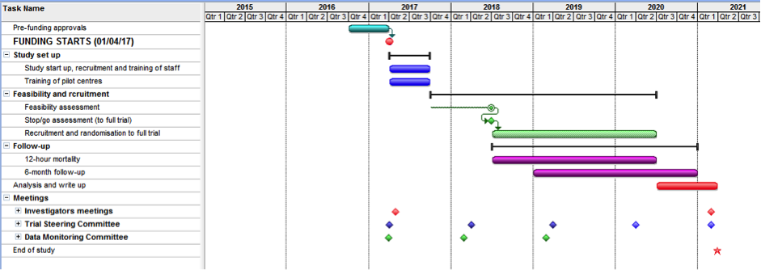

- UK-REBOA Trial authorship policy

1. Defining authorship
Authorship of published or presented papers is based on the following criteria:^{C1}
- Substantial contributions to the conception or design of the work; or the acquisition, analysis, or interpretation of data for the work; AND
- Drafting the work or revising it critically for important intellectual content; AND
- Final approval of the version to be published; AND
- Agreement to be accountable for all aspects of the work in ensuring that questions related to the accuracy or integrity of any part of the work are appropriately investigated and resolved.

2. PRINCIPLES OF AUTHORSHIP
The following principles of authorship have been derived from editorial publications from leading journals^{C2,C3} and are in accordance with the rules of the International Committee of Medical Journal Editors (ICMJE).¹
All contributors must fulfil the criteria detailed in section 1: DEFINING AUTHORSHIP in order to qualify for authorship.
Contributors who meet fewer than all four of the criteria for authorship listed above should not be listed as authors, but they should be acknowledged. For example, participation solely in the acquisition of funding, collection of data or technical editing, language editing or proofreading the article is insufficient by itself to justify authorship.^{C1} Those persons may be acknowledged and their contribution described. See section 3: ACKNOWLEDGEMENTS.

2.1 Preferred CHaRT authorship
Where possible, all CHaRT studies should publish using all the named contributors who qualify for authorship in the byline i.e. Jane Doe, John Doe, John Smith and Ann Other.
However, there may be situations where this is not possible, for example if the journal limits the number of authors. In such circumstance, group authorship may be appropriate using bylines similar to “The UK-REBOA Trial group” or “Jane Doe, John Doe, John Smith, Ann Other and the UK-REBOA Trial group”. The article should carry a footnote of the names of the people (and their institutions) represented by the corporate title.
Group authorship may also be appropriate for publications where one or more authors take responsibility for a group, in which case the other group members are not authors but may be listed in the acknowledgement (the byline would read 'Jane Doe for the Trial Group').^{C2} Again, the article should carry a footnote of the names of the people (and their institutions) represented by the corporate title.

2.2 Determining authorship
These authorship criteria are intended to reserve the status of authorship for those who deserve credit and can take responsibility for the work. The criteria are not intended for use as a means to disqualify colleagues from authorship who otherwise meet authorship criteria by denying them the opportunity to meet criterion numbers (ii) or (iii). Therefore, all individuals who meet the first criterion should have the opportunity to participate in the review, drafting, and final approval of the manuscript.¹
Tentative decisions on authorship should be made as early as possible. ^{C3} These should be justified to, and agreed by, the Project Management Group. Any difficulties or disagreements will be resolved by the Trial Steering Committee (TSC).

2.3 Ordering of authors
The following rules may help with the ordering of authors, particularly for publications with individual authorship:
- The person who has taken the lead in writing may be the first author.
- The senior author may wish to be the last named author.
- Those who have made a major contribution to analysis or writing (i.e. have done more than commenting in detail on successive drafts) may follow the first author immediately; where there is a clear difference in the size of these contributions, this should be reflected in the order of these authors.
- All others who fulfil the four authorship criteria described in Section 1: DEFINING AUTHORSHIP may complete the list in alphabetical order of their surnames.

3. ACKNOWLEDGEMENTS
All those who make a contribution to a publication, but who do not fulfil the criteria for authorship, such as interviewers, data processors, staff at the recruiting sites, secretaries and funding bodies, should be acknowledged by name, usually in an ‘Acknowledgements’ section specifying their contributions. Because acknowledgment may imply endorsement by acknowledged individuals of a study’s data and conclusions, authors are advised to obtain written permission to be acknowledged from all acknowledged individuals¹.

4. DISCLAIMERS
All papers arising from CHaRT must include the full title of the Health Services Research Unit (HSRU) and the appropriate disclaimer specified by the Chief Scientist Office (CSO). For the current disclaimer please see Q-Pulse.
Authors should also ensure they include the study funder’s disclaimer: refer to the funders website for details. Be aware that other disclaimers may also be required.

5. QUALITY ASSURANCE
Ensuring quality assurance is essential to the good name of the trial group. All reports of work arising from the UK-REBOA Trial, including conference abstracts, should be peer reviewed by the Project Management Group. The Project Management Group will be responsible for decisions about submission following internal peer review. Submission may be delayed or vetoed if there are serious concerns about the scientific quality of the report. If individual members of the group are dissatisfied by decisions, the matter may be referred to the TSC.
It is hoped that the adoption and dissemination of this policy will prevent disputes that cannot be resolved by informal discussion. However, any member off the study team with a concern about authorship should discuss it with the relevant Chief Investigator, TSC, Line Manager or Programme Director as appropriate.

6. References
C1. Recommendations for the Conduct, Reporting, Editing, and Publication of Scholarly Work in Medical Journals. Developed by members of the ICMJE over the period 2011 to 2013. (www.icmje.org/#authors)
C2. Huth EJ. Guidelines on authorship of medical papers. Annals of Internal Medicine 1986; 104: 269-274.
C3. Glass RM (1992). New information for authors and readers. Group authorship, acknowledgements and rejected manuscripts. Journal of the American Medical Association 1992; 268: 99.

