**Participant Information Leaflet**

|  |  |
| --- | --- |
| **Study Title:** | **SLEEP:** Supporting empLoyEes with insomnia and Emotion regulation Problems |
| **Investigator(s):** | Krishane Patel (University of Warwick), Talar Moukhtarian (University of Warwick), Carla Toro (University of Warwick), Laura Chandler (University of Warwick), Nicole Tang (University of Warwick), Feroz Jadhakhan (University of Birmingham), Arianna Prudenzi (University of Birmingham), Steven Marwaha (University of Birmingham), Lukasz Walasek (University of Warwick), Caroline Meyer (University of Warwick) |

**Introduction**

You are invited to take part in a research study. Before you decide if you want to take part, you need to understand why the research is being done and what it would involve for you. Please take the time to read the following information carefully. Please ask us if there is anything that is not clear or if you would like more information (wmg-mhpp@warwick.ac.uk). Take the time to decide whether or not you wish to take part.

**Who is organising and funding the study?**

This project is funded by the Midlands Engine partnership which brings together public sector partners and businesses to generate added value for the whole of the Midlands, its communities and the wider UK. The design, implementation and management of this study is being conducted by the University of Warwick and the University of Birmingham.

**What is the study about?**

The **SLEEP** study aims to test the efficacy of a hybrid digital intervention designed to improve employee wellbeing, targeting sleep problems to stay engaged and productive in work. Mental health problems affect one in six workers each year and are the leading cause of sickness absence, where stress, anxiety and depression are responsible for approximately half of the working days lost (Deloitte, 2020). The study will assess the efficacy of a digital hybrid intervention, that is based on cognitive behavioural therapy (CBT) models for insomnia and emotion regulation skills to improve problems with insomnia and stress. CBT is a type of talking treatment, that combines cognitive therapy (examining the things you think) and behaviour therapy (examining the things you do) and focuses on how your thoughts, beliefs and attitudes affect your feelings and behaviour, and teaches you skills for dealing with different problems. For further information on CBT, you can refer to the NHS[1] and MIND[2] websites.

**Why have I been chosen for this trial?**

You registered your interest to take part in one of the pilot trials and completed screening questionnaires to check your eligibility against the study inclusion criteria. Based on the responses you provided, we are inviting you to take part in the **SLEEP** intervention of the Mental Health and Productivity Pilot (https://mhpp.me/).

**What would taking part involve?**

Participation in this study is voluntary and you can withdraw your involvement at any time, and this would not affect you or your employment. If you agree to take part in the **SLEEP** trial, please follow the link provided at the end of this form to consent to take part in the trial and complete the baseline measures of the study, which consists of a set of questionnaires on well-being, workplace productivity, job satisfaction, and health-related quality of life. In addition, you will be asked to provide some demographic information (i.e. employer name and address, gender identity, age, ethnicity, working hours, income band, education level, relationship status, number in household, number of absent days from work, what medications- prescription and over-the-counter you use) to understand the characteristics of our target sample and use that information to guide future larger-scale studies. At 8 weeks, you will be asked to complete the same questionnaire measures again. All questionnaire measures will be self-completed on an online platform called Qualtrics accessed through links sent to you by email.

You will then be randomly placed into either the **SLEEP** intervention group or a waitlist control group. Those in the intervention group will start with a 1-week sleep tracking facilitated by a sleep tracker provided by us. The sleep tracker is a compact and lightweight activity monitoring device that you need to wear on your wrist like a watch for the duration of that week, which tracks your sleep and physical movement. We will be sending out the sleep trackers along with a detailed instruction manual and a free-post envelop for you to return them after the tracking week. We will use data from the sleep tracker to assess your sleep quality. Following the sleep tracking week, you will be enrolled in the 6-week digital intervention consisting of an hour of weekly commitment, in addition to four 45-minute online sessions with trained specialists (see figure 2 below for interventions schedule). Before starting the intervention, you will be asked to note your preferences (e.g. day, am/pm) for the therapist sessions. The research team will do its best to accommodate you as much as possible. You will also be asked to fill in a paper-pencil sleep diary via a booklet sent by the research team. Data from the sleep diary will be used during the sessions with the therapists to understand your sleep patterns. You will then be sent another sleep tracker to complete a final 1-week of sleep tracking, and asked to return it, along with your sleep diary booklet in the provided free-post envelope.

Those in the waitlist control group will start with a 1-week sleep tracking facilitated by a sleep tracker provided by us. Following the sleep tracking week, you will be asked to continue life as usual for 6-week. You will then be asked to complete a final 1-week of sleep tracking. Subsequently, you will be offered the 6-week digital intervention as explained above, finished with another 1-week of sleep tracking.

At the end of the digital intervention, we may ask you to take part in a qualitative feedback interview (if you consent to be interviewed) aiming to explore the effectiveness, acceptability, barriers, and facilitators of the intervention to inform future trials for subsequent evaluations. Interviews will be conducted online on Microsoft Teams or via telephone (participant’s choice) by members of the research team, and audio-recorded using University of Warwick managed digital recording devices and then subsequently transcribed by the research team.

You will be contacted again after one month to complete the same questionnaire measures you completed at the start of the trial and at 8 weeks.

Overall, the study will last for 3 months if you are placed initially in the intervention group. If you are initially placed in the waitlist control group, you will be offered the intervention after an 8-week delay, and be in the study for 5 months. For practical reasons, we will be running the trial in 3 separate cohorts, which participants will randomly be allocated to. This means eligible participants enrolled in the **SLEEP** study may have to wait for a short period (up to 13 weeks from consent to trial) as we pick a time slot for your start. For more information please see the study flow chart on the next page.

The digital intervention will include guidance through CBT for insomnia and emotional regulation skills training designed to alleviate stress.

|  |  |  |
| --- | --- | --- |
| Register interest | | |
|  | | |
| Consent to screen & complete screening | | |
|  |  | |
| **Not eligible**  Signposted to self-help resources | **Eligible**  Consent to trial  Complete baseline measures | |
|  |  |  |
|  | Randomised to waitlist control | Randomised to digital intervention |
|  |  | |
|  | 1-week sleep tracking | |
|  |  |  |
|  | Life as normal | 6-week  intervention |
|  |  | |
|  | 1-week sleep tracking | |
|  |  | |
|  | End-of-intervention outcome measures | |
|  |  |  |
|  | Enrolled in digital intervention |  |
|  |  | 25 selected for interview |
|  |  |  |
|  |  | 1-month follow up measures |

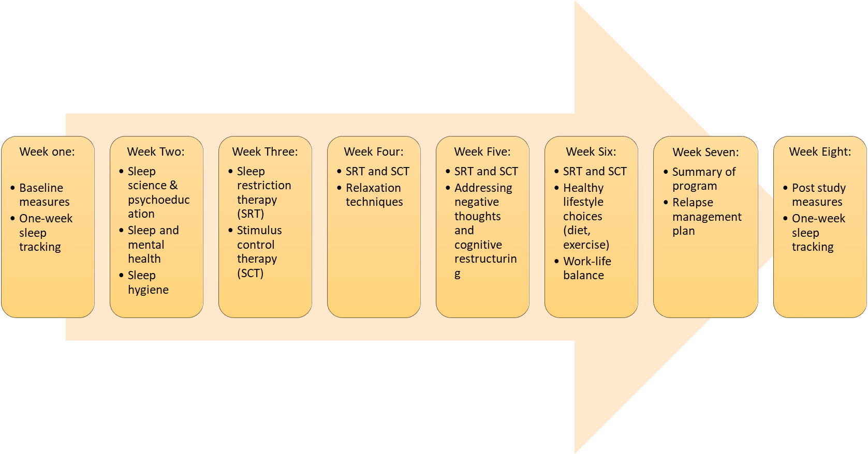

**Do I have to take part?**

Participation in this study is completely voluntary and choosing not to take part will not affect you or your employment in any way. You can also choose to withdraw your participation at any time, without giving a reason by contacting the research team at [wmg-mhpp@warwick.ac.uk](mailto:wmg-mhpp@warwick.ac.uk). Further details about withdrawing from the study are provided at the end of this page. .

**What are the possible benefits of taking part in this study?**

In this trial, we expect our digital intervention to reduce stress, improve sleep, and overall wellbeing to maintain and improve engagement and productivity at work. This will help businesses to get back on their feet in the current COVID-19 climate, helping businesses in the Midlands become more productive.

**What are the possible disadvantages, side effects or risks, of taking part in this study?**

We do not anticipate any major disadvantages, side effects or risks in taking part. The **SLEEP** intervention could involve “sleep restriction therapy” and/or sleep re-scheduling therapy, which may be associated with minor side effects such as daytime sleepiness. You will be fully instructed as to the rationale and potential side effects of the treatment at the outset. In addition, you will be advised to not drive or operate machinery if experiencing excessive daytime sleepiness.

Some participants will be randomly placed on the waitlist control group, in which case, the intervention will still be provided to them, but after a delay. You will be offered different channels to communicate with our research team and will be encouraged to report any unwanted/unexpected effects (attributable or not to the treatment offered) to the research team as soon as they emerge.

The process evaluation interviews for **SLEEP**, which aim to explore the effectiveness, acceptability, barriers, and facilitators of the intervention might cause distress to some individuals. Should that occur, we will offer to pause and/or stop the interview and offer you appropriate support.

Due to the minimal direct contact the research team will have with participants, we advise and encourage you to report any event that you think may or may not be related to your being part of the study to the research team by email ([wmg-mhpp@warwick.ac.uk](mailto:wmg-mhpp@warwick.ac.uk)) or to your therapist during the online sessions.

**Expenses and payments**

For each of the three assessment waves (i.e. upon completion of baseline questionnaires and return of sleep trackers with prepaid envelops, after intervention at 8 weeks and return of sleep trackers with prepaid envelops, and at 1-month follow-up), you will be provided with a £10 Amazon voucher as a gesture of good-will for your time and commitment to the study. Of those who have completed the intervention and have agreed to take part in the qualitative interview, we will randomly select 25 participants- those who complete the interview will also receive an additional £10 amazon voucher.

**Will my taking part be kept confidential?**

Your data will be kept confidential throughout the study. Research data will be de-identified as quickly as possible after data collection. Your study data will instead be associated with a unique participant ID number to complete all assessments and interventions. The key to identification will be stored separately and securely to the research data to safeguard your identity and access will be limited to the lead researcher (CT) and the project manager (CK), neither of whom will have any access to the study data. We are collecting your phone number and email address to contact you during the course of the study (e.g. sessions with therapist) and your postal address to send out the sleep tracker devices. At the end of the intervention, you may be invited to take part in qualitative interviews (if you consent). The interviews will be audio recorded using University of Warwick manged digital recording devices for transcriptions, from which direct quotes may be included in the publication, however, these will not reveal any information that could identify enrolled employees (e.g. name). Personally identifiable data (e.g. name, email, postal address) collected in this study will be stored in password protected folders, kept separate from study data; all of which will be stored securely on the  University of Warwick servers.

Your participation and individual data collected from the study will not be shared with your employer, nor are you under obligation to report your participation to your employer. Your employer has agreed to provide an allowing environment to employees wanting to take part in the trials. This may take the form of completing the trial “homework” during normal working hours, or requesting computer access from your employer (subject to availability). We would like you to note that any resource request may identify you and therefore renders your participation not to be fully anonymous. Nevertheless, your employer has agreed that your participation will not affect you or your employment.

Participating businesses will only receive a summary report which will not include any identifiable information about enrolled employees. Additionally, no identifiable information (e.g., name) will be used for analysis or in publications emerging from this study.

**What will happen to the data collected about me?**

We will be using information from you in order to undertake this study and will act as the data controller for this study. We are committed to protecting the rights of individuals in line with data protection legislation.

Data from the activity and sleep trackers (MotionWatch) will be stored locally on each device. Once you send the device back to the research team, your data will be deleted from the device immediately after being transferred to a password protected folder on the University of Warwick servers.

Data from the printed sleep diary booklet will be entered in a password protected excel file on the University of Warwick servers, and the physical booklets will be shredded immediately after.

We will examine individual usage of the digital intervention platform, this will include the number of logins, the frequency with which you use hyperlinks, how often you download any resources, submit assignments and any other additional requirements. The pseudo-anonymous intervention adherence data will be downloaded from the platform and transferred to a password protected folder on the University of Warwick servers.

The process evaluation interviews (conducted on a selected 25 participants only) will be done through a telephone or online through Microsoft Teams (participant’s choice) and will be audio recorded using University of Warwick managed digital recording devices. The audio data will be transcribed then immediately deleted. The transcriptions will be kept in a password protected folder, with all personal identifiable information removed and pseudonyms used to protect participants’ identity.

Study and personal data: Questionnaire data will be deleted from the Qualtrics platform, immediately after being transferred to the University of Warwick servers. We will also delete all personal data from the University of Warwick servers immediately after the trial is completed (anticipated date: 12/2021). The pseudo-anonymised study data will be deleted after 10 years from the University of Warwick servers.

Study data may also be used for future research, including impact activities following review and approval by an independent Research Ethics Committee and subject to your consent at the outset of this research project.

For further information, please refer to the University of Warwick Research Privacy Notice which is available here: <https://warwick.ac.uk/services/idc/dataprotection/privacynotices/researchprivacynotice> or by contacting the Information and Data Compliance Team at [GDPR@warwick.ac.uk](mailto:GDPR@warwick.ac.uk).

**What will happen if I don’t want to carry on being part of the study?**

Participation is entirely voluntary; you have the right to withdraw at any time without giving a reason. If you wish to withdraw you will need to email the research team [wmg-mhpp@warwick.ac.uk](mailto:wmg-mhpp@warwick.ac.uk) stating your intention to withdraw. In this event we will remove your study data and all identifiable data from the separate dataset.

**What will happen to the results of the study?**

The data collected will be analysed by researchers at the University of Warwick. The results are expected to be published in peer reviewed scientific journals and reported at national and international research meetings. Additionally, summary reports will be shared with all participating employers and our funders, the Midlands Engine. It will not be possible to identify you personally in these publications and reports.

**Who has reviewed the study?**

This study has been reviewed and given favourable opinion by the University of Warwick’s Biomedical & Scientific Research Ethics Committee (BSREC). Ref: BSREC 45/20-21

**Who should I contact if I want further information?**

For more information contact the research team’s Dr Krishane Patel or Dr Talar Moukhtarian at [wmg-mhpp@warwick.ac.uk](mailto:wmg-mhpp@warwick.ac.uk).

**Who should I contact if I wish to make a complaint?**

Any complaint about the way you have been dealt with during the study or any possible harm you might have suffered will be addressed. Please address your complaint to the person below, who is a senior University of Warwick official entirely independent of this study:

**Head of Research Governance**

Research & Impact Services

University House

University of Warwick

Coventry

CV4 8UW

Email: [researchgovernance@warwick.ac.uk](mailto:researchgovernance@warwick.ac.uk)

Tel: 02476 575733

If you wish to raise a complaint on how we have handled your personal data, you can contact our Data Protection Officer who will investigate the matter: DPO@warwick.ac.uk.

If you are not satisfied with our response or believe we are processing your personal data in a way that is not lawful you can complain to the Information Commissioner’s Office (ICO).

**How do I sign up?**

Please click on the following link to consent to the **SLEEP** study and complete the baseline measures-

**Thank you for taking the time to read this Participant Information Leaflet.**

1. https://www.nhs.uk/conditions/cognitive-behavioural-therapy-cbt/
2. https://www.mind.org.uk/information-support/drugs-and-treatments/cognitive-behavioural-therapy-cbt/about-cbt/