Trial title: Population differences in vaccine response: the role, reversibility and mediators of immunomodulation by chronic infections in the tropics. The effect of intensive treatment for schistosomiasis on response to vaccines among island adolescents (POPVAC A)

Statistical Analysis Plan
Version 2.0
1st December 2020

This SAP has been written based on information contained in the POPVAC A protocol version 3.0 dated 15th June 2020.

Introduction

Background and rationale
Several important licensed and investigational vaccines have lower efficacy, and induce impaired immune responses, in low-income countries (LICs) compared to high-income countries and in rural, compared to urban, settings. Understanding these population differences is crucial for informing strategies towards optimisation of vaccine effectiveness in the tropics. We hypothesise that repeated exposure to, and immunomodulation by, chronic helminth infections may affect responses to vaccines.
To address this hypothesis, POPVAC A trial is being carried out among adolescents in the Koome Islands of Lake Victoria to assess if intensive versus standard treatment with praziquantel (PZQ) for Schistosoma mansoni infection before administering vaccines will impact on vaccine responses in this population.

Research Objectives and hypothesis
Study objectives
The primary objective of this trial is to determine whether there are reversible effects of chronic Schistosoma mansoni infection on vaccine response in adolescents.
Secondary objectives are:
- To determine effects on vaccine response waning
- To determine whether there are differential effects on priming vs boosting immunisations
- To determine effect of intensive praziquantel treatment on S. mansoni infection status and intensity

The exploratory objective is to explore immunology among subsets of participants to further characterise effects of treating S. mansoni on vaccine responses.

Primary objective hypothesis
The null hypothesis is that there is no difference in the mean responses induced by BCG, YF-17D, Ty21a, HPV and Td vaccines between adolescents who received intensive and standard PZQ treatment. The alternative hypothesis is that the mean vaccine responses will differ between adolescents receiving intensive and standard PZQ treatment.

Study Methods

Trial design
This trial is a randomised, parallel group open trial comparing intensive versus standard praziquantel intervention for S. mansoni infection on vaccine response outcomes. Treatment allocation is a 1:1 ratio for the trial intervention.

Sample size considerations
A sample size of 480 healthy adolescents (240 in each arm) of whom 80% (384) are expected to have S. mansoni infection at baseline will be enrolled into the trial. The sample size was informed by the expected difference in vaccine responses between the two arms. Full details of the sample size considerations are presented in the protocol.

Randomisation
Eligible volunteers who consent will be enrolled and allocated sequentially to one of the two trial arms according to the randomisation code, until the required total sample size is achieved. The randomisation code was generated using a randomly permuted block size (sizes 4, 6, 8 and 10) and will be used to allocate participants to either receive quarterly PZQ (intensive arm) or annual PZQ (standard arm).

Blinding
Immunology laboratory staff assessing trial outcomes will be blinded to the treatment allocation. Participants and clinical staff will not be blinded.

Statistical interim analyses and stopping guidance
Analyses will be conducted for safety reviews as outlined in the Data Safety Monitoring Board (DSMB) charter. For each safety analysis, the DSMB members will review data on trial progress and adverse events. Details of the Safety holding rules are detailed in the protocol. Since recruitment will be conducted over a short time period, there is no statistical interim analysis planned for comparison of vaccine responses between the two arms.

Timing for the primary outcome analysis
Analysis for comparison of each of the vaccine responses between the two trial arms will take place after enrolment of all participants in the two arms has been completed and samples for assessing the primary outcomes have been taken, laboratory assays for that particular vaccine primary outcome have been conducted and the data have been entered and cleaned.

Timing of outcome assessment
In the following section, week numbers in brackets are based on the schedule in the protocol, with BCG immunisation given at week 0, and YF-17D, Ty21a and first dose of HPV given at week 4.
Timing of primary outcomes
BCG: BCG-specific IFN-γ ELIspot response eight weeks post BCG immunisation (week 8)
YF-17D: neutralising antibody titres (plaque-reduction neutralisation test) at four weeks post YF immunisation (week 8).
Ty21a: Salmonella typhi lipopolysaccharide (LPS)-specific immunoglobulin(Ig)G concentration at four weeks post Ty21a immunisation (week 8).
HPV: IgG specific for L1-proteins of HPV-16/18 at four weeks post HPV priming immunisation (week 8).
Td: tetanus and diphtheria toxoid-specific IgG concentration at 24 weeks post Td immunisation (week 52). This outcome was originally planned to be assessed at four weeks post Td immunisation (week 32) but will now be assessed at week 52, due to alterations to the trial schedule from week 32 onwards as a result of COVID-19 pandemic disruption.
Timing of secondary outcomes
Protective immunity: Proportions with protective neutralising antibody (YF), i.e. neutralising antibody>1/10; protective IgG levels (TT), i.e. IgG>0.1 IU/ml; seroconversion rates (Ty21a) at four weeks post the corresponding immunisation (week 8).
Response waning: Primary outcome measures for all vaccines (with the exception of Td) repeated at week 52 (weeks 8 and 52).
Priming versus boosting: HPV vaccine responses four weeks after the priming dose (week 8) and 24 weeks after the boosting dose (week 52).
Current S. mansoni infection status and intensity: Serum/plasma levels of circulating anodic antigen (CAA) assessed retrospectively on stored samples collected on immunisation days (weeks 0, 4, 8 and 28) and on primary (weeks 8 and 52) and secondary endpoint days (week 52).

Statistical Principles

Level of statistical significance
All applicable statistical tests will be 2-sided. All tests will be performed using a 5% significance level. 95% confidence intervals will be presented.

Compliance and Protocol Deviations
Compliance to the protocol schedule will be assessed based on the percent of participants who have attended the scheduled visits and received the appropriate assigned vaccines within the permitted time windows around the vaccinations and sample collection visits as specified in the schedule of visits and procedures in the protocol.

Analysis population
The primary analysis will be done on participants who are infected with S. mansoni at baseline in order to investigate the effect of parasite removal. The secondary analysis will include all randomised individuals. For all responses to vaccines, analysis will be done by intention to treat (ITT), that is, participants will be included in the arm to which they were randomised, regardless of whether they have received all allocated PZQ treatments.

Analysis population for the primary outcomes
BCG-specific IFN-γ ELIspot: The analysis population for BCG-specific IFN-γ ELIspot response will include all enrolled participants who receive BCG at week 0 and have BCG-specific IFN-γ ELIspot response measurement at week 8.
YF-17D: The analysis population for YF-17D vaccine response will include all enrolled participants who receive Yellow fever vaccine at week 4 and have YF-17D response measurement at week 8.
Ty21a: The analysis population for Typhoid vaccine Ty21a response will include all enrolled participants who receive Typhoid vaccine Ty21a at week 4 and have Ty21a response measurement at week 8.
HPV: The analysis population for HPV vaccine response will include all enrolled participants who receive HPV vaccine at week 4 and have HPV response measurement at week 8.
Td: The analysis population for Td vaccine response will include all enrolled participants who receive Tetanus and diphtheria vaccine at week 28 and have Td response measurement at week 52.

Analysis population for the secondary outcomes
Protective immunity: Analysis population for YF, Ty21a and Td protective immunity will include all enrolled participants who receive the respective vaccine (YF-17D, Ty21a at week 4, Td vaccine at week 28) and have responses to the respective vaccines at 4 weeks post vaccination.
Response waning: Analysis population will include all enrolled participants who receive any of BCG, YF-17D, Ty21a and HPV vaccines; have corresponding responses to any of these vaccines at weeks 8, and 52 post vaccination.
Priming versus boosting: Analysis population will include all enrolled participants who receive a priming dose of HPV vaccine at week 4 and a boosting dose at week 28 and have corresponding responses to the vaccine (at weeks 8 and 52).
Current S. mansoni infection status and intensity: Analysis population will include all enrolled participants who have serum/plasma samples and corresponding results at any of these time points; baseline (week -8), on immunisation days (weeks 0, 4, 8 and 28), and on primary (weeks 8 and 52) and secondary endpoint days (week 52).

Trial population

Screening, eligibility, recruitment and lost to follow up of participants.
A CONSORT flow diagram will be used to summarise the number of participants in each trial arm who were:
• assessed for eligibility at screening • ineligible at screening* • eligible and randomised • received vaccines • did not receive vaccines* • lost to follow-up* • included in the primary analysis • excluded from the primary analysis*
*reasons for these events will be provided.

CONSORT Flow Diagram
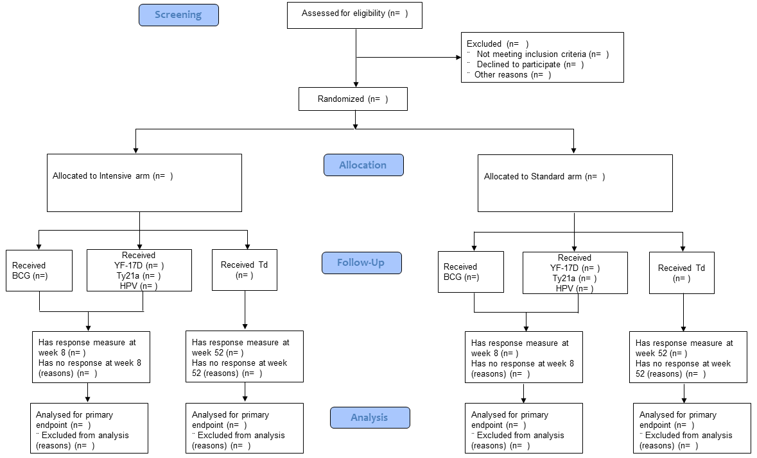
Note: Details of inclusion and exclusion criteria are listed in the protocol

Baseline characteristics
Participants will be described with respect to their baseline characteristics including age, sex, school, location of birth, prior vaccination status, helminth infection status and malaria infection status both overall and separately for each arm.
Categorical variables will be summarised by numbers and percentages. Continuous variables will be summarised by mean, SD and range if data are normal or median, IQR and range if data are skewed. No statistical tests will be done to compare baseline characteristics between arms.

Analysis of outcomes

Outcome definitions
Timing for the outcome assessments are described in section 2.7

Outcomes for primary objective
- BCG: BCG-specific IFN-γ ELIspot response
- YF-17D: neutralising antibody titres
- Ty21a: Salmonella typhi lipopolysaccharide (LPS)-specific immunoglobulin(Ig)G concentration
- HPV: IgG specific for L1-proteins of HPV-16/18 at four weeks post HPV priming immunisation
- Td: tetanus and diphtheria toxoid-specific IgG concentration

Outcomes for secondary objective
- Protective immunity: Proportions with protective neutralising antibody (YF), i.e. >1/10; protective IgG levels (TT), i.e. >0.1 IU/mL; seroconversion rates (Ty21a).
- Response waning: Primary outcome measures for all vaccines repeated at week 52.
- Priming versus boosting: IgG specific for L1-proteins of HPV-16/18.
- Current S. mansoni infection status and intensity: Infection status (infected and uninfected) and intensity (light, medium and heavy)

Analysis methods

Analysis of primary objective outcome measures
Unpaired t tests will be used to compare means of primary outcome responses between participants in the intensive and standard arms. The effect estimate will be presented as a mean difference in the responses reported with 95% confidence intervals and p values. There will be no adjustment for confounders. For each of the primary outcomes, we will investigate adjusting for the corresponding measure at baseline. Subgroup analyses by sex for all the primary outcome measures will be conducted and unpaired t tests will be used to compare mean responses in each group, with interaction terms fitted to assess whether effects of the intervention on outcomes differ between subgroups.

Analysis of secondary objective outcome measures
Protective immunity: Proportions of participants in each category will be presented by trial arm and comparisons between trial arms will be made using chi square test.
Response waning: Area under the curve will used for analysis of response waning. Response measurements from week 8 and week 52 will be used for this analysis.
Priming versus boosting: Mean HPV responses will be presented and paired t test will be used to compare HPV responses at weeks 8 and 52.
Current S. mansoni infection status and intensity: Proportions of participants in each infection status category will be presented by trial arm and comparisons between trial arms will be made using chi square test.

Checking assumptions
For statistical analyses that require data to be normally distributed, the normality assumption of the data will be checked using graphical assessment of normality (Q-Q plot) and a Kolmogorov-Smirnov test for normality. If the data are found to be non-normal, medians (IQR) or geometric means (GMs) will be presented instead of means (SD). A log transformation will be applied to achieve normality and if not achieved, alternative tests such as the Wilcoxon rank sum test will be used to compare outcomes between trial arms. If normality is achieved through log transformation, then the parametric tests described in sections 5.2.1, 5.2.2 and 5.2.3 will be applied to the log transformed data. The assumption of equal variances will be checked by testing if standard deviations of the two sample outcome responses are approximately equal e.g. using the F test. If the variances are found to differ, a t test allowing for unequal variance will be used.

Missing data
Participants with missing data on BCG, YF-17D, Ty21a, HPV and Td vaccination and/or measurement for primary endpoints will be excluded from the respective analysis as detailed in the analysis population section. There will be no imputation of missing data.

Statistical software
The analysis will be carried out using Stata version 12 or above. Other packages such as R and SAS may be used if necessary.

Sample tables

Baseline characteristics of study participants
Table 1: Baseline characteristics of study participants by trial arm
 | Intensive |  | Standard
Characteristic | n | Col% | n | Col%
Sex (Male)
Age
School
Good hope day and boarding
Etc…
Helminth infection status
Infected
Malaria infection status
Infected
Etc...

Comparison of primary outcome responses between trial arms
Table 2: Differences in responses between intensive and Standard arms at week 8 for BCG, YF-17D, Ty21a, HPV and week 52 for Td.
 | Intensive | Standard
Vaccine | Mean(SD)** | Mean (SD)** | Mean difference | 95% CI | P value*
BCG
YF-17D
Ty21a
HPV
Td
*P values reported from unpaired t test
** If data are non-normally distributed, median (IQR) or geometric mean (SD) will be presented

Comparison of secondary outcome responses between trial arms
Table 3: Proportions with protective immunity between intensive and Standard arm participants at 4 weeks post the corresponding vaccination (24 weeks for TT)
 | Intensive |  | Standard |  | Risk difference (95% CI) | P value*
 | n/N | Col % | n/N | Col %
Protective neutralising antibody (YF)
Protective IgG levels (TT)
Seroconversion rates (Ty21a)
*P values reported from chi square test

Table 4: Priming versus boosting: Comparison of HPV responses after priming and boosting doses
 | 4 weeks after priming dose, mean (SD)** | 24 weeks after boosting dose, mean (SD)** | P value*
Arm
Intensive
Standard
*P values reported from paired t test
** If data are non-normally distributed, median (IQR) or geometric mean (SD) will be presented

Table 5: Comparison of S. mansoni infection between intensive and standard arms
 | Intensive |  | Standard |  | P value*
 | n | Col % | n | Col %
S. mansoni infection status
Infected
Uninfected
S. mansoni infection intensity
Light
Medium
Heavy
*P values reported from chi square test

