**Participant Flow:**

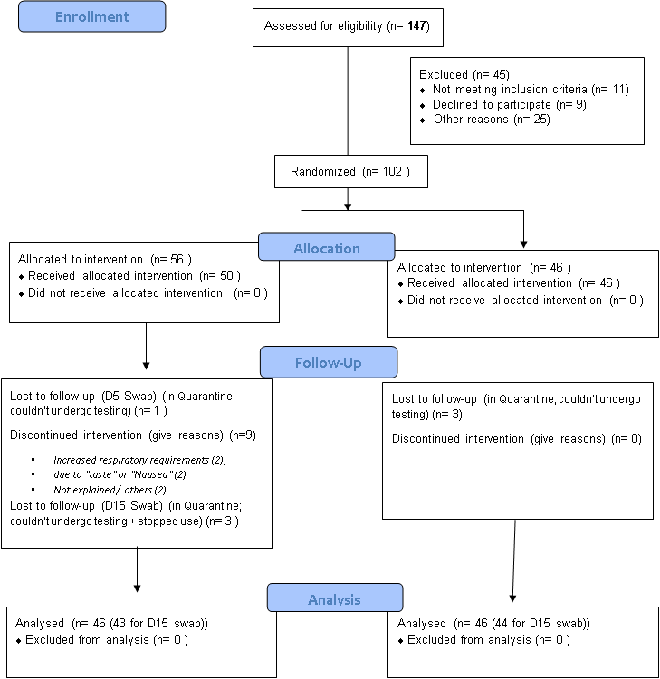

**Baseline Characteristics:**

|  |  |  |  |
| --- | --- | --- | --- |
| Characteristics of the study population | | **Control** (N = 46) | **Intervention** (N = 46) |
| Personal background | Age (mean; yrs) | **49.4** (+/- 11.9) | **49.7** (+/- 13.4) |
| Gender (M:F) | **41:5** | **41:5** |
| Residency status | *Lives alone* | **6** (13%) | **8** (17.4%) |
| *One Cohabitant* | **1** (2.2%) | **0** |
| *Family (>2)* | **30** (65.2%) | **26** (56.5%) |
| *Dorms \** | **9** (19.6%) | **12** (26.1%) |
| *\* Non-related cohabitants >2 persons, sharing the housing facilities* | | | |
| Comorbidities | *Diabetes Milletus* | **18** (39.1%) | **20** (76.9%) |
| *Hypertension* | **18** (39.1%) | **16** (34.8%) |
| *Cor. Art. Disease* | **4** (8.9%) | **2** (4.4%) |
| *Ch. Lung Disease* | **1** (2.2%) | **4** (8.9%) |
| *Ch. Kidney Disease* | **6** (13%) | **5** (10.7%) |
| *Smoking* | **8** (17.4%) | **4** (8.9%) |
| *BMI > 30* | **14** (30.4%) | **15** (32.6%) |
| *Contact with COVID19 +ve case* | **20** (43.5%) | **19** (41.3%) |
| *Others* | **18** (39.1%) | **15** (32.6%) |
| Comorbidities (count) | No comorbidities (0) | **9** (19.6%) | **10** (21.7%) |
| 1 | **16** (34.8%) | **15** (32.6%) |
| 2 | **10** (21.7%) | **9** (19.6%) |
| > 2 | **11** (23.9) | **12** (26%) |
| Duration of symptoms prior to starting treatment (onset of symptoms to onset of treatment; “days”) | | **5.7** (+/- 2.98) | **5.3** (2.86) |
| **P-value > 0.05 for all the variables above; no statistically significant difference** | | | |

**Outcome Measures:**

*Table 2: COVID PCR tests: Results of COVID19-rtPCR for np/op Swabs; ad D:0 (diagnosis), Day-5 and Day-15 of treatment*

|  |  |  |  |  |  |  |
| --- | --- | --- | --- | --- | --- | --- |
| **COVID**  **RT-PCR test results** | **Diag. PCR (Day-0)**  **(N = 92)** | | **Day-5 PCR**  **(N = 89)** | | **Day-15 PCR**  **(N = 87)** | |
| **Intervention** | **Control** | **Intervention** | **Control** | **Intervention** | **Control** |
| **Negative** | **0** (0%) | **0** (0%) | 6 (13.3%) | 0 (0%) | 15 (34.9%) | 9 (20.5%) |
| **Inconclusive** | **0** (0%) | **0** (0%) | 5 (11.1%) | 6 (13.6%) | 14 (32.6%) | 17 (38.6%) |
| **35-40** | 1 (2.2%) | **0** (0%) | 0 (0%) | 0 (0%) | 4 (9.3%) | 5 (11.4%) |
| **30 – 34.99** | 6 (13%) | 5 (10.9%) | 2 (4.4%) | 3 (6.8%) | 7 (16.3%) | 11 (25%) |
| **25 – 29.99** | 13 (28.3%) | 12 (26.1%) | 19 (42.2%) | 19 (43.2%) | 3 (7%) | 1 (2.3%) |
| **20 – 24.99** | 13 (28.3%) | 12 (26.1%) | 8 (17.8%) | 11 (25%) | **0** (0%) | 1 (2.3%) |
| **15 – 19.99** | 9 (19.6%) | 11 (23.9%) | 4 (8.9%) | 4 (9.1%) | **0** (0%) | **0** (0%) |
| **< 15** | 4 (8.7%) | 6 (13%) | 1 (2.2%) | 1 (2.3%) | **0** (0%) | **0** (0%) |
| ***Total*** | *46* | *46* | *45* | *44* | ***43*** | ***44*** |
| **P-value** | **P – Value: 0.37** | | **\* P-value = 0.047** | | **P-value = 0.22** | |

Table 3: Gross extent of improvement:

|  |  |  |  |  |  |
| --- | --- | --- | --- | --- | --- |
| **Clinical Cat.**  **Disposition** | **NCP Asymptomatic** | **NCP mild symptoms** | **MILD CP** | **MODERATE CP** | **SEVERE CP** |
| **Discharged Home** | **4** | **12** | **26** | **1** | **8** |
| **Quarantine facility** | **1** | **8** | **14** | **2** | **9** |
| **Extended hospital stay > 4 weeks** | **0** | **1** | **2** | **\*4** | **0** |
| **Intubation** | **0** | **0** | **0** | **\*2** | **\*1** |
| **Death** | **0** | **0** | **0** | **\*1** | **\*1** |
| * Calculated twice; as it fulfills the requirements of two categories | | | | | |

Table 4: Improvement in symptoms (using modified STAT-10 tool) after two days of treatment

|  |  |  |  |  |  |
| --- | --- | --- | --- | --- | --- |
| Mod. STAT score | Group | N | Mean | 95% CI | **P-value** |
| Day 3 of treatment | Intervention | 41 | **7.6** | **5.74 – 9.53** | **0.002** |
| Control | 36 | **14.8** | **10.61 - 18.95** |
| Day 4 of treatment | Intervention | 38 | **5.6** | **3.75 - 7.41** | **0.006** |
| Control | 34 | **11.2** | **7.46 - 14.89** |
| Day 5 of treatment | Intervention | 36 | **3.9** | **2.11 - 5.77** | **0.039** |
| Control | 36 | **7.6** | **4.59 - 10.69** |

**Adverse Events: None**